BOARD MEETING MINUTES
DATE | Tuesday, August 27, 2021
TIME | 11:00 AM
LOCATION | Via Zoom Teleconference
PURPOSE | Special Called Commission Meeting
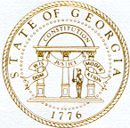
Georgia Nonpublic Postsecondary
Education Commission

Meeting Chair | Toby Hinton
Meeting Title | Board of Commissioners
Members Present | - Toby Hinton, Chairman, Degree-Granting Institution Representative  - Norma Nunez-Cortes, Vice Chair, At-Large Post #6  - Amanda Shailendra, Secretary, At-Large Post #4  - Ryan Blythe, Certificate-Granting Institution Representative  - Dr. Drew Van Horn, Exempt Institution Representative  - Pranay Udutha, At-Large Post #1  - Doug Roper, At-Large Post #2  - P.K. Martin, At-Large Post #3  - Holly Kirbo, At-Large Post #5  - Kate Patterson, At-Large Post #8
Members Absent | - VACANT, At-Large Post #7
Staff Present | Kirk Shook, Executive Director  Dr. Laura Vieth, Associate Executive Director  Adam Hawk, Division Director  Pat Neri, Program Manager  Maggie Rivers, Program Manager  Phil Embry, External Auditor  James Cheek, Regulatory Specialist  Shirlene Mitchell, Office Manager
Visitors | Isabella Lugo, Office of the Attorney General  Erin Greenberg, Office of Planning and Budgeting

- CALL TO ORDER AND INVOCATION
Chairman Hinton called the meeting to order at 11:02 AM and called the roll. All members were present and a quorum was declared.
- WELCOME/INTRODUCTION OF VISITORS
Chairman Hinton welcome all the guests and visitors on the teleconference.
- APPROVAL OF AGENDA
Commissioner Kirbo moved to adopt the Agenda for the August 27, 2021 Special Called Commission Meeting of the Georgia Nonpublic Postsecondary Education Commission. Commissioner Shailendra seconded the motion.

Upon unanimous vote, it was RESOLVED that the Agenda for the August 27, 2021 Special Called Commission Meeting of the Georgia Nonpublic Postsecondary Education Commission be adopted.

- APPROVAL OF FY23 AGENCY BUDGET SUBMISSION
Executive Director Shook presented the FY23 Agency Annual Operating Budget proposal to be submitted to the Governor’s Office of Planning and Budgeting. He explained that Governor Kemp requested no additional cuts and that budgets for FY23 remain the same as FY22. The following budget proposal and object classes were presented for Commission approval pursuant to O.C.G.A. § 45-12-78:

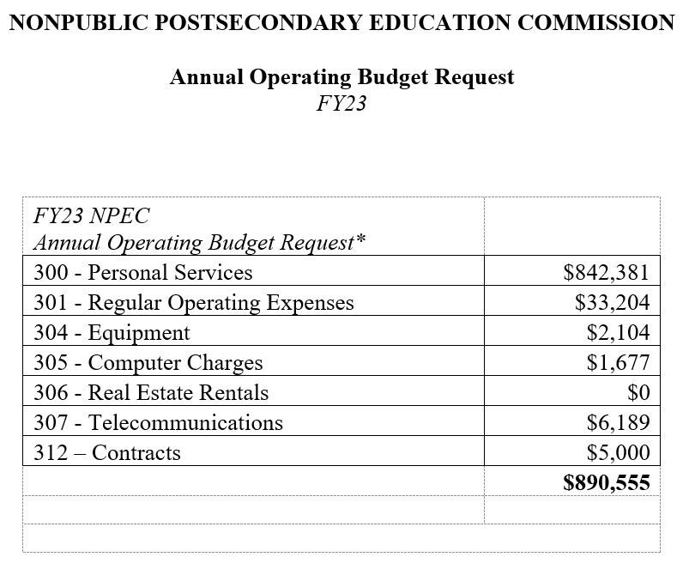

Commissioner Van Horn moved to adopt the NPEC FY23 Agency Budget Request Proposal. Commissioner Blythe seconded the motion. Upon unanimous vote, it was RESOLVED that the NPEC FY23 Agency Budget Request Proposal be adopted.

- EXECUTIVE DIRECTOR REPORT
Presented by Kirk Shook, Executive Director
- FY21 Performance Measures
- FY22-24 Strategic Plan
- Hearing Request, Realtime Voice Academy

No approval required for this report.

- OTHER BUSINESS
The next Quarterly Commission Meeting is October 25, 2021 at 1pm at Helms College/Augusta, 3145 Washington Rd, Augusta, GA.

- PUBLIC COMMENTS
Chairman Hinton opened the floor for any public comments and none were made.

- ADJOURN
Commissioner Martin moved to adjourn the meeting. Vice Chair Nunez-Cortes seconded the motion.

There being no further business, the meeting adjourned at 11:33 AM.

COMMISSION CHAIR APPROVAL: COMMISSION SECRETARY APPROVAL:

____________________________________ ____________________________________
Signature Signature

____________________________________ ____________________________________
Date Date

