BOARD MEETING MINUTES
DATE | Tuesday, August 18, 2020
TIME | 1:00 PM
LOCATION | Via Zoom Teleconference
PURPOSE | Special Called Commission Meeting
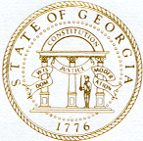
Georgia Nonpublic Postsecondary
Education Commission

Meeting Chair | Mollie Cohen
Meeting Title | Board of Commissioners
Members Present | - Mollie Cohen, Chair, At-Large Post #2  - Karen Gilbert, Vice Chair, Exempt Institution Representative  - Toby Hinton, Secretary, Degree-Granting Institution Representative  - Ryan Blythe, Certificate-Granting Institution Representative  - Amanda Shailendra, At-Large Post #4  - Holly Kirbo, At-Large Post #5  - Norma Nunez-Cortes, At-Large Post #6  - Dr. Arthur Vaughn, At-Large Post #7
Members Absent | - Victoria Agyekum, At-Large Post #1  - Lee Todd, At-Large Post #3
Staff Present | Kirk Shook, Executive Director  Dr. Laura Vieth, Deputy Director  Shirlene Mitchell, Office Manager  Pat Neri, Program Manager  Maggie Rivers, Program Manager  Phil Embry, External Auditor  Chad Woodard, Regulatory Specialist  Hannah Morris, Intern
Visitors | Kristen Settlemire, Office of the Attorney General  Brian Annino, GSFC General Counsel

- CALL TO ORDER AND INVOCATION
Chair Cohen called the meeting to order at 1:05 PM and gave the invocation. Chair Cohen called the roll. Eight members were present and a quorum was declared.
- WELCOME/INTRODUCTION OF VISITORS
Chair Cohen welcome all the guests and visitors on the teleconference.
- APPROVAL OF AGENDA
Commissioner Shailendra moved to adopt the Agenda for the August 18, 2020 Special Called Commission Meeting of the Georgia Nonpublic Postsecondary Education Commission. Commissioner Vaughn seconded the motion.

Upon unanimous vote, it was RESOLVED that the Agenda for the August 18, 2020 Special Called Commission Meeting of the Georgia Nonpublic Postsecondary Education Commission be adopted.

- APPROVAL OF FY22 AGENCY BUDGET SUBMISSION
Executive Director Shook presented the FY22 Agency Annual Operating Budget proposal to be submitted to the Governor’s Office of Planning and Budgeting. He explained that Governor Kemp requested no additional cuts and that budgets for FY22 remain the same as FY21. The following budget proposal and object classes were presented for approval:

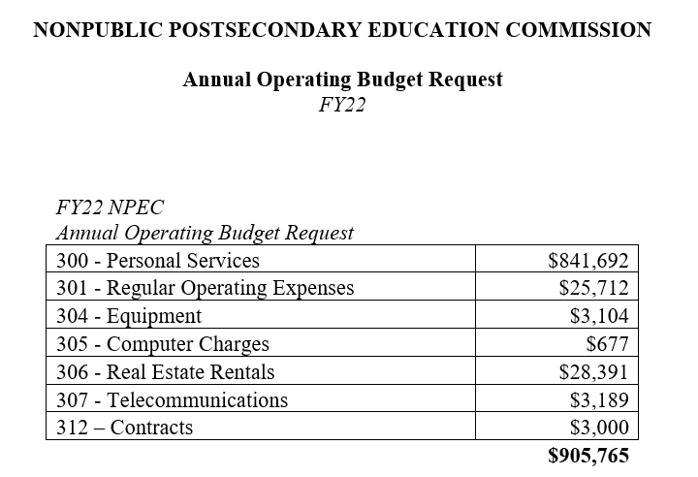

Commissioner Vaughn moved to adopt the NPEC FY22 Agency Budget Request Proposal. Commissioner Nunes-Cortes seconded the motion. Upon unanimous vote, it was RESOLVED that the NPEC FY22 Agency Budget Request Proposal be adopted.

- EXECUTIVE DIRECTOR REPORT
Presented by Kirk Shook, Executive Director
- Updated Strategic Plan (FY21-24)
- FY20 Performance Measures report

No approval required for this report.

- OTHER BUSINESS
The next Quarterly Commission Meeting is October 26, 2020, 2020 at 1pm at Herzing University/Atlanta, 50 Hurt Plaza SE, Suite 400, Atlanta, GA 30303.

- PUBLIC COMMENTS
Chair Cohen opened the floor for any public comments and none were made.

- ADJOURN
Commissioner Hinton moved to adjourn the meeting. Commissioner Kirbo seconded the motion.

There being no further business, the meeting adjourned at 1:16 PM.

COMMISSION CHAIR APPROVAL: COMMISSION SECRETARY APPROVAL:

____________________________________ ____________________________________
Signature Signature

____________________________________ ____________________________________
Date Date

