BOARD MEETING MINUTES

MEETING: | Board of Commissioners, Nonpublic Postsecondary Education Commission  Quarterly Meeting
DATE: | August 18, 2025
LOCATION: | GNPEC Office, 2082 East Exchange Place, Tucker, GA 30084
TIME: | 1:00 pm, or at the conclusion of the Quarterly TGTF Board of Trustees Meeting
PUBLIC CALL-IN INSTRUCTIONS: | Dial-in Number: (667) 770-1484  Participant Code: 317138#


Georgia Nonpublic Postsecondary
Education Commission

Meeting Chair | P.K. Martin, Chairman, At-Large Post #3
Meeting Title | NPEC Board of Commissioners
Members Present | - P.K. Martin, Chairman, At-Large Post #3  - Jim Squire, Vice Chairman, At-Large Post #7  - Pranay Udutha, Secretary, At-Large Post #1  - Ryan Blythe, Certificate-Granting Institution Representative  - Dr. Linda Adkison, Degree-Granting Institution Representative  - Dr. Donald Dowless, Exempt Institution Representative  - Michael Foor, At-Large Post #4  - Dr. Lance Barry, At-Large Post #5  - Dr. Norma Nunez-Cortes, At-Large Post #6  - Kate Patterson, At-Large Post #8
Members Absent | - Doug Roper, At-Large Post #2
Staff Present | - Maggie Rivers, Associate Executive Director/GA-SARA Coordinator  - Pat Neri, Program Manager/Compliance  - Phil Embry, External Auditor  - James Cheek, Director of Operations  - Mike Kaiser, Program Manager/Exemptions & Initial  - Carley Henry, Administrative Assistant  - Caroline Fairhurst, Compliance Specialist/Site Visits  - Theresa Friday, Regulatory Specialist
Visitors | - Stephen DeBaun, GSFC  - Erin Greenburg, GSFC

- CALL TO ORDER AND INVOCATION
Chairman Martin called the meeting to order at 1:04 pm and gave the invocation.

- ROLL CALL
Chairman Martin called the roll, and a quorum was declared.
- WELCOME/INTRODUCTION OF VISITORS
Presented by Chairman Martin

ACTION ITEMS
Presented by Chairman Martin

- APPROVAL OF AGENDA
Commissioner Patterson moved to adopt the Agenda for the August 18, 2025, Quarterly Commission Meeting of the Georgia Nonpublic Postsecondary Education Commission. Commissioner Foor seconded the motion. There was no discussion.

Upon unanimous vote, it was RESOLVED that the Agenda for the August 18, 2025, Quarterly Commission Meeting of the Georgia Nonpublic Postsecondary Education Commission be adopted.

- APPROVAL OF MINUTES
Commissioner Adkison moved to adopt the Minutes from the May 19, 2025, Quarterly Meeting of the Georgia Nonpublic Postsecondary Education Commission. Commissioner Patterson seconded the motion. There was no discussion.

Upon a unanimous vote, it was RESOLVED that the Minutes from the May 19, 2025, Quarterly Meeting of the Georgia Nonpublic Postsecondary Education Commission be adopted.

- APPROVAL OF QUARTERLY REPORT: TUITION GUARANTY TRUST FUND (unaudited)
Presented by Phil Embry, External

  - FY25 4th Quarter Report (April – June 2025) [Unaudited], Phil Embry
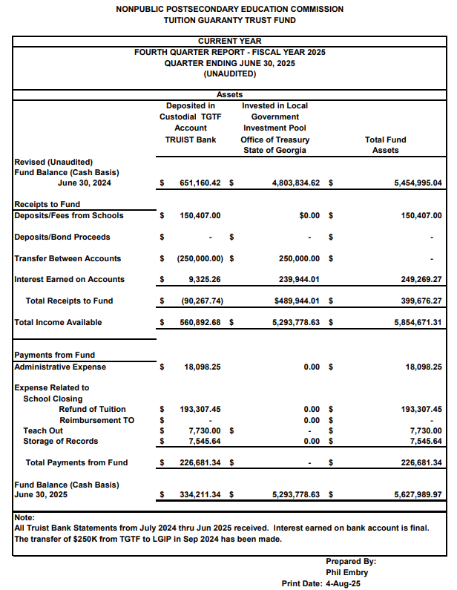

Commissioner Patterson moved to adopt the Quarterly Report of the Tuition Guaranty Trust Fund for April – June 2025 period, as presented. Commissioner Blyth seconded the motion. There was no discussion.

Upon unanimous vote, it was RESOLVED that the Quarterly Report of the Tuition Guaranty Trust Fund April – June 2025 as approved by the Board of Trustees of the Tuition Guaranty Trust Fund, be adopted.

- APPROVAL OF FY27 Budget Proposal

Dr. Shook presented the FY27 Budget Proposal:

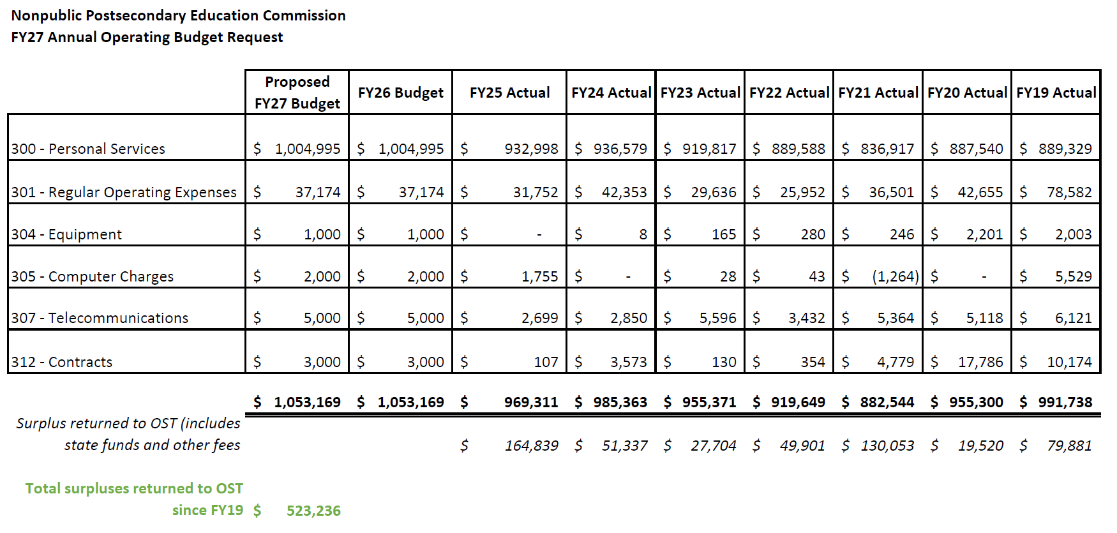
Vice Chairman Squire moved to adopt the FY27 Budget Proposal, as presented. Commissioner Foor seconded the motion. There was no discussion.

Upon unanimous vote, it was RESOLVED that the FY27 Budget Proposal be approved.

- APPROVAL OF FY26 NPEC REVISED SCHEDULE OF FEES

Dr. Shook presented the revised proposed FY26 Schedule of Fees. The below changes were presented:

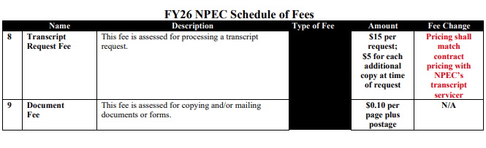
Commissioner Blythe moved to adopt the revised FY26 NPEC Schedule of Fees, as presented. Commissioner Patterson seconded the motion. There was no discussion.

Upon unanimous vote, it was RESOLVED that the revised FY26 NPEC Schedule of Fees be adopted.

- APPROVAL OF POLICY UPDATES

Dr. Shook noted that there were no written submissions received related to the proposed changes to Policy 14 and there were no speakers in the room who had comments on the policy change. The following changes were proposed for Commission consideration:

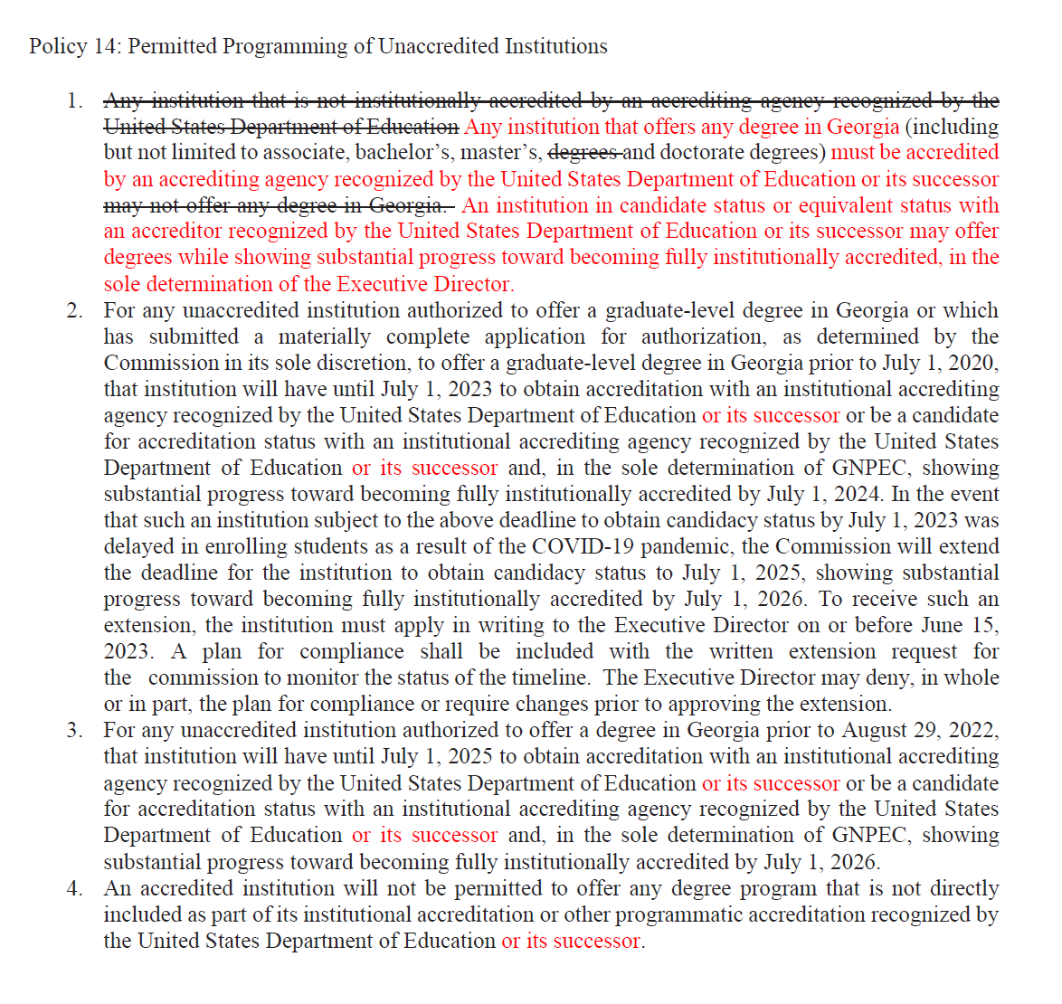

Commissioner Adkison moved to adopt the Policy Updates, as amended. Commissioner Nunez-Cortes seconded the motion. There was no discussion.

Upon unanimous vote, it was RESOLVED that the Policy Updates be adopted.

- EXECUTIVE DIRECTOR REPORT
Presented by Dr. Kirk Shook, Executive Director

- NPEC FY25 Operations Budget (4th Quarter)
- Quarterly Budget Comparison (FY24 Q4 v. FY25 Q4)
- FY25 Performance Metrics
- FY25 Strategic Plan Metrics
- FY26 Agency Reorganization and Personnel Changes
  - Theresa Friday joined NPEC
- Program Evaluation Changes – Student Outcome Data Benchmarks

- AGENCY OPERATIONS REPORTS
Presented by Maggie Rivers, Associate Executive Director

- FY25 4th Quarter Staff Actions

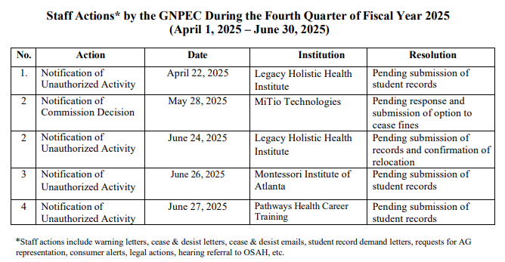

- FY25 4th Quarter Newly Authorized Schools Report
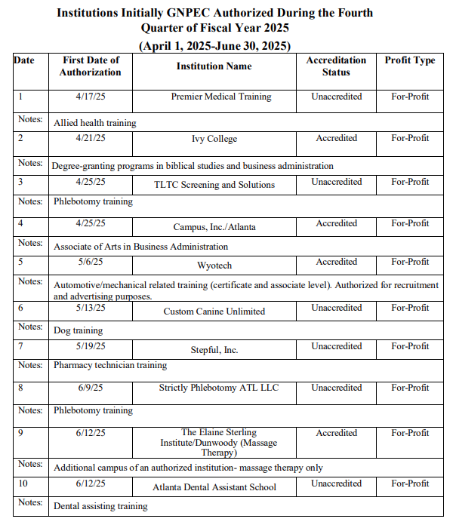

- EXECUTIVE SESSION

Vice Chairman Squire moved to enter Executive Session. Commissioner Patterson seconded the motion. There was no discussion.

Upon a unanimous vote, the meeting of the GNPEC Board of Commissioners entered the Executive Session.

    - Pursuant to O.C.G.A. § 50-14-2(1), this portion of the meeting was “closed in order to consult and meet with legal counsel pertaining to pending or potential litigation, settlement, claims, administrative proceedings, or other judicial actions brought or to be brought by or against the agency”
    - Report on pending litigation from Keith Pridgen, Assistant Attorney General

Commissioner Foor moved for the Commissioners to exit Executive Session. Commissioner Barry seconded the motion. There was no discussion.

Upon a unanimous vote, the meeting of the GNPEC Board of Commissioners exited Executive Session and reported that the Board took a vote concerning GNPEC v. MiTio Technologies, authorizing the Attorney General’s Office to move forward with pursuing the fines accrued for noncompliance.

- SCHOOL SPOTLIGHT
Presented by Dr. Kirk Shook, Executive Director
Dr. Shook presented information submitted by the following schools that each entity wanted to highlight before the Commission:

- Georgia Trade School
- Ultimate Medical Academy
- Fortis College/Atlanta

- OTHER BUSINESS
Presented by Chairman Martin

- The next Quarterly Commission Meeting is November 17, 2025, at 1pm, or at the conclusion of the TGTF Board of Trustees meeting
      - Location: Zoom

- PUBLIC COMMENTS

All public comments are limited to three (3) minutes per individual

- ADJOURN

Chairman Martin moved to adjourn the meeting. The meeting was adjourned at 2:51 pm.

