MEETING: | Board of Trustees, Tuition Guaranty Trust Fund  Quarterly Meeting
DATE: | August 18, 2025
LOCATION: | GNPEC Office, 2082 East Exchange Place, Tucker, GA 30084
TIME: | 12:45pm
PUBLIC CALL-IN INSTRUCTIONS: | Dial-in Number: (667) 770-1484  Participant Code: 317138#

BOARD MEETING MINUTES

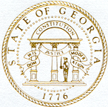

Georgia Nonpublic Postsecondary
Education Commission

Meeting Chair | P.K. Martin, Chairman
Meeting Title | Board of Trustees of the NPEC Tuition Guaranty Trust Fund
Members Present | Dr. Linda Adkison  Jim Squire, Vice Chairman  Dr. Don Dowless  Pranay Udutha  Dr. Kirk Shook, Secretary (Non-Voting Member)
Members Absent | None
Staff Present | Maggie Rivers, Associate Executive Director/GA-SARA Coordinator  Pat Neri, Program Manager/Compliance  Phil Embry, External Auditor  James Cheek, Director of Operations  Mike Kaiser, Program Manager/Exemptions & Initial  Carley Henry, Administrative Assistant  Caroline Fairhurst, Compliance Specialist/Site Visits  Theresa Friday, Regulatory Specialist
Visitors | Stephen DeBaun, GSFC  Erin Greenburg, GSFC

- CALL TO ORDER AND ROLL CALL
P.K Martin, Chairman called the meeting to order at 12:47 pm. Roll Call was taken, and a quorum was declared.

- APPROVAL OF AGENDA
Trustee Udutha moved to adopt the Agenda for the August 18, 2025, Quarterly Meeting of the Board of Trustees of the Tuition Guaranty Trust Fund. Trustee Squire seconded the motion.

Upon unanimous vote, it was RESOLVED that the Agenda of the August 18, 2025, Quarterly Meeting of the Board of Trustees of the Tuition Guaranty Trust Fund be adopted.
- APPROVAL OF MINUTES
Trustee Adkison moved to adopt the Minutes from May 19, 2025, Quarterly Meeting of the Board of Trustees of the Tuition Guaranty Trust Fund. Trustee Dowless seconded the motion.

Upon unanimous vote, it was RESOLVED that the Minutes from May 19, 2025, Quarterly Meeting of the Board of Trustees of the Tuition Guaranty Trust Fund be adopted.

- APPROVAL OF QUARTERLY REPORT (unaudited): TUITION GUARANTY TRUST FUND
External Auditor Phil Embry reported on the following:

- FY25 4th Quarter Report (April – June 2025)

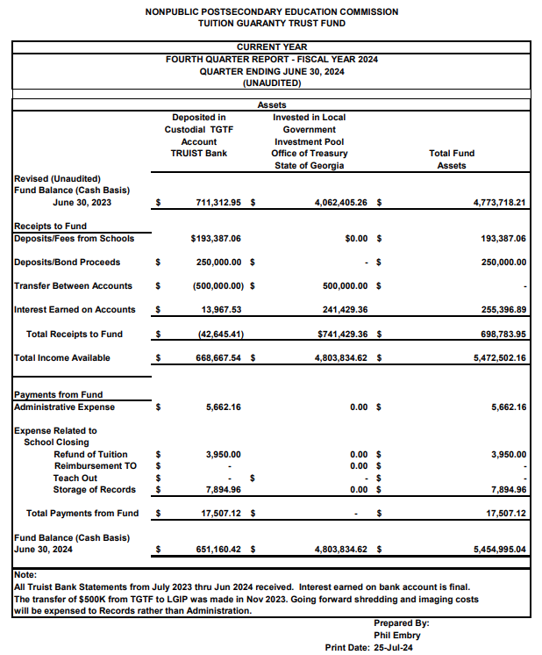

Trustee Udutha moved to adopt the amended Quarterly Report of the Tuition Guaranty Trust Fund. Trustee Squire seconded the motion.

Upon unanimous vote, it was RESOLVED that the Quarterly Report of the Tuition Guaranty Trust Fund for the period April – June 2025 be adopted.

- EXECUTIVE DIRECTOR REPORT
- Georgia Fund Market Update, Phil Embry

- REPORT ON FY25 4th QUARTER SCHOOL CLOSURES
Presented by Maggie Rivers, Associate Executive Director
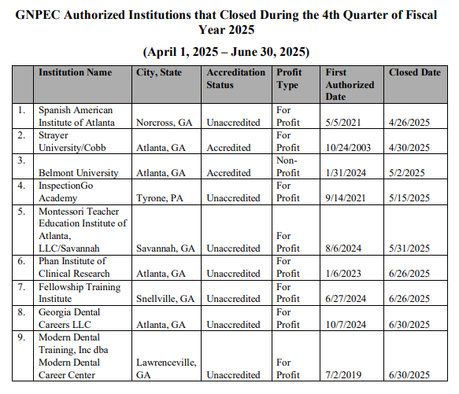No approval required.

- OTHER BUSINESS
- The next Quarterly TGTF Board of Trustees Meeting is November 17, 2025, at 12:45 pm
- Location: Zoom

ADJOURNMENT
Trustee Udutha moved to adjourn the meeting. Trustee Adkison seconded the motion.

There being no further business, the meeting was adjourned at 1:03 pm.

BOARD OF TRUSTEES CHAIR BOARD OF TRUSTEES SECRETARY
APPROVAL: APPROVAL:

____________________________________ ____________________________________
Signature Signature

____________________________________ ____________________________________
Date Date

