BOARD MEETING MINUTES
MEETING: | Board of Commissioners, Nonpublic Postsecondary Education Commission  Quarterly Meeting
DATE: | August 26, 2024
LOCATION: | Georgia Nonpublic Postsecondary Education Commission  2082 East Exchange Pl., Tucker, GA
TIME: | 1:00pm, or at the conclusion of the Quarterly TGTF Board of Trustees Meeting
PUBLIC CALL-IN INSTRUCTIONS: | Dial-in Number: (667) 770-1484  Participant Code: 317138#


Georgia Nonpublic Postsecondary
Education Commission

 | Meeting Chair |  | Dr. Drew Van Horn, Chairman, Exempt Institution Representative
 | Meeting Title |  | NPEC Board of Commissioners
Members Present |  | - Dr. Drew Van Horn, Chairman, Exempt Institution Representative  - P.K. Martin, Vice Chairman, At-Large Post #3  - Kate Patterson, Secretary, At-Large Post #8  - Dr. Linda Adkinson, Degree-Granting Institution Representative  - Ryan Blythe, Certificate-Granting Institution Representative  - Pranay Udutha, At-Large Post #1  - Doug Roper, At-Large Post #2  - Dr. Lance Barry, At-Large Post #5  - Dr. Norma Nunez-Cortes, At-Large Post #6  - Jim Squire, At-Large Post #7
Members Absent |  | - Amanda Shailendra, At-Large Post #4
Staff Present |  | - Dr. Kirk Shook, Executive Director  - Maggie Rivers, Deputy Director  - Pat Neri, Program Manager, Compliance  - Phil Embry, External Auditor  - James Cheek, Program Manager/Authorization  - Mike Kaiser, Program Manager/Initial Authorization  - Caroline Fairhurst, Compliance Specialist  - Shirlene Mitchell, Office Manager  - Warren Albert, Regulatory Specialist  - Olivia Sternagle, Intern
Visitors |  | - Steven Walters, AG  - Lynne Riley, President GSFC

- CALL TO ORDER AND INVOCATION
Chairman Van Horn called the meeting to order at 1:06pm and gave the invocation.

- ROLL CALL
Chairman Van Horn called the roll, and a quorum was declared.

- WELCOME/INTRODUCTION OF VISITORS
Presented by Chairman Van Horn

ACTION ITEMS
Presented by Chairman Van Horn

- APPROVAL OF AGENDA
Secretary Patterson moved to adopt the Agenda for the August 26, 2024, Quarterly Commission Meeting of the Georgia Nonpublic Postsecondary Education Commission. Commissioner Roper seconded the motion. There was no discussion.

Upon unanimous vote, it was RESOLVED that the Agenda for the August 26, 2024, Quarterly Commission Meeting of the Georgia Nonpublic Postsecondary Education Commission be adopted.

- APPROVAL OF MINUTES
Commissioner Squire moved to adopt the Minutes from the May 20, 2024, Quarterly Meeting of the Georgia Nonpublic Postsecondary Education Commission. Commissioner Roper seconded the motion. There was no discussion.

Upon a unanimous vote, it was RESOLVED that the Minutes from the May 20, 2024, Quarterly Meeting of the Georgia Nonpublic Postsecondary Education Commission be adopted.

- APPROVAL OF MINUTES FROM AUGUST 2, 2024, SPECIAL CALLED COMMISSION MEETING
Vice Chairman Martin moved to adopt the Minutes from the August 2, 2024, Special Called Commission Meeting of the Georgia Nonpublic Postsecondary Education Commission. Commissioner Udutha seconded the motion. There was no discussion.

Upon a unanimous vote, it was RESOLVED that the Minutes from the August 2, 2024, Special Called Commission Meeting of the Georgia Nonpublic Postsecondary Education Commission be adopted.

- APPROVAL OF QUARTERLY REPORT: TUITION GUARANTY TRUST FUND (unaudited)
Presented by Phil Embry, External

  - FY24 4th Quarter Report (Apr - Jun 2024)
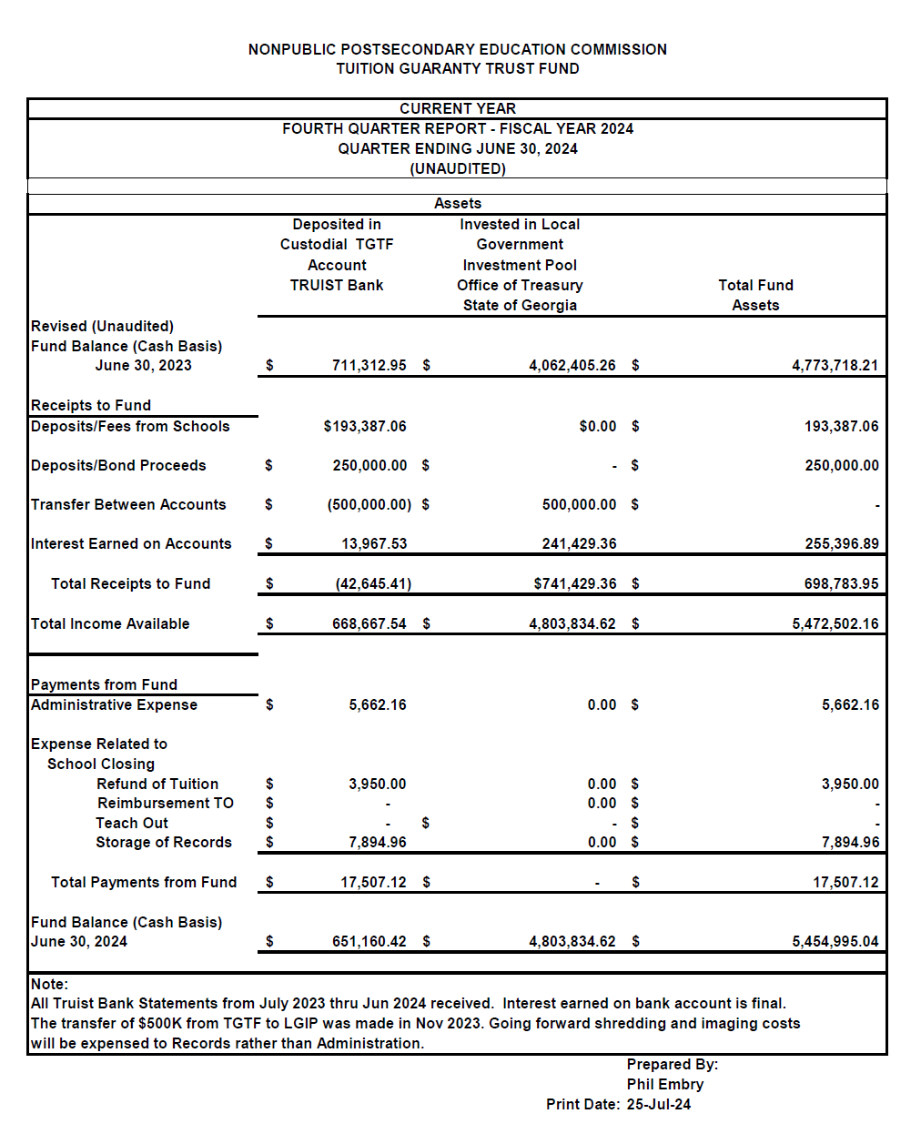
Commissioner Udutha moved to adopt the Quarterly Report of the Tuition Guaranty Trust Fund for April - June 2024 period, as presented, and to approve the $250,000 transfer of funds from the TGTF operating account to the LGIP account, as approved by the TGTF Board of Trustees. Commissioner Roper seconded the motion. There was no discussion.

Upon unanimous vote, it was RESOLVED that the Quarterly Report of the Tuition Guaranty Trust Fund for April - June 2024, as approved by the Board of Trustees of the Tuition Guaranty Trust Fund, be adopted.

- APPROVAL OF FY26 NPEC BUDGET

Dr. Shook presented the FY26 budget proposal. He explained that the Governor recommended not changes from the FY25 to FY26 budgets.
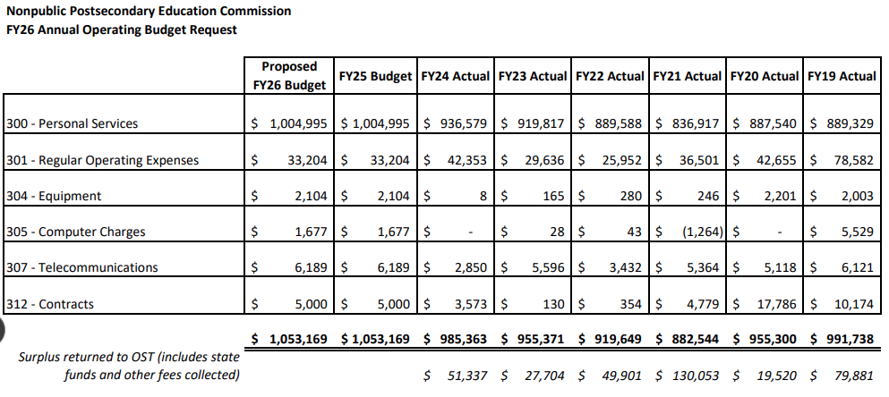

Vice Chairman Martin moved to adopt the FY26 NPEC Budget, as presented. Commissioner Udutha seconded the motion. There was no discussion.

Upon unanimous vote, it was RESOLVED that the FY26 NPEC Budget, be adopted.

- APPROVAL OF UPDATE TO TGTF BOARD OF TRUSTEES BYLAWS

Dr. Shook presented the proposed changes to the TGTF Board of Trustees bylaws. He explained that these changes were to ensure that the Board is in compliance with Georgia Open Meetings laws.
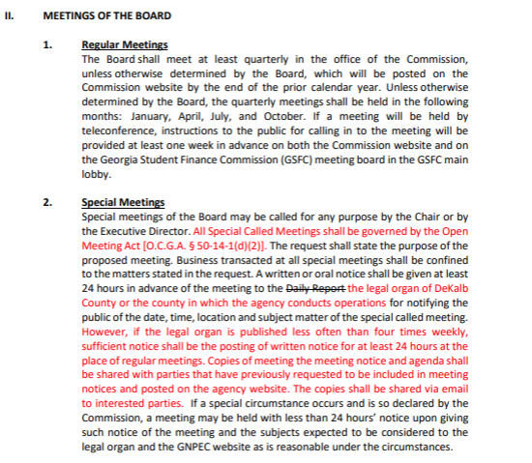
Commissioner Blythe moved to adopt the update to TGTF Board of Trustees Bylaws, as presented, with one typographical error correction. Secretary Patterson seconded the motion. There was no discussion.

Upon unanimous vote, it was RESOLVED that the update to TGTF Board of Trustees Bylaws, be adopted.

- APPROVAL OF UPDATE TO BOARD OF COMMISSIONERS BYLAWS

Dr. Shook presented the proposed changes to the TGTF Board of Trustees bylaws. He explained that these changes were to ensure that the Board is in compliance with Georgia Open Meetings laws.

Secretary Patterson moved to adopt the update to Board of Commissioners Bylaws, as presented, with one typographical error correction. Commissioner Roper seconded the motion. There was no discussion.

Upon unanimous vote, it was RESOLVED that the update to NPEC Board of Commissioners Bylaws, be adopted.

- APPROVAL OF REVISIONS TO FY25 SCHEDULE OF FEES

Dr. Shook presented the proposed FY25 Schedule of Fees. The below changes were presented:

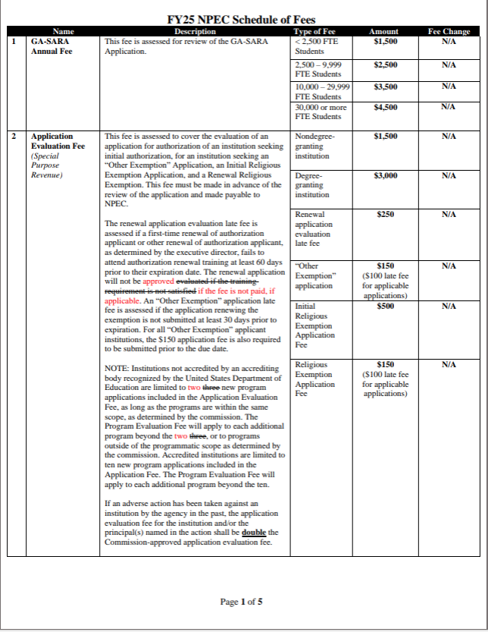

Commissioner Nunez-Cortes moved to adopt the Revisions of FY25 NPEC Schedule of Fines, as presented. Commissioner Blythe seconded the motion. There was no discussion.

Upon unanimous vote, it was RESOLVED that the Revisions of FY25 NPEC Schedule of Fines, be adopted.

- EXECUTIVE DIRECTOR REPORT
Presented by Dr. Kirk Shook, Executive Director

- NPEC FY24 Operations Budget (4th Quarter)
- Quarterly Budget Comparison (FY23 Q4 v. FY24 Q4)
- FY24 Performance Measures
- FY24 Strategic Plan Metrics
- Update on Administrative Hearing

- AGENCY OPERATIONS REPORTS
Presented by Maggie Rivers, Deputy Director

- FY24 4th Quarter Staff Actions

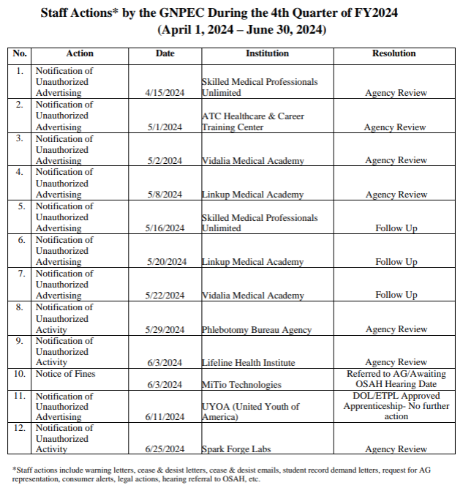

No approval required for this report.

- AGENCY OPERATIONS REPORTS (cont.)
Presented by Maggie Rivers, Deputy Director

- FY24 4th Quarter Newly Authorized Schools Report
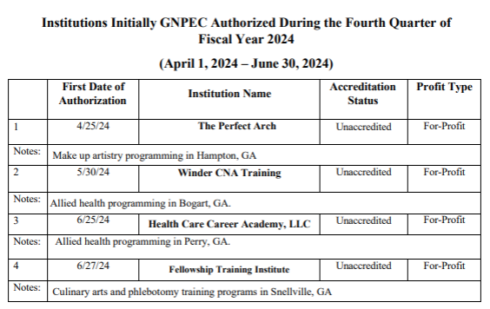

No approval required for this report.

- EXECUTIVE SESSION

There was no need for executive session at this meeting.

- SCHOOL SPOTLIGHT
Presented by Dr. Kirk Shook, Executive Director

Convenient Lab & Phlebotomy School
- First authorized in July 2023; offers certificates in phlebotomy
- A student who graduated in September 2023 had been to numerous job interviews and was passed over for positions.
- The school held a job interview prep at the school, and it helped the former student secure a job the following week.

- OTHER BUSINESS
Presented by Chairman Van Horn

- The next Quarterly Commission Meeting is November 18, 2024, at 1pm
- Location: Zoom

- PUBLIC COMMENTS

No public comments were made.

- ADJOURN
Commissioner Squire moved to adjourn the meeting. Commissioner Roper seconded the motion. There being no further business, the meeting adjourned at 2:08pm.

