MEETING: | Board of Trustees, Tuition Guaranty Trust Fund  Quarterly Meeting
DATE: | August 26, 2024
LOCATION: | Georgia Nonpublic Postsecondary Education Commission, 2082 East Exchange Pl, Tucker, GA
TIME: | 12:45pm
PUBLIC CALL-IN INSTRUCTIONS: | Dial-in Number: (667) 770-1484  Participant Code: 317138#

BOARD MEETING MINUTES



Georgia Nonpublic Postsecondary
Education Commission

Meeting Chair | Dr. Drew Van Horn, Chairman
Meeting Title | Board of Trustees of the NPEC Tuition Guaranty Trust Fund
Members Present | Dr. Drew Van Horn, Chairman  P.K. Martin, Vice Chairman  Ryan Blythe  Kate Patterson  Jim Squire  Dr. Kirk Shook, Secretary (Non-Voting Member)
Members Absent | None
Staff Present | Maggie Rivers, Deputy Director  Pat Neri, Program Manager, Compliance  Phil Embry, External Auditor  James Cheek, Program Manager/Authorization  Mike Kaiser, Program Manager/Initial Authorization  Caroline Fairhurst, Compliance Specialist  Shirlene Mitchell, Office Manager  Olivia Sternagle, Intern
Visitors | Steven Walters, AG

- CALL TO ORDER AND ROLL CALL
Chairman Van Horn called the meeting to order at 12:45 pm. Roll Call was taken, and a quorum was declared.

- APPROVAL OF AGENDA
Trustee Squire moved to adopt the Agenda for August 26, 2024, Quarterly Meeting of the Board of Trustees of the Tuition Guaranty Trust Fund. Trustee Blythe seconded the motion.

Upon unanimous vote, it was RESOLVED that the Agenda of the August 26, 2024, Quarterly Meeting of the Board of Trustees of the Tuition Guaranty Trust Fund be adopted.
- APPROVAL OF MINUTES
Vice Chairman Martin moved to adopt the Minutes from the May 20, 2024, Quarterly Meeting of the Board of Trustees of the Tuition Guaranty Trust Fund. Trustee Squire seconded the motion.

Upon unanimous vote, it was RESOLVED that the Minutes from the May 20, 2024, Quarterly Meeting of the Board of Trustees of the Tuition Guaranty Trust Fund be adopted.

- APPROVAL OF QUARTERLY REPORT (unaudited): TUITION GUARANTY TRUST FUND
External Auditor Phil Embry reported on the following:

- FY24 4th Quarter Report (Apr – Jun 2024)

Vice Chairman Martin moved to adopt the amended Quarterly Report of the Tuition Guaranty Trust Fund. Trustee Patterson seconded the motion.

Upon unanimous vote, it was RESOLVED that the Quarterly Report of the Tuition Guaranty Trust Fund for the period January – March 2024 be adopted.

- APPROVAL OF TRANSFER OF FUNDS FROM TGTF OPERATING ACCOUNT TO LGIP ACCOUNT

Dr. Shook recommended that the Board of Trustees approve a transfer of $250,000 from the TGTF Operating Account to the LGIP Account to bring the bank account balance below the $250,000 FDIC-insured amount, as well as to take advantage of the higher rates of return in the LGIP.

Vice Chairman Martin moved to approve the transfer of $250,000 from the TGTF Operating Account to LGIP Account. Trustee Squire seconded the motion.

Upon unanimous vote, it was RESOLVED that the Transfer of Funds from TGTF Operating Account to LGIP Account be adopted.

- EXECUTIVE DIRECTOR REPORT
    - Georgia Fund Market Update, Phil Embry
    - Update on Precipitous Closures (Art Institute of Atlanta, Miami International University of Art & Design, and Omnitech Institute)

- REPORT ON FY24 4th QUARTER SCHOOL CLOSURES
Presented by Maggie Rivers, Deputy Director

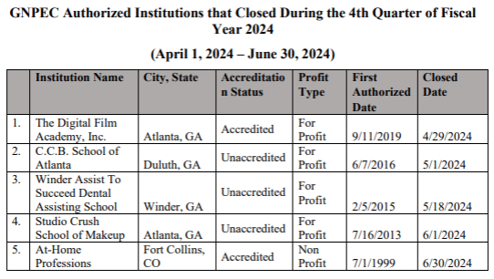
No approval required.

OTHER BUSINESS
- The next Quarterly TGTF Board of Trustees Meeting is November 18, 2024, at 12:45pm
- Location: Zoom

ADJOURNMENT
Trustee Squire moved to adjourn the meeting. Trustee Patterson seconded the motion.

There being no further business, the meeting adjourned at 1:05pm.

BOARD OF TRUSTEES CHAIR BOARD OF TRUSTEES SECRETARY
APPROVAL: APPROVAL:

____________________________________ ____________________________________
Signature Signature

____________________________________ ____________________________________
Date Date

