MEETING: | Board of Trustees, Tuition Guaranty Trust Fund  Quarterly Meeting
DATE: | February 24, 2025
LOCATION: | Interactive College of Technology - Chamblee
TIME: | 12:45pm
PUBLIC CALL-IN INSTRUCTIONS: | Dial-in Number: (667) 770-1484  Participant Code: 317138#

BOARD MEETING MINUTES

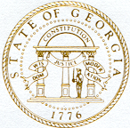

Georgia Nonpublic Postsecondary
Education Commission

Meeting Chair | P.K. Martin, Vice Chairman
Meeting Title | Board of Trustees of the NPEC Tuition Guaranty Trust Fund
Members Present | Kate Patterson  Jim Squire  Dr. Kirk Shook, Secretary (Non-Voting Member)
Members Absent | Ryan Blythe
Staff Present | Maggie Rivers, Deputy Director  Pat Neri, Program Manager, Compliance  Phil Embry, External Auditor  James Cheek, Program Manager/Authorization  Mike Kaiser, Program Manager/Initial Authorization  Margaret Gotlieb, Regulatory Specialist  Warren Albert, Regulatory Specialist  Lily Grant, Regulatory Specialist  Michelle Williams, Regulatory Specialist  Olivia Sternagle, Intern
Visitors | Steven Walters, AG  Shirlene Mitchell  Laura Vieth, EDvera  Dr. Drew Van Horn  Camile Van Horn  Amanda Shailendra  Elmer Smith, Interactive College of Technology

- CALL TO ORDER AND ROLL CALL
P.K Martin, Vice Chairman called the meeting to order at 12:50 pm. Roll Call was taken, and a quorum was declared.

- APPROVAL OF AGENDA
Trustee Squire moved to adopt the Agenda for the February 24, 2025, Quarterly Meeting of the Board of Trustees of the Tuition Guaranty Trust Fund. Vice Chairman Martin seconded the motion.

Upon unanimous vote, it was RESOLVED that the Agenda of the February 24, 2025, Quarterly Meeting of the Board of Trustees of the Tuition Guaranty Trust Fund be adopted.

- APPROVAL OF MINUTES
Trustee Squire moved to adopt the Minutes from the November 18, 2024, Quarterly Meeting of the Board of Trustees of the Tuition Guaranty Trust Fund. Trustee Patterson seconded the motion.

Upon unanimous vote, it was RESOLVED that the Minutes from the November 18, 2024, Quarterly Meeting of the Board of Trustees of the Tuition Guaranty Trust Fund be adopted.

- APPROVAL OF QUARTERLY REPORT (unaudited): TUITION GUARANTY TRUST FUND
External Auditor Phil Embry reported on the following:

- FY25 2nd Quarter Report (October – December 2024)
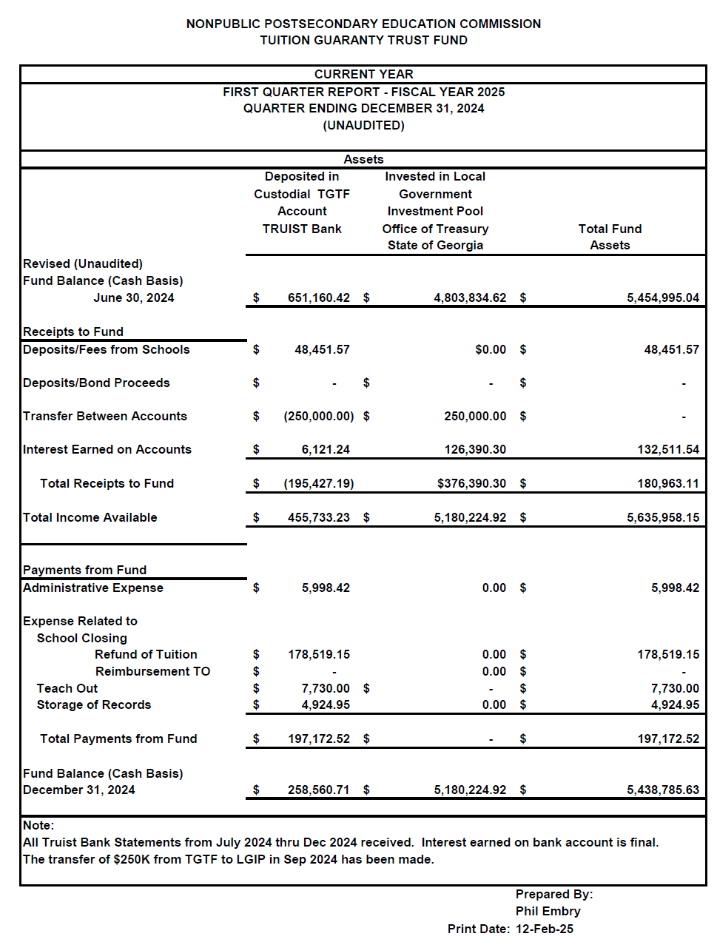

Trustee Squire moved to adopt the amended Quarterly Report of the Tuition Guaranty Trust Fund. Vice Chairman Martin seconded the motion.

Upon unanimous vote, it was RESOLVED that the Quarterly Report of the Tuition Guaranty Trust Fund for the period October – December 2024 be adopted.

- APPROVAL OF INITIAL PAYOUT FOR HEALTH AND STYLE INSTITUTE CLOSURE
Dr. Shook presented the proposed initial payout form the closure of Health and Style Institute:
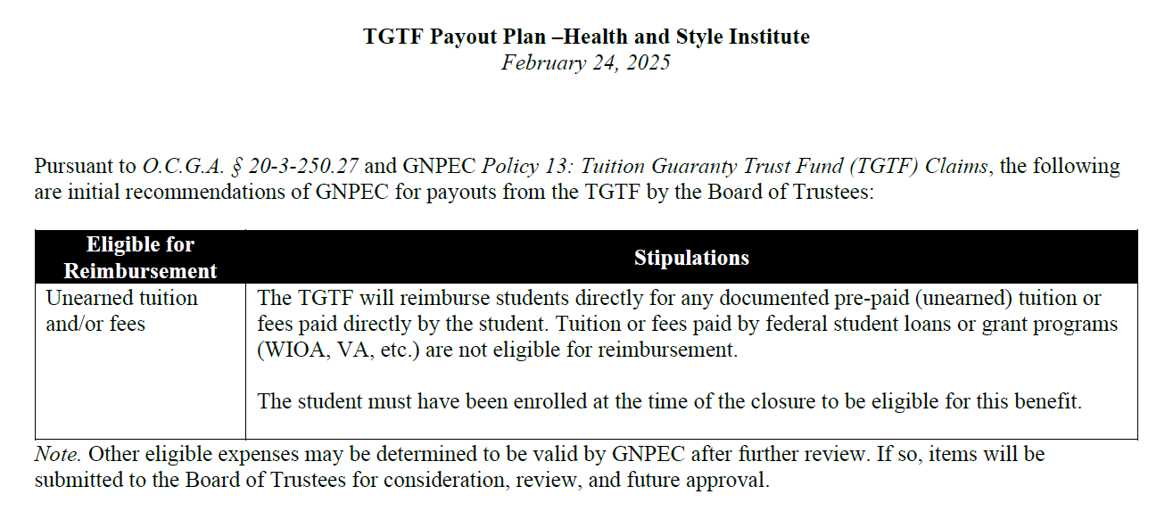

Trustee Squire moved to adopt Initial Payout for Health and Style closure. Trustee Patterson seconded the motion.

Upon unanimous vote, it was RESOLVED that the Initial Payout for Health and Style closure be adopted.

- EXECUTIVE DIRECTOR REPORT
Georgia Fund Market Update, Phil Embry
- Update on Precipitous Closures
    - Art Institute of Atlanta, Miami International University of Art & Design, Omnitech Institute, Atlanta School of Massage, and Athens Institute of Allied Health

Art Institute of Atlanta/Miami International University of Art and Design
- Closed in September 2023. Detailed information can be found here.
- Approximately 400 students enrolled at the time of closure.
- Two bonds were in place at the time of closure, totaling $250,000.
- 13 students submitted documentation of losses and $178,538.05 in refunds were issued in November 2024. Payouts ranged from $34,425.00 to $18.90, with an average payout of $13,733.70.
- All checks have been cashed by students except for 1 check totaling $18.90.

Omnitech Institute
- Closed in October 2023. Detailed information can be found here.
- The 42 students enrolled at the time of closure have been contacted several times about their options.
- On November 27, 2023, the TGTF Board of Trustees voted on a TGTF payout plan, which includes certification exam reimbursement and paying for a teachout at another institution.
- NPEC signed an agreement with a teachout institution on February 16, 2024. Students interested in a teachout were contacted and asked to complete an application for teachout. Once this occurs, NPEC will provide this information to the teachout institution to begin enrolling these students to allow them to finish their programs.
- Students had until June 1, 2024 to complete an application for a teachout or submit reimbursement for certification exams. Students have been reminded multiple times. Six students submitted an application for a teachout.
- There was no bond in place at the time of closure.
- To date, the agency has paid for teachouts for 5 students, totaling $8,130.00.

Atlanta School of Massage
- Closed in September 2024. Detailed information can be found here.
- There were 38 massage students enrolled at the time of closure. An unknown number of students in the esthetician programs were affected by the closure. These students are under the purview of the Board of Cosmetology.
- The massage program students were contacted by NPEC and asked to complete a survey to determine initial losses.
- Based on the initial results, NPEC recommended that unearned tuition/fees, loss of transfer credit/extra hours of training required, additional equipment/supply fees be considered for reimbursement from the Tuition Guaranty Trust Fund.
- On November 18, 2024, the TGTF Board of Trustees voted on the TGTF payout plan for this school, which included all the areas recommended by NPEC staff.
- Students have been contacted to gather documentation on the approved payout areas and begin the claims process.
- To date, 8 students have provided documented claims totaling $9,791.
- There was no bond in place at the time of closure.

- Athens Institute of Allied Health
- Closed in October 2024.
- The school principal has been uncooperative after the closure, but from what we have been able to obtain from the students enrolled at the time, it seemed like there were only three (3) enrolled students at the time of closure.
- NPEC staff have been working with individual students to try to help them determine next steps.
- On November 18, 2024, the TGTF Board of Trustees voted on a TGTF payout plan, which includes teachout/externship expenses, unearned tuition/fees, and extra hours of training/loss of transfer credit.
- Three students were contacted to gather documentation on the approved payout areas and begin the claims process. None of which have filed claims to date.
- There was no bond in place at the time of closure.

- REPORT ON FY25 2nd QUARTER SCHOOL CLOSURES
Presented by Maggie Rivers, Deputy Director

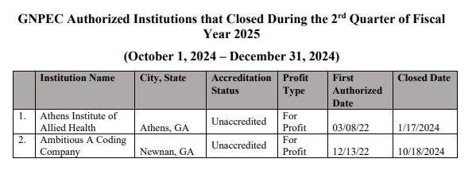
No approval required.

- OTHER BUSINESS
- The next Quarterly TGTF Board of Trustees Meeting is May 19, 2025, at 12:45pm
- Location: Zoom

ADJOURNMENT
Trustee Squire moved to adjourn the meeting. Trustee Patterson seconded the motion.

There being no further business, the meeting adjourned at 1:07pm.

BOARD OF TRUSTEES CHAIR BOARD OF TRUSTEES SECRETARY
APPROVAL: APPROVAL:

____________________________________ ____________________________________
Signature Signature

____________________________________ ____________________________________
Date Date

