BOARD MEETING MINUTES
DATE | Monday, February 26, 2024
TIME | 1:00 PM
LOCATION | February 26, 2024
PURPOSE | Quarterly Commission Meeting
Public Call-In Instructions | Dial-in Number: (646) 558-8656  Meeting ID: 831 4209 3002  Passcode: 874155

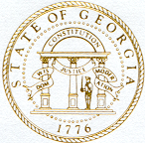
Georgia Nonpublic Postsecondary
Education Commission

Meeting Chair | Dr. Drew Van Horn
Meeting Title | NPEC Board of Commissioners
Members Present | - Dr. Drew Van Horn, Chairman, Exempt Institution Representative  - P.K. Martin, Vice Chairman, At-Large Post #3  - Kate Patterson, Secretary, At-Large Post #8  - Toby Hinton, Degree-Granting Institution Representative  - Ryan Blythe, Certificate-Granting Institution Representative  - Pranay Udutha, At-Large Post #1  - Holly Kirbo, At-Large Post #5  - Dr. Norma Nunez-Cortes, At-Large Post #6  - Jim Squire, At-Large Post #7
Members Absent | - Amanda Shailendra, At-Large Post #4  - Doug Roper, At-Large Post #2
Staff Present | - Kirk Shook, Executive Director  - Maggie Rivers, Deputy Director  - Pat Neri, Program Manager-Compliance  - James Cheek, Program Manager-Authorization  - Michael Kaiser, Program Manager-Exemptions & Initials  - Phil Embry, External Auditor  - Michelle Williams, Regulatory Specialist  - Warren Albert, Regulatory Specialist
Visitors | - Isabelle Keenum, OPB Analyst  - Stephen Debaun, GSFC General Counsel  - Kristen Settlemire, Assistant AG

- CALL TO ORDER AND INVOCATION
Chairman Van Horn called the meeting to order at 1:05pm and gave the invocation. Chairman Van Horn called the roll, and a quorum was declared.
- WELCOME/INTRODUCTION OF VISITORS
Chairman Van Horn welcomed all the guests and visitors in attendance.

- PRESENTATION OF GOVERNOR’S COMMENDATION
Adam Hawk

- APPROVAL OF AGENDA
Commissioner Kirbo moved to adopt the Agenda for the February 26, 2024, Quarterly Commission Meeting of the Georgia Nonpublic Postsecondary Education Commission. Secretary Patterson seconded the motion. There was no discussion.

Upon unanimous vote, it was RESOLVED that the Agenda for the February 26, 2024, Quarterly Commission Meeting of the Georgia Nonpublic Postsecondary Education Commission be adopted.

- APPROVAL OF MINUTES
Commissioner Udutha moved to adopt the Minutes from the November 27, 2023, Quarterly Meeting of the Georgia Nonpublic Postsecondary Education Commission with changes. Commissioner Kirbo seconded the motion. There was no discussion.

Upon a unanimous vote, it was RESOLVED that the Minutes from the November 27, 2023, Quarterly Meeting of the Georgia Nonpublic Postsecondary Education Commission be adopted.

- APPROVAL OF QUARTERLY REPORT: TUITION GUARANTY TRUST FUND (unaudited)
External Auditor Phil Embry reported on the following:
- FY24 2nd Quarter Report (Oct – Dec 2023)

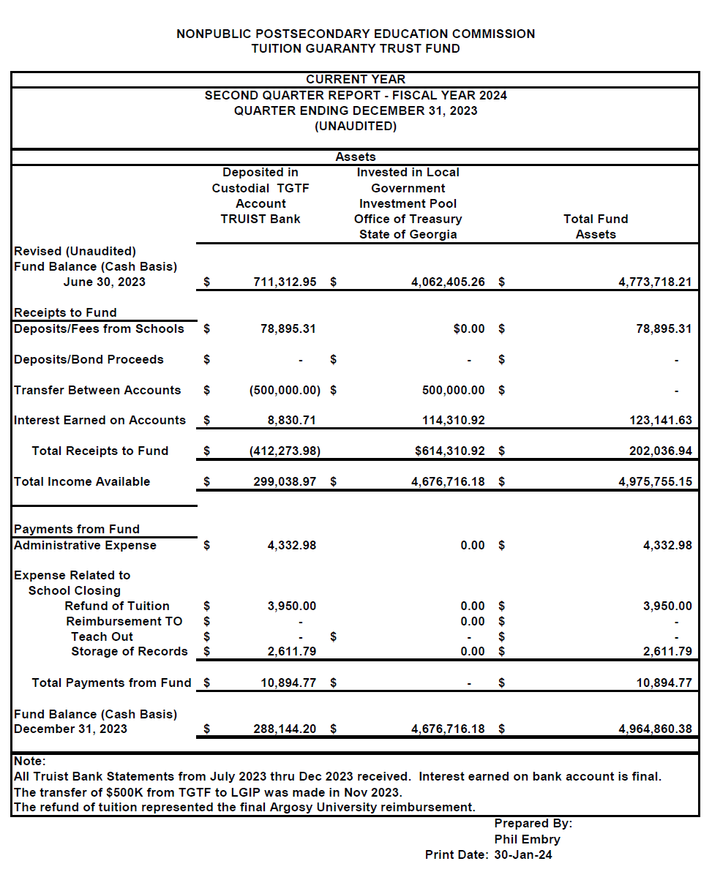
Commissioner Blythe moved to adopt the Quarterly Report of the Tuition Guaranty Trust Fund for October - December 2023 period, as presented. Commissioner Kirbo seconded the motion. There was no discussion.

Upon unanimous vote, it was RESOLVED that the Quarterly Report of the Tuition Guaranty Trust Fund for October - December 2023, as approved by the Board of Trustees of the Tuition Guaranty Trust Fund, be adopted.

- EXECUTIVE DIRECTOR REPORT
Presented by Kirk Shook, Executive Director
- NPEC FY24 Operations Budget (2nd Quarter)
- Quarterly Budget Comparison (FY23 Q2 v. FY24 Q2)
- Update from the Legislature
- Legislation
- Budget
- Agency Updates
- Precipitous Closures
- Revision of Agency Performance Review Instrument
- Teaching Site Changes
- Marketing/Business Plan Information

- AGENCY OPERATIONS REPORT
Presented by Maggie Rivers, Deputy Director

- FY24 1st Quarter Staff Actions

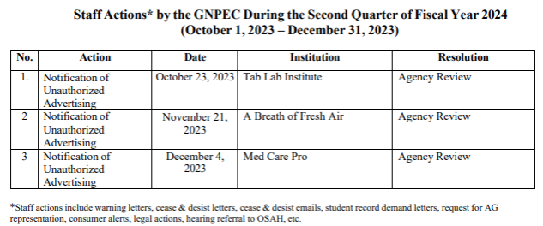

No approval required for this report.

- AUTHORIZATION COMPLIANCE REPORT
Presented by Maggie Rivers, Deputy Director

- Division Reports
    - FY23 4th Quarter Newly Authorized Schools Report

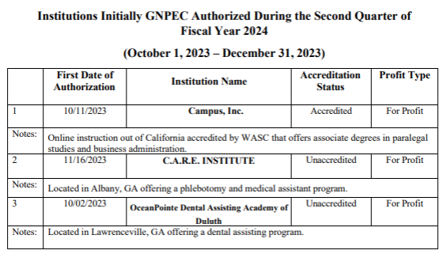

No approval required for this report.

- EXECUTIVE SESSION

There was no need for the Commission to enter into Executive Session.

- SCHOOL SPOTLIGHT
Kirk Shook, Executive Director

- Survival Kit of Phlebotomy Training

Student Success Story:  “Abby Greer took this phlebotomy program to start her career path not knowing she was going to complete, as she never had any medical experience. Once she graduated, she enrolled at Georgia College and State University. She continued her career path by pursuing her nursing degree in the R.N. program. She graduated in December 2023 and is now working as Registered Nurse. We are so proud of her accomplishment! All because she wanted to try and see if she could achieve it and she did!” | 

- OTHER BUSINESS
Presented by Dr. Drew Van Horn, Chairman
- The next Quarterly Commission Meeting is May 20, 2024, at 1pm (Covenant College, 14049 Scenic Hwy., Lookout Mountain, GA)
- Board officer elections at May Quarterly Meeting

- PUBLIC COMMENTS
(No public comments)

- ADJOURN
Commissioner Blythe moved to adjourn the meeting. Commissioner Squire seconded the motion. There being no further business, the meeting adjourned at 1:51pm, All approved.

