DATE | Monday, February 26, 2024
TIME | 12:45 PM
LOCATION | Online Meeting via Zoom
PURPOSE | Quarterly TGTF Meeting
PUBLIC CALL-IN INSTRUCTIONS: | Dial-in Number: (646) 558-8656  Meeting ID: 831 4209 3002  Passcode: 874155

BOARD MEETING MINUTES

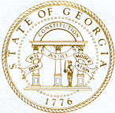

Georgia Nonpublic Postsecondary
Education Commission

Meeting Chair | Dr. Drew Van Horn
Meeting Title | Board of Trustees of the NPEC Tuition Guaranty Trust Fund
Members Present | Dr. Drew Van Horn, Chairman  P.K. Martin, Vice Chairman  Ryan Blythe  Kate Patterson  Kirk Shook, Secretary (Non-Voting Member)
Members Absent | Jim Squire
Staff Present | Kirk Shook, Executive Director  Maggie Rivers, Deputy Director  Pat Neri, Program Manager-Compliance  Phil Embry, External Auditor  Michelle Williams, Regulatory Specialist  Warren Albert, Regulatory Specialist
Visitors | Isabelle Keenum, OPB Analyst  Stephen Debaun, GSFC General Counsel  Kristen Settlemire, Assistant AG

- CALL TO ORDER AND ROLL CALL
Chair Van Horn called the meeting to order at 12:47 pm. Roll Call was taken, and a quorum was declared.

- APPROVAL OF AGENDA
Trustee Patterson moved to adopt the Agenda for the February 26, 2024, Quarterly Meeting of the Board of Trustees of the Tuition Guaranty Trust Fund. Vice Chairman Martin seconded the motion.

Upon unanimous vote, it was RESOLVED that the Agenda of the February 26, 2024, Quarterly Meeting of the Board of Trustees of the Tuition Guaranty Trust Fund be adopted.

- APPROVAL OF MINUTES
Vice Chairman Martin moved to adopt the Minutes from the November 27, 2023, Quarterly Meeting of the Board of Trustees of the Tuition Guaranty Trust Fund. Trustee Patterson seconded the motion.

Upon unanimous vote, it was RESOLVED that the Minutes from the November 27, 2023, Quarterly Meeting of the Board of Trustees of the Tuition Guaranty Trust Fund be adopted.

- QUARTERLY REPORT (unaudited): TUITION GUARANTY TRUST FUND
External Auditor Phil Embry reported on the following:
- FY24 2nd Quarter Report (Oct – Dec 2023)
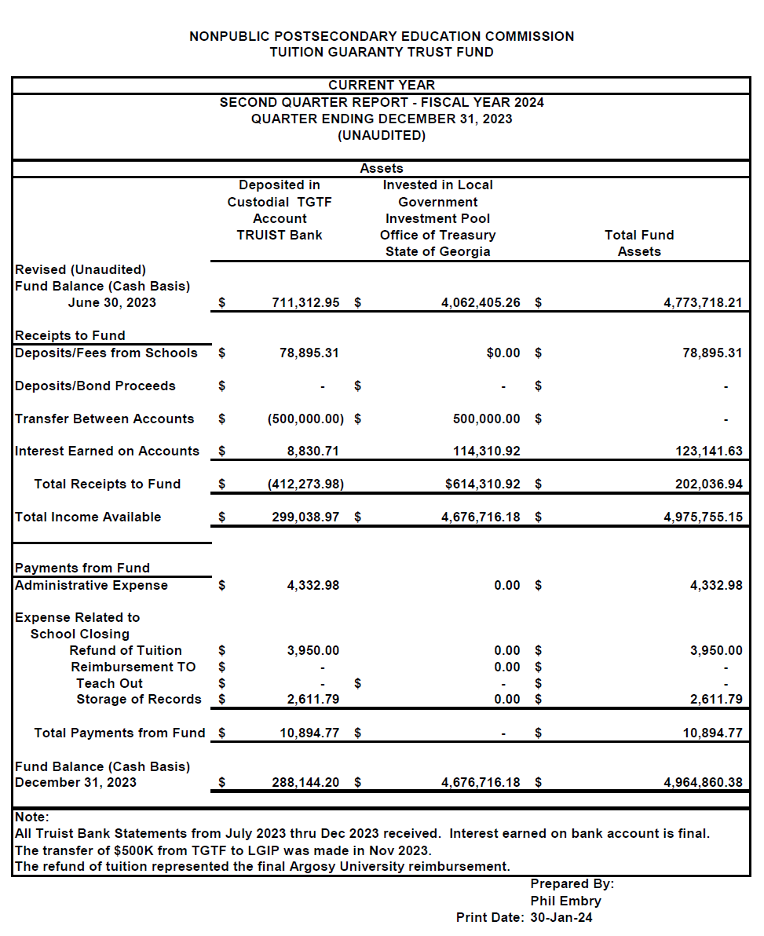

Vice Chairman Martin moved to adopt the amended Quarterly Report of the Tuition Guaranty Trust Fund. Trustee Blythe seconded the motion.

Upon unanimous vote, it was RESOLVED that the Quarterly Report of the Tuition Guaranty Trust Fund
for the period October – December 2023 be adopted.

- APPROVAL OF ART INSTITUTE OF ATLANTA/MIAMI INTERNATIONAL UNIVERSITY OF ART & DESIGN PAYOUT CATEGORIES
Executive Director Shook presented the following payout proposal for students affected by the precipitous closure of Art Institute of Atlanta and Miami International University of Art & Design:

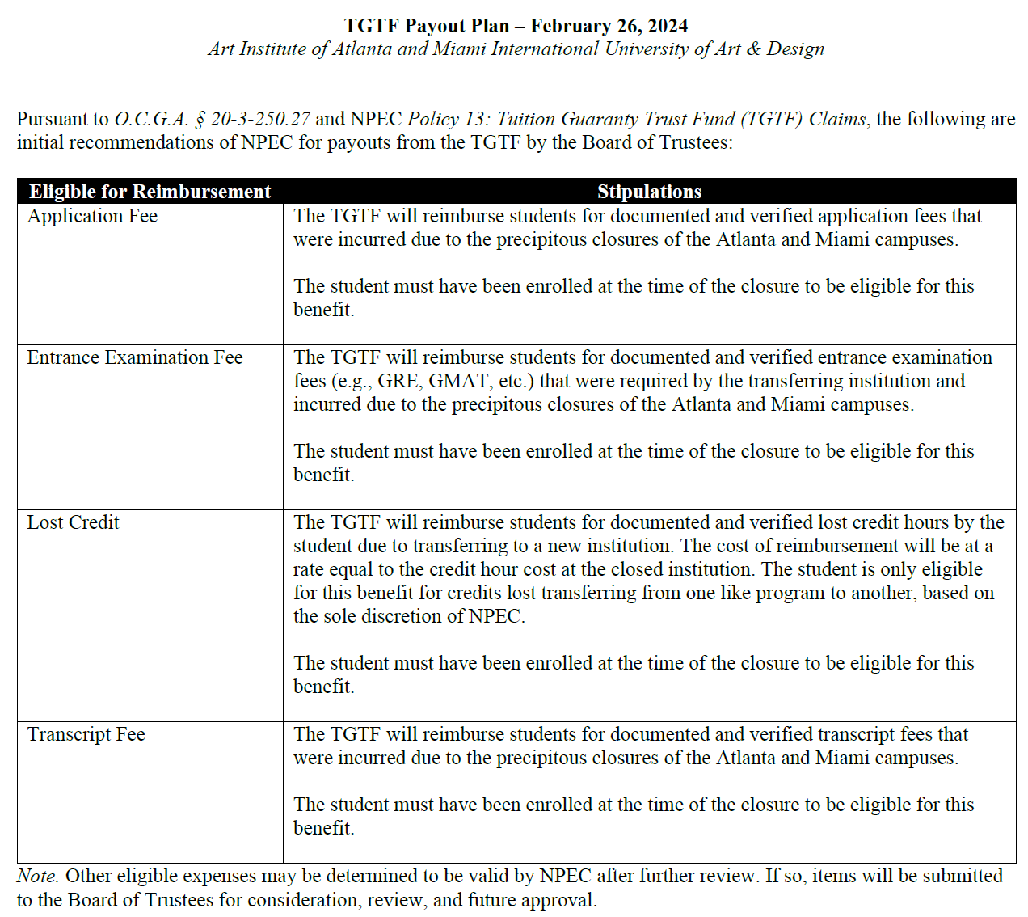

Trustee Patterson moved to adopt the approval of the funding of Art Institute of Atlanta/Miami International University of Art & Design Payout Categories. Trustee Blythe seconded the motion.

Upon unanimous vote, it was RESOLVED that the approval of the funding of Art Institute of Atlanta/Miami International University of Art & Design Payout Categories be adopted.

- EXECUTIVE DIRECTOR REPORT
- Georgia Fund Market Update, Phil Embry

REPORT ON FY24 1st QUARTER SCHOOL CLOSURES
Presented by Maggie Rivers, Deputy Director

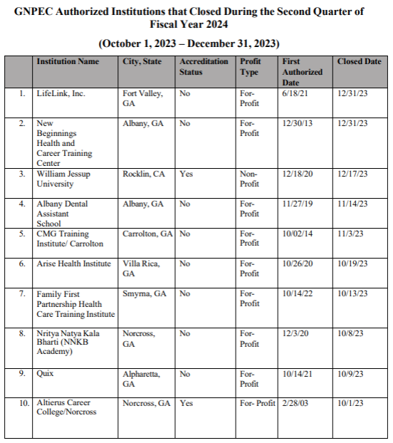
No approval required.

OTHER BUSINESS
- The next TGTF Board of Trustees Meeting is May 20, 2024, at 12:45pm (Covenant College, 14049 Scenic Hwy., Lookout Mountain, GA)

- ADJOURNMENT
Trustee Blythe moved to adjourn the meeting. Trustee Patterson seconded the motion.

There being no further business, the meeting adjourned at 1:04 pm

BOARD OF TRUSTEES CHAIR BOARD OF TRUSTEES SECRETARY
APPROVAL: APPROVAL:

____________________________________ ____________________________________
Signature Signature

____________________________________ ____________________________________
Date Date

