BOARD MEETING MINUTES
DATE | Monday, February 27, 2023
TIME | 1:00 PM
LOCATION | Virtual Zoom Meeting
PURPOSE | Quarterly Commission Meeting

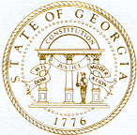
Georgia Nonpublic Postsecondary
Education Commission

Meeting Chair | Dr. Drew Van Horn
Meeting Title | NPEC Board of Commissioners
Members Present | - Dr. Drew Van Horn, Chairman, Exempt Institution Representative  - P.K. Martin, Vice Chairman, At-Large Post #3  - Kate Patterson, Secretary, At-Large Post #8  - Toby Hinton, Degree-Granting Institution Representative  - Ryan Blythe, Certificate-Granting Institution Representative  - Pranay Udutha, At-Large Post #1  - Doug Roper, At-Large Post #2  - Amanda Shailendra, At-Large Post #4  - Jim Squire, At-Large Post #7
Members Absent | - Holly Kirbo, At-Large Post #5  - Dr. Norma Nunez-Cortes, At-Large Post #6
Staff Present | Kirk Shook, Executive Director  Adam Hawk, Deputy Director  Maggie Rivers, Division Director  Pat Neri, Program Manager  Mike Kaiser, Program Manager  Phil Embry, External Auditor  Lily Grant, Regulatory Specialist  Warren Albert, Intern
Visitors | Elizabeth Vaugh, AG  Stephen DeBaun, GSFC  Lisa Hardt, Governor’s Office of Planning and Budget  Erin Greenberg, GFSC  Adam Rutledge, Ralston College  Stephen Blackwood, Ralston College

- CALL TO ORDER AND INVOCATION
Chairman Van Horn called the meeting to order at 1:00 PM and gave the invocation. Chairman Van Horn called the roll, and a quorum was declared.
- WELCOME/INTRODUCTION OF VISITORS
Chairman Van Horn welcomed all the guests and visitors in attendance.

- APPROVAL OF AGENDA
Vice Chairman Martin moved to adopt the Agenda for the November 28, 2022, Quarterly Commission Meeting of the Georgia Nonpublic Postsecondary Education Commission. Commissioner Hinton seconded the motion. There was no discussion.

Upon unanimous vote, it was RESOLVED that the Agenda for the November 28, 2022, Quarterly Commission Meeting of the Georgia Nonpublic Postsecondary Education Commission be adopted.

- APPROVAL OF MINUTES
Secretary Patterson moved to adopt the Minutes from the November 28, 2022, Quarterly Meeting of the Georgia Nonpublic Postsecondary Education Commission with changes. Commissioner Hinton seconded the motion. There was no discussion.

Upon a unanimous vote, it was RESOLVED that the Minutes from the November 28, 2022, Quarterly Meeting of the Georgia Nonpublic Postsecondary Education Commission be adopted.

- APPROVAL OF QUARTERLY REPORT: TUITION GUARANTY TRUST FUND (unaudited)
External Auditor Phil Embry reported on the following:
  - FY23 2nd Quarter Report (October – December 2022)

Commissioner Squire moved to adopt the Quarterly Report of the Tuition Guaranty Trust Fund for October – December 2022 period, as presented. Commissioner Blythe seconded the motion. There was no discussion.

Upon unanimous vote, it was RESOLVED that the Quarterly Report of the Tuition Guaranty Trust Fund for the October – December 2022, as approved by the Board of Trustees of the Tuition Guaranty Trust Fund, be adopted.

- APPROVAL OF REVISION TO FY23 MEETING CALENDAR
Secretary Patterson moved to adopt Approval of Revision to FY23 Meeting Calendar, as presented. Commissioner Roper seconded the motion. There was no discussion.

Upon unanimous vote, it was RESOLVED that the revision to the FY23 Meeting Calendar be adopted. The following changes were adopted:

  - Move May 22nd Quarterly Commission Meeting to May 15th

- EXECUTIVE DIRECTOR REPORT
Presented by Kirk Shook, Executive Director
- GNPEC FY23 Operations Budget (2nd Quarter)
- Quarterly Budget Comparison (FY22 Q2 v. FY23 Q2)
- State Talent Partner Planning Session, Adam Hawk & Maggie Rivers
- Policy 14 Update, Adam Hawk
- Action Research Update

- AGENCY OPERATIONS REPORT
Presented by Maggie Rivers, Division Director

- FY23 2nd Quarter Staff Actions
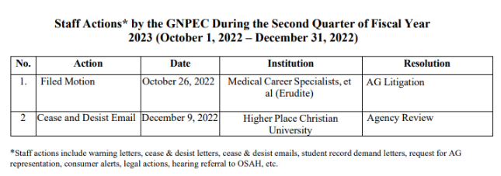 No approval required for this report.

- AUTHORIZATION COMPLIANCE REPORT
Presented by Adam Hawk, Deputy Director
- Division Reports
    - FY23 2nd Quarter Newly Authorized Schools Report

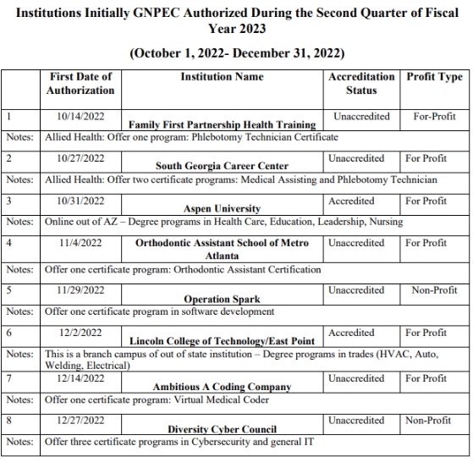

No approval required for this report.

- EXECUTIVE SESSION
- No executive session was needed for this meeting. Assistant AG Elizabeth Vaughan and General Counsel Stephen DeBaun had nothing to report at this time.

- SCHOOL SPOTLIGHT
- None submitted this quarter

- OTHER BUSINESS
Presented by Dr. Drew Van Horn, Chairman
- The next Quarterly Commission Meeting is May 15, 2023, at 1pm (Georgia Trade School, 4231 Southside Drive, Acworth)

- PUBLIC COMMENTS
- Adam Rutledge, Ralston College
- Stephen Blackwood, Ralston College

16. ADJOURN
Vice Chairman Martin moved to adjourn the meeting. Secretary Patterson seconded the motion. There being no further business, the meeting adjourned at 1:37 PM.

COMMISSION CHAIR APPROVAL: COMMISSION SECRETARY APPROVAL:

____________________________________ ____________________________________
Signature Signature

____________________________________ ____________________________________
Date Date

