DATE | Monday, February 27, 2023
TIME | 12:45 PM
LOCATION | Zoom Meeting
PURPOSE | Quarterly TGTF Meeting
PUBLIC CALL-IN INSTRUCTIONS: | Dial-in Number: (646) 558-8656  Meeting ID: 85852465020

BOARD MEETING MINUTES

Georgia Nonpublic Postsecondary
Education Commission

Meeting Chair | Dr. Drew Van Horn
Meeting Title | Board of Trustees of the NPEC Tuition Guaranty Trust Fund
Members Present | Dr. Drew Van Horn, Chairman  P.K. Martin, Vice Chairman  Ryan Blythe  Kate Patterson  Jim Squire  Kirk Shook, Secretary (Non-Voting Member)
Members Absent
Staff Present | Kirk Shook, Executive Director  Adam Hawk, Deputy Director  Maggie Rivers, Division Director  Phil Embry, External Auditor
Visitors

- CALL TO ORDER AND ROLL CALL
Chair Van Horn called the meeting to order at 12:46. The Roll Call was taken, and a quorum was declared.

- APPROVAL OF AGENDA
Trustee Squire moved to adopt the Agenda for the November 28, 2022, Quarterly Meeting of the Board of Trustees of the Tuition Guaranty Trust Fund. Trustee Patterson seconded the motion.

Upon unanimous vote, it was RESOLVED that the Agenda of the November 28, 2022, Quarterly Meeting of the Board of Trustees of the Tuition Guaranty Trust Fund be adopted.

- APPROVAL OF MINUTES
Trustee Squire moved to adopt the Minutes from the November 28, 2022, Quarterly Meeting of the Board of Trustees of the Tuition Guaranty Trust Fund. Trustee Patterson seconded the motion.

Upon unanimous vote, it was RESOLVED that the Minutes from the November 28, 2022, Quarterly Meeting of the Board of Trustees of the Tuition Guaranty Trust Fund be adopted.

- QUARTERLY REPORT (unaudited): TUITION GUARANTY TRUST FUND
External Auditor Phil Embry reported on the following:
- FY23 2nd Quarter Report (October – December 2022)

Trustee Squire moved to adopt the amended Quarterly Report of the Tuition Guaranty Trust Fund. Trustee Patterson seconded the motion.

Upon unanimous vote, it was RESOLVED that the Quarterly Report of the Tuition Guaranty Trust Fund
for the period October – December 2022.

- EXECUTIVE DIRECTOR REPORT
Georgia Fund Market Update, Phil Embry

- REPORT ON FY23 2nd QUARTER SCHOOL CLOSURES
Presented by Adam Hawk, Deputy Director

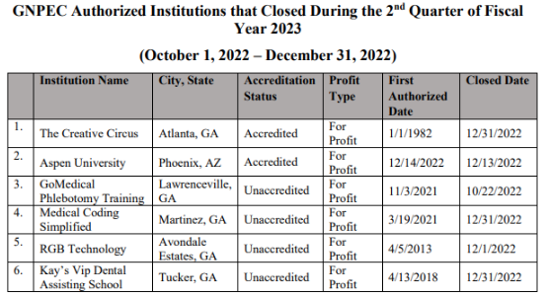
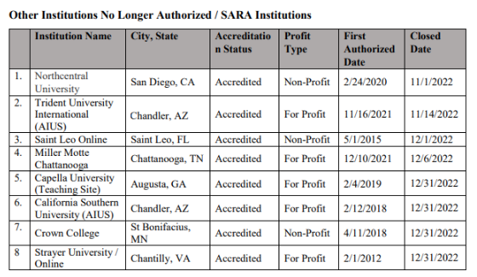
No approval required.

- OTHER BUSINESS
The next TGTF Board of Trustees Meeting is May 15, 2023, at 12:45pm (Georgia Trade School, 4231 Southside Dr., Acworth) if data change approved by Commission vote

- ADJOURNMENT
Trustee Squire moved to adjourn the meeting. Trustee Patterson seconded the motion.

There being no further business, the meeting adjourned at 12:59 p.m.

BOARD OF TRUSTEES CHAIR BOARD OF TRUSTEES SECRETARY
APPROVAL: APPROVAL:

____________________________________ ____________________________________
Signature Signature

____________________________________ ____________________________________
Date Date

