Georgia Corporate Registration FAQs
For Domestic (In-State) Entities:
Detailed instructions can be found here: https://georgia.gov/registering-corporation
For Foreign (Out-of-State) Entities:
How to Register Foreign Entities with the Georgia Secretary of State
- This institution does not seek to open a campus in the state of Georgia. Should I still file with the Georgia Secretary of State (SOS)?
  - Yes, foreign entities (entities outside of the state of Georgia) are required to file both a Certificate of Authority and a yearly Annual Registration if the institution wishes to enroll Georgia students or open a new campus. https://sos.ga.gov/how-to-guide/how-to-guide-register-foreign-entity
GNPEC operates in accordance with both the Georgia Limited Liability Company Act and O.C.G.A. §14-3-1501: “A foreign corporation may not transact business in this state until it obtains a certificate of authority from the Secretary of State,” and O.C.G.A. §14-11-702 “A foreign limited liability company transacting business in this state shall procure a certificate of authority to do so from the Secretary of State.”
- When do I file a Certificate of Authority?
  - As soon as possible. Foreign entities must file 30 days before commencing business in Georgia. Profit Corporations, if the commencement date provided in the application is more than 30 days prior to the effective date of this application, a $500 penalty must be paid to the Georgia Secretary of State. Penalties are statutory and cannot be waived by the Secretary of State.
- When do I file an Annual Registration?
  - Please file your Annual Registration between January 1st and April 1st of each year. Late filings will be penalized through the Georgia Secretary of State’s office. Please note that the SOS office does not accept early filing for the upcoming year.
- What is the process for filing a foreign entity with the Georgia Secretary of State’s Office?
  - To file documents online, create an account with the GA SOS here to access Online Services below. Once you log in, you can access the Online Services via the Home button.
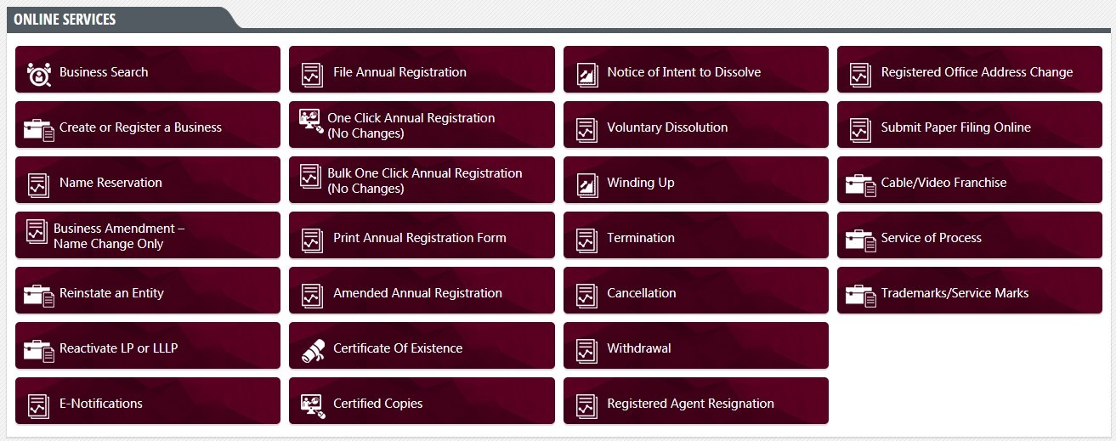
  - Please complete the Name Reservation Process available on the dashboard after creating an account. Please note if your institution uses the word “College” or “University”, your business name must be approved by the Executive Director of GNPEC, as explained in Policy 12.
  - (Foreign Profits/Nonprofits only) Obtain an original Certificate of Existence/Good Standing from the home state’s SOS office.
  - Send in a physical Certificate of Authority Application (or file electronically) with the $225 fee payable to the Georgia Secretary of State. Profit/Nonprofit Corporations are required to attach an original Certificate of Existence from the home state to the application.
  - File an Annual Registration online each year.
- What is a Certificate of Existence/Good Standing?
  - A Certificate of Existence (or Certificate of Good Standing depending on the home state) is a document from the home state’s Secretary of State’s office that informs the Georgia Secretary of State that the institution is compliant within the home state. This certificate must be original and less than 90 days old. This document effectively replaces the need to file a new Articles of Incorporation in the state of Georgia.
- As a foreign nonprofit, am I required to file a Certificate of Authority and Annual Registration with the Georgia Secretary of State?
  - Yes, your institution is required to file the same documentation as a foreign profit entity. However, the yearly Annual Registration fee for nonprofits is reduced to $30 per year.
- I am not sure if my institution has filed the correct documents. How can I check my institution’s filing history?
  - Please go to Georgia Corporations Division (ga.gov) and click the “One-Click Annual Registration” Button. Search for your institution’s Legal Business Name in the toolbar. This tool can be utilized to access the institution’s filing history as well as download the correct documents without having to create an account.
  - If your institution does not appear, it means your institution has never filed the correct documentation in the state of Georgia. Please note that this information is public.
- I have obtained the necessary documents. Where should I attach them in EDvera?
  - In your Initial Authorization Application or Renewal of Authorization Application, please attach both the Certificate of Authority and Annual Registration in Tab 1 under the “Ownership” section.
  - Please label the attachments “Certificate of Authority” and “Annual Registration” respectively so your Regulatory Specialist recognizes that the correct documents have been attached.
- What institutional name is required to be registered with the Secretary of State?
  - The corporate or company name must be registered with the Secretary of State.
  - If an institution is utilizing an official d/b/a (also known as a “trade name”), it must be filed with the Superior Court of the county in which the institution is situated. The institution should not use a d/b/a unless it has filed with the Superior Court. Documentation of this filing should be provided in the Initial Authorization Application or Renewal of Authorization Application.
Ownership and SOS Cheat Sheet
 | Ownership | SOS
Private In-State For-profit | Statement of ownership required | Needs to register with the SOS
Private In-State Non-profit | The name of any nonprofit corporation which owns the institution | Needs to register with the SOS
Private Out-of-State For-profit | Statement of ownership required | Needs to register with the SOS
Private Out of State Non-Profit | The name of any nonprofit corporation which operates the institution | Needs to register with the SOS
Nonprofit Institutions not governed by non-profit corporations | Document the institution officers and the Board of Trustees members and record the name of the non- profit registered entity | See Comments Below*†
Public Out-of-State | No statement of ownership required | Does NOT need to register with the SOS‡
*For nonprofit institutions, we would want the name of any nonprofit corporation which governs the institution (which also needs to register with the SOS). For nonprofit institutions which are not governed by nonprofit corporations – we would want to at least know who the institution officers are. However, most nonprofit institutions would want to have a nonprofit corporation in order to ensure tax exempt status.
†It is recommended that we only request a statement of ownership from proprietary institutions. If the institution is nonprofit, then the institution should provide us with the name of the nonprofit entity which operates the institution.
‡Out of state public institutions generally don’t need to register with the SOS. Also, if an institution is not owned by any business entity, a sole proprietorship, it would not have to register with the SOS. We would want the names of individual owners of proprietary institutions.

Requirements Associated with d/b/a Entities
Any institution with an expiration date of June 30, 2025 or later whose institution name does not match the business name on the SOS registration document will be required to provide d/b/a documentation. A d/b/a is filed with the Superior Court of the county in which the institution is situated. The name on the d/b/a should be the name utilized in all applications and corresponding documents. If any of the institution’s documents utilize any other operational name, an explanation of the discrepancy needs to be provided if a d/b/a is not utilized and documented.

