BOARD MEETING MINUTES
DATE | Monday, January 24, 2022
TIME | 1:00 PM
LOCATION | Teleconference
PURPOSE | Quarterly Commission Meeting
Georgia Nonpublic Postsecondary
Education Commission

Meeting Chair | Toby Hinton
Meeting Title | NPEC Board of Commissioners
Members Present | - Toby Hinton, Chair, Degree-Granting Institution Representative  - Dr. Norma Nunez-Cortes, Vice Chair, At-Large Post #6  - Amanda Shailendra, Secretary, At-Large Post #4  - Ryan Blythe, Certificate-Granting Institution Representative  - Dr. Drew Van Horn, Exempt Institution Representative  - Pranay Udutha, At-Large Post #1  - P.K. Martin, At-Large Post #3  - Jim Squire, At-Large Post #7  - Kate Patterson, At-Large Post #8
Members Absent | - Doug Roper, At-Large Post #2  - Holly Kirbo, At-Large Post #5
Staff Present | Kirk Shook, Executive Director  Adam Hawk, GA-SARA Coordinator  Pat Neri, Program Manager  Maggie Rivers, Program Manager  Phil Embry, External Auditor  James Cheek, Senior Regulatory Specialist  Ally Konishi, Regulatory Specialist  Shirlene Mitchell, Office Manager  Brian Annino, NPEC/GSFC General Counsel
Visitors | Lisa Hardt, Governor’s Office of Planning and Budget

- CALL TO ORDER AND INVOCATION
Chairman Hinton called the meeting to order at 1:38 PM and gave the invocation. Chairman Hinton called the roll and a quorum was declared.
- WELCOME/INTRODUCTION OF VISITORS
Chairman Hinton welcomed all the guests and visitors in attendance.
- INTRODUCTION OF NEW COMMISSIONER
Chairman Hinton welcomed and introduced the new Post #7 Commissioner, Jim Squire. With Commissioner Squire’s appointment and swearing-in on December 29, 2021, the Commission now has no vacant positions.

- APPROVAL OF AGENDA
Commissioner Van Horn moved to adopt the Agenda for the January 24, 2022 Quarterly Commission Meeting of the Georgia Nonpublic Postsecondary Education Commission. Vice Chair Nunez-Cortes seconded the motion. There was no discussion.

Upon unanimous vote, it was RESOLVED that the Agenda for the January 24, 2022 Quarterly Commission Meeting of the Georgia Nonpublic Postsecondary Education Commission be adopted.

- APPROVAL OF MINUTES
Commissioner Van Horn moved to adopt the Minutes from the October 25, 2021 Quarterly Meeting of the Georgia Nonpublic Postsecondary Education Commission. Commissioner Patterson seconded the motion. There was no discussion.

Upon a unanimous vote, it was RESOLVED that the Minutes from the October 25, 2021 Quarterly Meeting of the Georgia Nonpublic Postsecondary Education Commission be adopted.

- APPROVAL OF QUARTERLY REPORT: TUITION GUARANTY TRUST FUND (unaudited)
External Auditor Phil Embry reported on the following:
- FY22 2nd Quarter Report ending December 31, 2021
- Tuition Guaranty Trust Fund 2nd Quarter Yearly Comparison Report

Commissioner Udutha moved to adopt the Quarterly Report of the Tuition Guaranty Trust Fund for the six-month period ending December 31, 2021, as presented. Vice Chair Nunez-Cortes seconded the motion. There was no discussion.

Upon unanimous vote, it was RESOLVED that the Quarterly Report of the Tuition Guaranty Trust Fund for the six-month period ending December 31, 2021, as approved by the Board of Trustees of the Tuition Guaranty Trust Fund, be adopted.

- APPROVAL OF COMMISSION DATE CHANGE
Due to reporting time constraints associated with the original April meeting date, Executive Director Shook proposed that the next Quarterly Commission meeting be moved to May. Commissioner Van Horn moved for the next Commission meeting to be held on May 16, 2022 at Brenau University. Commissioner Squire seconded the motion. There was no discussion.

Upon unanimous vote, it was RESOLVED that the motion to move the next Quarterly Commission meeting from April 18, 2022 to May 16, 2022 at Brenau University, be adopted.

- APPROVAL OF POLICY UPDATES
Chairman Hinton opened the floor for the reading of submitted comments or those wishing to speak to the proposed policy changes. There were no comments made.

The following policy proposal was reviewed:

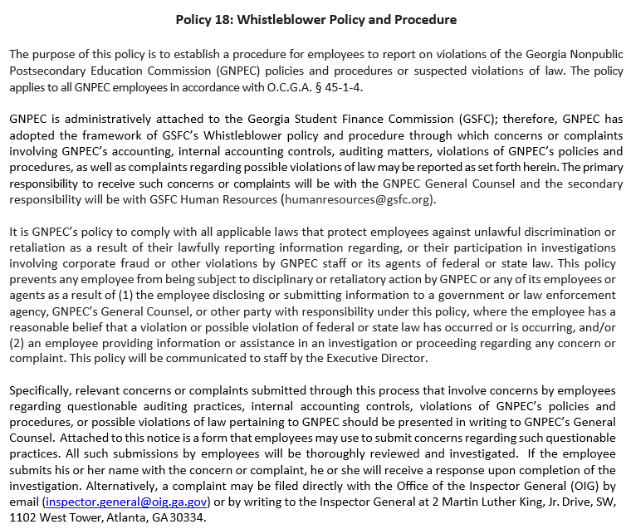

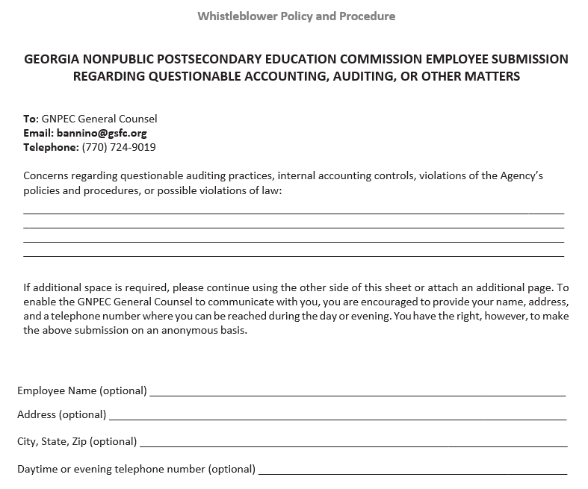

Commissioner Patterson moved for the approval of Policy 18: Whistleblower Policy and Procedure. Commissioner Van Horn seconded the motion. There was no discussion.

Upon unanimous vote, it was RESOLVED that Policy 18: Whistleblower Policy and Procedure, be adopted.

- EXECUTIVE DIRECTOR REPORT
Presented by Kirk Shook, Executive Director
- GNPEC FY22 Operations Budget (2nd Quarter)
- Quarterly Budget Comparison (FY21 Q2 v. FY22 Q2)
- Governor’s Budget Recommendation—AFY22 & FY23
- Personnel (New Contractor—Ally Konishi; Senior Regulatory Specialist Promotions)
- Meeting modality shift starting in April 2022 (all virtual or all in-person)
- Non-Compliant Institution List beginning 2/1/22
- Affidavit of Public Official due to the State Ethics Commission by January 31st

No approval required for this report.

- AGENCY OPERATIONS REPORT
Presented by Pat Neri and Maggie Rivers, Program Managers
- Compliance, Pat Neri
  - FY22 1st Quarter Staff Actions Report

Staff Actions* by the GNPEC During the Second Quarter of Fiscal Year 2022
(October 1, 2021 – December 31, 2021)
No. | Action | Date | Institution | City and State | Resolution
1. | Complaint Filed | October 5, 2021 | Allied Medical Training | Hinesville, Savannah & Vidalia, Georgia | AG Litigation
2. | Consumer Alert | October 19, 2021 | Atlanta Institute of Business | Norcross, Georgia | Consumer Alert, Agency Review, and Advised AG
3. | Cease and Desist Letter | October 21, 2021 | Atlanta Institute of Business | Norcross, Georgia | Pre-litigation
4. | Consumer Alert | November 2, 2021 | GNPEC Help | Suwanee, Georgia | Consumer Alert Only
5. | Consumer Alert | November 27, 2021 | Chronicles Billing Inc | Jonesboro, Georgia | Consumer Alert Only
6. | Cease and Desist Email | December 1, 2021 | North Georgia Dental Assisting | Johns Creek, Georgia | Agency Review
7. | Cease and Desist Email | December 1, 2021 | JER Online | Dawsonville, Georgia | Agency Review
8. | Cease and Desist Email | December 8, 2021 | Xcellent Healthcare Services | Savannah, Georgia | Agency Review
9. | Cease and Desist Letter | December 30, 2021 | Xcellent Healthcare Services | Savannah, Georgia | Pre-litigation
*Staff actions include cease & desist letters, cease & desist emails, student record demand letters, requests for AG representation, consumer alerts, legal actions, hearing referral to OSAH, etc.

- Communications, Maggie Rivers
  - Legislative Liaison Report
    - SB 333
- Operations, Maggie Rives
  - Annual Report
  - Biennial Report

No approval required for this report.

- AUTHORIZATION COMPLIANCE REPORT
Presented by Adam Hawk, Division Director/GA-SARA Coordinator
- FY22 2nd Quarter Newly Authorized Schools Report

Institutions Initially GNPEC Authorized During the First Quarter of Fiscal Year 2022
(October 1, 2021- December 31, 2021)
 | First Date of Authorization | Institution Name | City, State | Accreditation  Status | Fiscal Type | Bond Amount
1 | October 6, 2021 | Alliance Dental Institute | Villa Rica, GA | Unaccredited | For Profit | $75,000
2 | October 12, 2021 | Anchored Phlebotomy Institute LLC | Duluth, GA | Unaccredited | For Profit | $20,000
3 | October 12, 2021 | K-Beauty School | Griffin, GA | Unaccredited | For Profit | $100,000
4 | October 13, 2021 | OTC Professional K9 Academy | Kennesaw, GA | Unaccredited | For Profit | $75,000
5 | October 13, 2021 | TechBridge, Inc. | Atlanta, GA | Unaccredited | Non Profit | $200,000
6 | October 14, 2021 | Six Consulting Training Center | Alpharetta, GA | Unaccredited | For Profit | $30,000
7 | October 20, 2021 | Creekside Dental Assisting Academy | Douglasville, GA | Unaccredited | For Profit | $50,000
8 | October 28, 2021 | Yes-M Systems LLC | Alpharetta, GA | Unaccredited | For Profit | $50,000
9 | November 1, 2021 | 1st Class Dental Assistant Academy | Marietta, GA | Unaccredited | For Profit | $20,000
10 | November 2, 2021 | Good Nursing and Medical Training, LLC. | Norcross, GA | Unaccredited | For Profit | $50,000
11 | November 3, 2021 | GoMedical Phlebotomy Training and Laboratory Services Institution | Lawrenceville, GA | Unaccredited | For Profit | $20,000
12 | November 15, 2021 | Atria Medical Institute | McDonough, GA | Unaccredited | For Profit | $30,000
13 | November 16, 2021 | MedCerts, LLC | Livonia, MI | Unaccredited | For Profit
14 | November 16, 2021 | Trident University International, a member of the American InterContinental University System | Chandler, AZ | Unaccredited | For Profit | $45,000
15 | December 6, 2021 | Golden Age Healthcare Training SW, LLC | Fayetteville, GA | Unaccredited | For Profit | $30,000
16 | December 10, 2021 | Miller-Motte College/ Chattanooga | Chattanooga, TN | Unaccredited | For Profit | $20,000
17 | December 14, 2021 | Aspen University | Denver, CO | Accredited | For Profit | $200,000
18 | December 17, 2021 | Georgia Training Center, LLC | Columbus, GA | Unaccredited | For Profit | $20,000
19 | December 21, 2021 | SSG Appliance Academy LLC | Lilburn, GA | Unaccredited | For Profit | $20,000

- Authorization Report
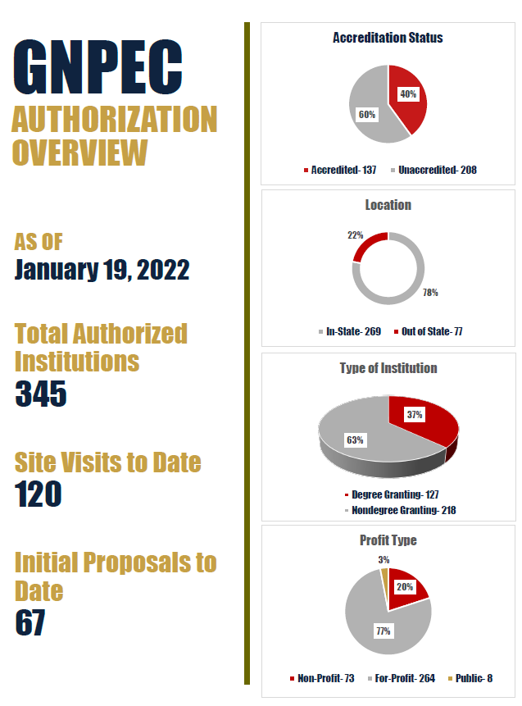
No approval required for this report.

- EXECUTIVE SESSION
Commissioner Van Horn moved for the Board of Commissioners to go into Executive Session at 2:54pm to discuss pending agency litigation. Commissioner Martin seconded the motion. The Commission voted unanimously to enter into Executive Session.

After discussing legal matters, Commissioner Van Horn moved to close the Executive Session. Commissioner Squire seconded the motion. Upon a unanimous vote, the Executive Session was closed at 3:04pm.

- OTHER BUSINESS
The next Quarterly Commission Meeting is scheduled for May 16, 2022 at 1pm (Brenau University, Brenau Downtown Center, 301 Main Street SW, Gainesville – no virtual option).

- PUBLIC COMMENTS
Chairman Hinton opened the floor for public comments. No public comments were made.

- ADJOURN
Commissioner Squire moved to adjourn the meeting. Commissioner Van Horn seconded the motion.

There being no further business, the meeting adjourned at 3:05 PM.

COMMISSION CHAIR APPROVAL: COMMISSION SECRETARY APPROVAL:

____________________________________ ____________________________________
Signature Signature

____________________________________ ____________________________________
Date Date

