BOARD MEETING MINUTES
DATE | Monday, July 26, 2021
TIME | 1:00 PM
LOCATION | Via Zoom Teleconference
PURPOSE | Quarterly Commission Meeting
Georgia Nonpublic Postsecondary
Education Commission

Meeting Chair | Toby Hinton
Meeting Title | NPEC Board of Commissioners
Members Present | - Toby Hinton, Chair, Degree-Granting Institution Representative  - Dr. Norma Nunez-Cortes, Vice Chair, At-Large Post #6  - Amanda Shailendra, Secretary, At-Large Post #4  - Ryan Blythe, Certificate-Granting Institution Representative  - Karen Gilbert, Exempt Institution Representative  - Mollie Cohen, At-Large Post #2  - Lee Todd, At-Large Post #3  - Kate Patterson, At-Large Post #8
Members Absent | - Victoria Agyekum, At-Large Post #1  - Holly Kirbo, At-Large Post #5
Staff Present | Kirk Shook, Executive Director  Dr. Laura Vieth, Associate Executive Director  Adam Hawk, GA-SARA Coordinator/Division Director  Phil Embry, External Auditor  Shirlene Mitchell, Office Manager  Hannah Morris, Regulatory Specialist  Brian Annino, NPEC/GSFC General Counsel
Visitors | Kristen Settlemire, Office of the Attorney General  Isabella Lugo, Office of the Attorney General  Erin Greenburg, Governor’s Office of Planning and Budget  Wazir Hossain, Georgia Student Finance Commission  Jet Toney, Georgia Independent College Association

- CALL TO ORDER AND INVOCATION
Chairman Hinton called the meeting to order at 1:00 PM and gave the invocation. Chairman Hinton called the roll and a quorum was declared.
- WELCOME/INTRODUCTION OF VISITORS
Chairman Hinton welcomed all the guests and visitors on the teleconference.
- HONORING OF OUTGOING COMMISSIONERS
Chairman Hinton honored each of the outgoing Commissioners. Dr. Arthur Vaughn submitted his resignation effective June 30, 2021. Other Commissioners who were term-limited and whose terms expired on June 30, 2021 are set to be replaced by Governor Kemp in August 2021. Each member was thanked for their long years of service and commitment to NPEC. Executive Director Kirk Shook announced that a plaque honoring each outgoing Commissioner will be sent in the coming weeks.

The following Commissioners were honored:
- Lee Todd, 7 years of service (August 2014 – August 2021)
- Dr. Arthur Vaughn, 6+ years of service (September 2014 – June 2021)
- Victoria Agyekum, 6+ years of service (October 2014 – August 2021)
- Karen Gilbert, 6+ years of service (October 2014 – August 2021)
- Mollie Cohen, 5+ years of service (October 2015 – August 2021)

It was noted that the following Commissioners would be joining the Board after being swearing-in on August 4, 2021:
- Dr. Drew Van Horn, Exemption Institution Representative
- Pranay Udutha, At-Large Post #1
- Doug Roper, At-Large Post #2
- P.K. Martin, At-Large Post #3
- APPROVAL OF AGENDA
Commissioner Gilbert moved to adopt the Agenda for the July 26, 2021 Quarterly Commission Meeting of the Georgia Nonpublic Postsecondary Education Commission. Vice Chair Nunez-Cortes seconded the motion. There was no discussion.

Upon unanimous vote, it was RESOLVED that the Agenda for the July 26, 2021 Quarterly Commission Meeting of the Georgia Nonpublic Postsecondary Education Commission be adopted.

- APPROVAL OF MINUTES
Commissioner Shailendra moved to adopt the Minutes from the April 26, 2021 Quarterly Meeting of the Georgia Nonpublic Postsecondary Education Commission. Commissioner Todd seconded the motion. There was no discussion.

Upon a unanimous vote, it was RESOLVED that the Minutes from the April 26, 2021 Meeting of the Georgia Nonpublic Postsecondary Education Commission be adopted.

- QUARTERLY REPORT (unaudited): TUITION GUARANTY TRUST FUND
Executive Director Shook reported on the following:
- FY21 4th Quarter Report ending June 30, 2021
- Tuition Guaranty Trust Fund 4th Quarter Yearly Comparison Report

Commissioner Cohen moved to adopt the Quarterly Report of the Tuition Guaranty Trust Fund for the twelve-month period ending June 30, 2021, as presented. Commissioner Shailendra seconded the motion. There was no discussion.

Upon unanimous vote, it was RESOLVED that the Quarterly Report of the Tuition Guaranty Trust Fund for the twelve-month period ending June 30, 2021, as approved by the Board of Trustees of the Tuition Guaranty Trust Fund, be adopted.

- APPROVAL OF REVISED FY22 COMMISSION MEETING DATES AND LOCATIONS
The following calendar of meeting dates were presented, with the revision of the April 2022 date to accommodate scheduled agency travel:

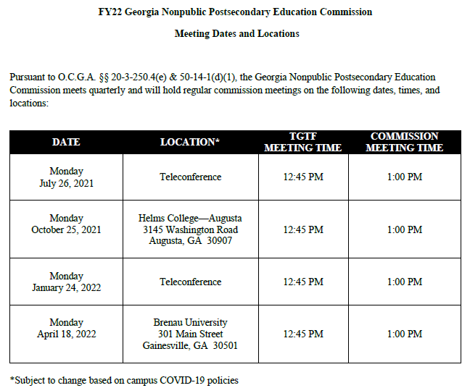

Commissioner Gilbert moved to adopt the Revised FY22 Commission Meeting Dates and Locations as presented. Vice Chair Nunez-Cortes seconded the motion. There was no discussion.

Upon unanimous vote, it was RESOLVED that the Revised FY22 Commission Meeting Dates and Locations be adopted.

- APPROVAL OF POLICY UPDATES
Chairman Hinton opened the floor for the reading of submitted comments or those wishing to speak regarding the proposed policy changes. There were no public comments.

The policy change, Policy 17: Use of the State Seal, was presented:

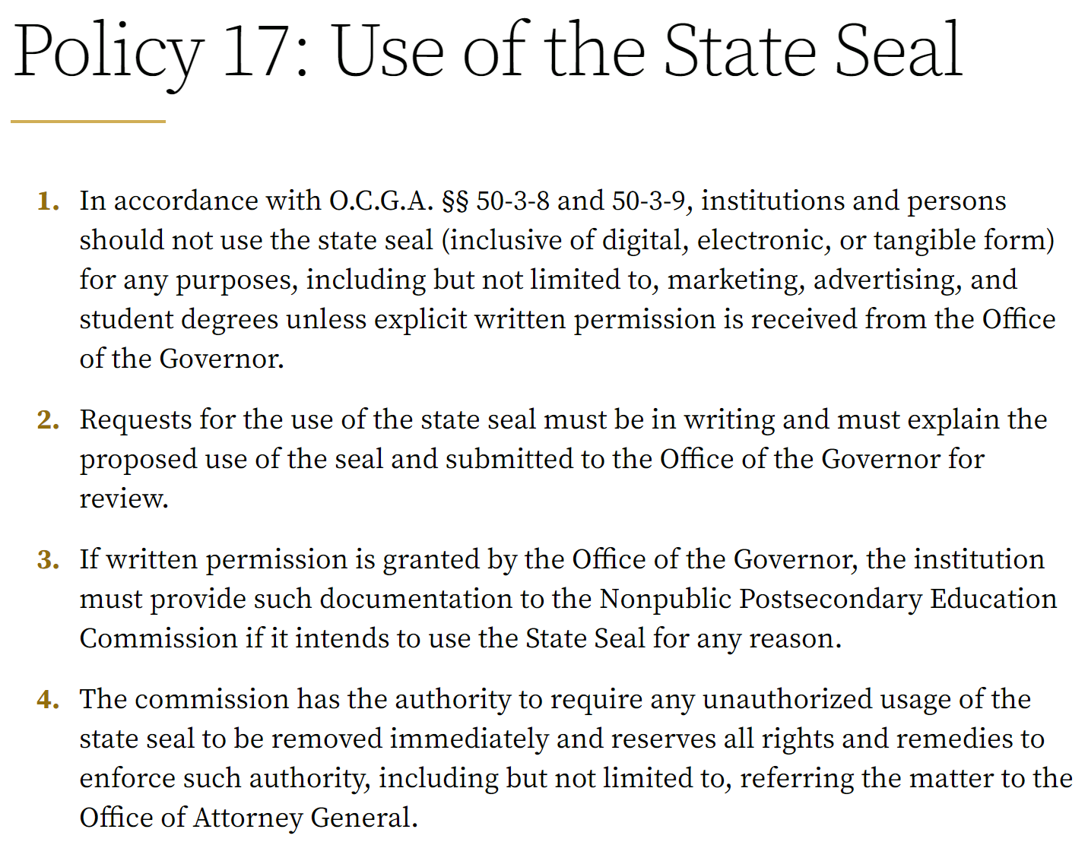

Commissioner Todd moved to adopt Policy 17: Use of the State Seal, as presented. Vice Chair Nunez-Cortes seconded the motion. In discussion, Commissioner Blythe asked if use of the state seal was a common problem that we see with our authorized institutions. Executive Director Shook explained that it is not common, but the agency has encountered recent unauthorized use of the state seal. This language was specifically in the previous Minimum Standards but was inadvertently omitted from the new version, passed by the Commission in December 2020. This policy clarifies NPEC intentions and fulfills the mandates of O.C.G.A. §§ 50-3-8 & 50-3-9.

Following discussion, a vote was held. Upon unanimous vote, it was RESOLVED that Policy 17: Use of the State Seal, be adopted.

- EXECUTIVE DIRECTOR REPORT
Presented by Kirk Shook, Executive Director
- NPEC FY21 Operations Budget (4th Quarter, ending June 30, 2021)
- Quarterly Budget Comparison (FY20 Q4 v. FY21 Q4)
- NPEC Historical Fee Collections (FY19-FY21)
- Agency Legislation Report (effective July 1, 2021)
- New Hire (started July 26, 2021), Laura Vieth
- FY22 Agency Restructure
- Division Reports
  - Compliance, Exemptions, Communications, & Operations, Laura Vieth
  - Financial Viability, GA-SARA, & Authorization, Adam Hawk
- Permanent Remote Work Transition, Adam Hawk
- Internship Report, Maggie Rivers

No approval required for this report.

- FY21 4th QUARTER NEWLY AUTHORIZED SCHOOLS
Presented by Adam Hawk, Division Director

No. | First Date of Authorization | Institution | Fiscal Type | Bond Amount
1 | April 1, 2021 | American Healthcare Documentation Professionals Group, Inc. (Shrewsbury, MA)  - Unaccredited  - Offers certificates in heathcare records | For-profit | $20k
2 | April 16, 2021 | OceanPointe Dental Academy of West Cobb (Powder Springs, GA)  - Unaccredited  - Offers a certificate in dental assisting | For-profit | $50k
3 | April 20, 2021 | theClubhou.se (Augusta, GA)  - Unaccredited  - Offers certificates in entrepreurship and web development | Nonprofit | $100k
4 | May 4, 2021 | INL Diesel Technician Academy (Atlanta, GA)  - Unaccredited  - Offers a certificate in diesal technician | For-profit | $150k
5 | May 5, 2021 | Spanish American Institute of Atlanta (Norcross, GA)  - Unaccredited  - Offers certificates in allied health | For-profit | $50k
6 | May 12, 2021 | Peach State School (Conyers, GA)  - Unaccredited  - Offers a degree in nursing | For-profit | $50k
7 | May 18, 2021 | City of Refuge (Atlanta, GA)  - Unaccredited  - Offers certificates in NAPA automotive, culinary arts, and Salesfore | Nonprofit | $50k
8 | May 18, 2021 | Bright Beginning’s Training (Cairo, GA)  - Unaccredited  - Offers certificates in allied health | For-profit | $20k
9 | May 27, 2021 | Universal Dental Assisting Training,LLC (Decatur, GA)  - Unaccredited  - Offers a certificate in dental assisting | For-profit | $50k
10 | May 27, 2021 | Crane Industry Services, LLC (Villa Rica, GA)  - Unaccredited  - Offers certificates in rigging and crane operation | For-profit | $100k
11 | June 8, 2021 | Community of Destiny Inc (Atlanta, GA)  - Unaccredited  - Offers a certificate in culinary arts | Nonprofit | $50k
12 | June 8, 2021 | Brite Futures Orthodontic Assisting, LLC (McDonough, GA)  - Unaccredited  - Offers a certificate in orthodontic assisting | For-profit | $20k
13 | June 18, 2021 | LifeLink, Inc. (Fort Valley, GA)  - Unaccredited  - Offers certificates in allied health | Nonprofit | $30k
14 | June 22, 2021 | Special Blends Bartending School (Powder Springs, GA)  - Unaccredited  - Offers certificate in bartending | For-profit | $30k
15 | June 23, 2021 | Chattahoochee Valley Community College (Phenix City, AL)  - Accredited by Southern Association of Colleges and Schools Commission on Colleges (SACSCOC)  - Offers certificate and degrees in allied health | State | $200k

No approval required for this report.

- FY21 4th QUARTER STAFF ACTIONS
Presented by Dr. Laura Vieth, Associate Executive Director

No. | Action | Date | Institution | Resolution
1. | Consumer Alert | April 6, 2021 | Erudite Nursing Institute/Medical Career Specialists  3330 Cumberland Blvd. SE, Suite 500  Atlanta, GA 30339 | Under Review of Office of the Attorney General
2. | Consent Agreement | April 6, 2021 | CCME Training Service  6714 Highway 85  Riverdale, GA 30274 | Under Review of Office of the Attorney General
3. | Motion for Default Judgement | April 15, 2021 | Terry University  (multiple addresses) | Granted April 20, 2021
4. | Consumer Alert | April 20, 2021 | Terry University  (multiple addresses) | Student Records not yet collected
5. | Consumer Alert | April 20, 2021 | Allied Medical Training  445 Elma G. Miles Parkway, Suite 104  Hinesville, GA 31313  Allied Medical Training  121 Oglethorpe Professional Ct., Suite B  Savannah, GA 31406  Allied Medical Training  305 B. Slayton Drive  Vidalia, GA 30474 | Under Review of Office of the Attorney General
6. | Cease and Desist Letter | May 5, 2021 | Medical Advance Prep, Inc.  1804 East Park Avenue, 3rd Floor  Valdosta, GA 31602-5503  Medical Advanced Prep, Inc.  223 North Ashley Street, Rm. 310  Valdosta, GA 31601  Dekoya Adams  Registered Agent for Medical Advance Prep, Inc.  1505 Madison Heights Dr.  Valdosta, GA 31601 | Referred to Office of Attorney General
7. | Cease and Desist Email | May 13, 2021 | Chronicles Billing, Inc.  2749 Mt Zion Parkway, Suite 200  Jonesboro, GA 30236 | Referred to Counsel
8. | Cease and Desist Email | June 9, 2021 | Construction Education Foundation of GA  261 Joseph E Lowery Blvd NW  Atlanta, GA 30304 | Institution is Seeking Authorization
9. | Cease and Desist Email | June 9, 2021 | Skillful Coding Prep Academy  P.O. Box 877 6080 GA-42, #110  Rex, GA 30273 | Referred to Counsel
10. | Cease and Desist Email | June 18, 2021 | Realtime Voice  250 Langley Drive  Lawrenceville, GA 30046 | Referred to Counsel

No approval required for this report.

- EXECUTIVE SESSION
Commissioner Cohen moved for the Board of Commissioners to go into Executive Session to discuss pending agency litigation. Commissioner Patterson seconded the motion. The Commission voted unanimously to enter into Executive Session.

After discussing legal matters, Commissioner Patterson moved to close the Executive Session. Commissioner Todd seconded the motion. Upon a unanimous vote, the Executive Session was closed.

- OTHER BUSINESS
The next Quarterly Commission Meeting is scheduled for October 25, 2021 at 1pm at Helms College–Augusta (3145 Washington Road, Augusta, GA).

There will be a Special Called Meeting of the Board of Commissioners in August via Zoom to approve the agency budget submission. A date will be determined in the future.

- PUBLIC COMMENTS
Chairman Hinton opened the floor for public comments. No public comments were made.

- ADJOURN
Commissioner Cohen moved to adjourn the meeting. Vice Chair Nunez-Cortes seconded the motion.

There being no further business, the meeting adjourned at 2:10 PM.

COMMISSION CHAIR APPROVAL: COMMISSION SECRETARY APPROVAL:

____________________________________ ____________________________________
Signature Signature

____________________________________ ____________________________________
Date Date

