BOARD MEETING MINUTES
DATE | Monday, May 15, 2023
TIME | 1:00 PM
LOCATION | Georgia Trade School, 4231 Southside Drive, Acworth
PURPOSE | Quarterly Commission Meeting


Georgia Nonpublic Postsecondary
Education Commission

Meeting Chair | Dr. Drew Van Horn
Meeting Title | NPEC Board of Commissioners
Members Present | - Dr. Drew Van Horn, Chairman, Exempt Institution Representative  - Kate Patterson, Secretary, At-Large Post #8  - Toby Hinton, Degree-Granting Institution Representative  - Ryan Blythe, Certificate-Granting Institution Representative  - Pranay Udutha, At-Large Post #1  - Doug Roper, At-Large Post #2  - Amanda Shailendra, At-Large Post #4  - Holly Kirbo, At-Large Post #5  - Jim Squire, At-Large Post #7
Members Absent | - P.K. Martin, Vice Chairman, At-Large Post #3  - Dr. Norma Nunez-Cortes, At-Large Post #6
Staff Present | Kirk Shook, Executive Director  Adam Hawk, Deputy Director  Maggie Rivers, Division Director  Pat Neri, Program Manager  Phil Embry, External Auditor  James Cheek, Regulatory Specialist
Visitors | Erin Greenberg, GSFC  Steven Debaun, GSFC  Lisa Hardt, OPB  Oliver Charrease, Atlanta Academy of Dental Assisting

- CALL TO ORDER AND INVOCATION
Chairman Van Horn called the meeting to order at 1:03pm and gave the invocation. Chairman Van Horn called the roll, and a quorum was declared.
- WELCOME/INTRODUCTION OF VISITORS
Chairman Van Horn welcomed all the guests and visitors in attendance.

- SCHOOL SPOTLIGHT
Georgia Trade School

- APPROVAL OF AGENDA
Commissioner Squire moved to adopt the Agenda for the February 27, 2023, Quarterly Commission Meeting of the Georgia Nonpublic Postsecondary Education Commission. Commissioner Kirbo seconded the motion. There was no discussion.

Upon unanimous vote, it was RESOLVED that the Agenda for the February 27, 2023, Quarterly Commission Meeting of the Georgia Nonpublic Postsecondary Education Commission be adopted.

- APPROVAL OF MINUTES
Commissioner Roper moved to adopt the Minutes from the February 27, 2023, Quarterly Meeting of the Georgia Nonpublic Postsecondary Education Commission with changes. Secretary Patterson seconded the motion. There was no discussion.

Upon a unanimous vote, it was RESOLVED that the Minutes from the February 27, 2023, Quarterly Meeting of the Georgia Nonpublic Postsecondary Education Commission be adopted.

- APPROVAL OF QUARTERLY REPORT: TUITION GUARANTY TRUST FUND (unaudited)
External Auditor Phil Embry reported on the following:
  - FY23 3rd Quarter Report (January – March 2023)

Commissioner Kirbo moved to adopt the Quarterly Report of the Tuition Guaranty Trust Fund for January – March 2023 period, as presented. Commissioner Roper seconded the motion. There was no discussion.

Upon unanimous vote, it was RESOLVED that the Quarterly Report of the Tuition Guaranty Trust Fund for January – March 2023, as approved by the Board of Trustees of the Tuition Guaranty Trust Fund, be adopted.

- APPROVAL OF REVISION TO FY24 MEETING CALENDAR
Commissioner Udutha moved to adopt Approval of Revision to FY24 Meeting Calendar, as presented. Commissioner Roper seconded the motion. There was no discussion.

Upon unanimous vote, it was RESOLVED that the revision to the FY24 Meeting Calendar be adopted.

- APPROVAL OF FY24 NPEC SCHEDULE OF FEES
Commissioner Patterson moved to adopt Approval of FY24 Schedule of Fines, as presented. Commissioner Squire seconded the motion. There was no discussion.

Upon unanimous vote, it was RESOLVED that the revision to the FY24 Schedule of Fines be adopted.

- APPROVAL OF FY24 NPEC SCHEDULE OF FINES
Commissioner Hinton moved to adopt Approval of FY24 Schedule of Fines, as presented. Secretary Patterson seconded the motion. There was no discussion.

Upon unanimous vote, it was RESOLVED that the revision to the FY24 Schedule of Fines be adopted.

- FY24 COMMISSION OFFICER ELECTIONS
Commissioner Squire moved to adopt Approval of FY24 Commission Officer Election, as presented. Commissioner Udutha seconded the motion. There was no discussion.

Upon unanimous vote, it was RESOLVED that the revision to the FY24 Commission Officer Election be adopted.

- FY24 TGTF ELECTIONS (5 MEMBERS)
Commissioner Hinton moved to adopt Approval of FY24 TGTF Election, as presented. Commissioner Udutha seconded the motion. There was no discussion.

Upon unanimous vote, it was RESOLVED that the revision to the FY24 TGTF Election be adopted.

- APPROVAL OF UPDATE TO EXEMPTION DEFINITIONS
Commissioner Squire moved to adopt Update to Exemption Definitions, as presented. Commissioner Roper seconded the motion. There was no discussion.

Upon unanimous vote, it was RESOLVED that the revision to the Exemption Definitions be adopted.

- APPROVAL OF POLICY UPDATES
Vote regarding the ratification of the following policy:
- Revision to Policy 11: Change of Ownership
- Revision to Policy 12: Use of “College” or “University”
- Revision to Policy 14: Permitted Programming of Unaccredited Institutions

Commissioner Hinton moved to adopt Approval of Policy Updates, as presented. Commissioner Udutha seconded the motion. There was no discussion.

Upon unanimous vote, it was RESOLVED that the revision to the Policy Updates be adopted.

- EXECUTIVE DIRECTOR REPORT
Presented by Kirk Shook, Executive Director
- GNPEC FY23 Operations Budget (3rd Quarter)
- Quarterly Budget Comparison (FY22 Q3 v. FY23 Q3)
- Action Research Update

- AGENCY OPERATIONS REPORT
Presented by Maggie Rivers, Division Director

- FY24 3rd Quarter Staff Actions
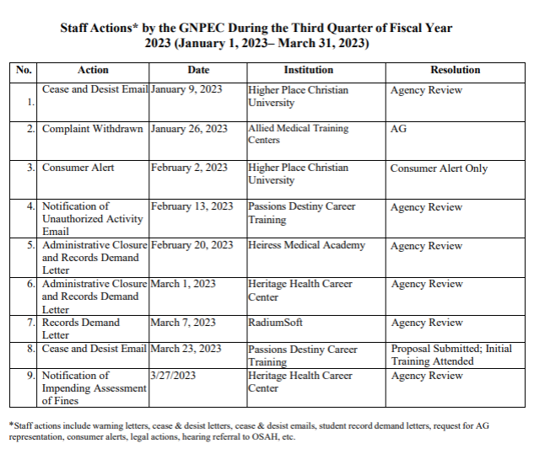 No approval required for this report.

- AUTHORIZATION COMPLIANCE REPORT
Presented by Adam Hawk, Deputy Director
- Division Reports
    - FY23 2nd Quarter Newly Authorized Schools Report

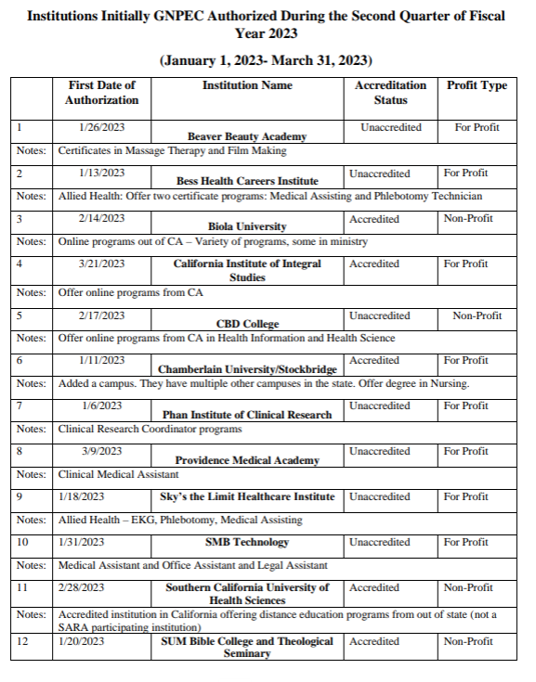
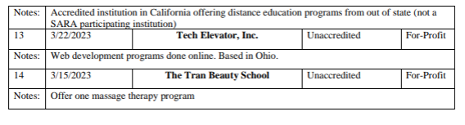

No approval required for this report.

- EXECUTIVE SESSION
- Pursuant to O.C.G.A. § 50-14-2(1), this portion of the meeting is “closed in order to consult and meet with legal counsel pertaining to pending or potential litigation, settlement, claims, administrative proceedings, or other judicial actions brought or to be brought by or against the agency”
  - Report on pending litigation from Elizabeth Vaughan, Assistant Attorney General

- SCHOOL SPOTLIGHT
- Life Solutions for Health
    - Became Accredited by the Accrediting Bureau of Health Education Schools in February 2023

- OTHER BUSINESS
Presented by Dr. Drew Van Horn, Chairman
- The next Quarterly Commission Meeting is August 28, 2023 at 1pm (Teleconference)

- PUBLIC COMMENTS

- ADJOURN
Commissioner Squire moved to adjourn the meeting. Commissioner Blythe seconded the motion. There being no further business, the meeting adjourned at 2:10pm.

COMMISSION CHAIR APPROVAL: COMMISSION SECRETARY APPROVAL:

____________________________________ ____________________________________
Signature Signature

____________________________________ ____________________________________
Date Date

