DATE | Monday, May 15, 2023
TIME | 12:45 PM
LOCATION | Georgia Trade School, 4231 Southside Drive, Acworth
PURPOSE | Quarterly TGTF Meeting
PUBLIC CALL-IN INSTRUCTIONS: | Dial-in Number: (667) 770-1484  Participant ID: 317138#

BOARD MEETING MINUTES

Georgia Nonpublic Postsecondary
Education Commission

Meeting Chair | Dr. Drew Van Horn
Meeting Title | Board of Trustees of the NPEC Tuition Guaranty Trust Fund
Members Present | Dr. Drew Van Horn, Chairman  Ryan Blythe  Kate Patterson  Jim Squire  Kirk Shook, Secretary (Non-Voting Member)
Members Absent | P.K. Martin, Vice Chairman
Staff Present | Kirk Shook, Executive Director  Adam Hawk, Deputy Director  Maggie Rivers, Division Director  Pat Neri, Program Manager  Phil Embry, External Auditor  James Cheek, Regulatory Specialist
Visitors | Erin Greenberg, GSFC  Steven Debaun, GSFC  Lisa Hardt, OPB  Oliver Charrease, Atlanta Academy of Dental Assisting

- CALL TO ORDER AND ROLL CALL
Chair Van Horn called the meeting to order at 12:51pm. The Roll Call was taken, and a quorum was declared.

- APPROVAL OF AGENDA
Trustee Squire moved to adopt the Agenda for the February 27, 2023, Quarterly Meeting of the Board of Trustees of the Tuition Guaranty Trust Fund. Trustee Patterson seconded the motion.

Upon unanimous vote, it was RESOLVED that the Agenda of the February 27, 2023, Quarterly Meeting of the Board of Trustees of the Tuition Guaranty Trust Fund be adopted.

- APPROVAL OF MINUTES
Trustee Patterson moved to adopt the Minutes from the February 27, 2023, Quarterly Meeting of the Board of Trustees of the Tuition Guaranty Trust Fund. Chairman Van Horn seconded the motion.

Upon unanimous vote, it was RESOLVED that the Minutes from the February 27, 2023, Quarterly Meeting of the Board of Trustees of the Tuition Guaranty Trust Fund be adopted.

- QUARTERLY REPORT (unaudited): TUITION GUARANTY TRUST FUND
External Auditor Phil Embry reported on the following:
- FY23 3rd Quarter Report (January – March 2023)

Trustee Squire moved to adopt the amended Quarterly Report of the Tuition Guaranty Trust Fund. Trustee Patterson seconded the motion.

Upon unanimous vote, it was RESOLVED that the Quarterly Report of the Tuition Guaranty Trust Fund
for the period January – March 2023.

- EXECUTIVE DIRECTOR REPORT
- Increase in TGTF minimum fee to $200 (in response to actuarial study of the fund; O.C.G.A. § 20-3-250.27(d)(1) requires the fund balance to be $10 million by 2040)

- Georgia Fund Market Update, Phil Embry

- REPORT ON FY23 3rd QUARTER SCHOOL CLOSURES
Presented by Adam Hawk, Deputy Director
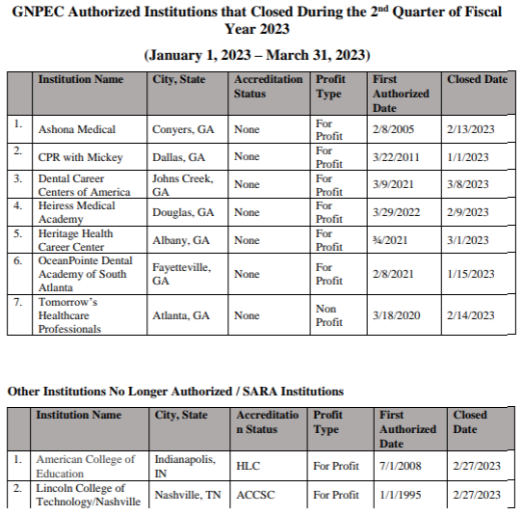
No approval required.

- OTHER BUSINESS
The next TGTF Board of Trustees Meeting is August 28, 2023, at 12:45pm via Teleconference

- ADJOURNMENT
Trustee Squire moved to adjourn the meeting. Trustee Patterson seconded the motion.

There being no further business, the meeting adjourned at 1:03pm

BOARD OF TRUSTEES CHAIR BOARD OF TRUSTEES SECRETARY
APPROVAL: APPROVAL:

____________________________________ ____________________________________
Signature Signature

____________________________________ ____________________________________
Date Date

