BOARD MEETING MINUTES
DATE | Monday, May 16, 2022
TIME | 1:00 PM
LOCATION | Brenau University  Brenau Downtown Center  301 Main St. SW  Gainesville, GA
PURPOSE | Quarterly Commission Meeting
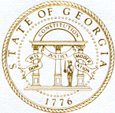
Georgia Nonpublic Postsecondary
Education Commission

Meeting Chair | Toby Hinton
Meeting Title | NPEC Board of Commissioners
Members Present | - Toby Hinton, Chair, Degree-Granting Institution Representative  - Dr. Norma Nunez-Cortes, Vice Chair, At-Large Post #6  - Ryan Blythe, Certificate-Granting Institution Representative  - Pranay Udutha, At-Large Post #1  - Doug Roper, At-Large Post #2  - P.K. Martin, At-Large Post #3  - Jim Squire, At-Large Post #7  - Kate Patterson, At-Large Post #8
Members Absent | - Dr. Drew Van Horn, Exempt Institution Representative  - Amanda Shailendra, Secretary, At-Large Post #4  - Holly Kirbo, At-Large Post #5
Staff Present | Kirk Shook, Executive Director  Adam Hawk, GA-SARA Coordinator  Pat Neri, Program Manager  Maggie Rivers, Program Manager  Phil Embry, External Auditor  James Cheek, Senior Regulatory Specialist
Visitors | Lisa Hardt, Governor’s Office of Planning and Budget

- CALL TO ORDER AND INVOCATION
Chairman Hinton called the meeting to order at 1:13 PM and gave the invocation. Chairman Hinton called the roll, and a quorum was declared.
- WELCOME/INTRODUCTION OF VISITORS
Chairman Hinton welcomed all the guests and visitors in attendance.
- APPROVAL OF AGENDA
Commissioner Squire moved to adopt the Agenda for the May 16, 2022, Quarterly Commission Meeting of the Georgia Nonpublic Postsecondary Education Commission. Commissioner Martin seconded the motion. There was no discussion.

Upon unanimous vote, it was RESOLVED that the Agenda for the May 16, 2022, Quarterly Commission Meeting of the Georgia Nonpublic Postsecondary Education Commission be adopted.

- APPROVAL OF MINUTES
Commissioner Martin moved to adopt the Minutes from the January 24, 2022, Quarterly Meeting of the Georgia Nonpublic Postsecondary Education Commission with changes. Commissioner Udutha seconded the motion. There was no discussion.

Upon a unanimous vote, it was RESOLVED that the Minutes from the January 24, 2022, Quarterly Meeting of the Georgia Nonpublic Postsecondary Education Commission be adopted.

- APPROVAL OF QUARTERLY REPORT: TUITION GUARANTY TRUST FUND (unaudited)
External Auditor Phil Embry reported on the following:
- FY22 3rd Quarter Report (January – March 2022)

Commissioner Squire moved to adopt the Quarterly Report of the Tuition Guaranty Trust Fund for January – March 2022 period, as presented. Vice Chair Nunez-Cortes seconded the motion. There was no discussion.

Upon unanimous vote, it was RESOLVED that the Quarterly Report of the Tuition Guaranty Trust Fund for the January – March 2022, as approved by the Board of Trustees of the Tuition Guaranty Trust Fund, be adopted.

- APPROVAL OF FY23 COMMISSION MEETING DATES
Commissioner Martin moved to adopt the FY23 Commission Meeting Dates. Commissioner Blythe seconded the motion. There was no discussion.

Upon unanimous vote, it was RESOLVED that the motion to approve the FY23 Commission Meeting Dates, be adopted.

- APPROVAL OF REVISION TO NPEC FY23 SCHEDULE OF FEES
Commissioner Martin moved to adopt the revision to NPEC schedule of fees with changes. Commissioner Squire seconded the motion. There was no discussion.

Upon unanimous vote, it was RESOLVED that the motion to approve the revision to NPEC Schedule of Fees with changes, be adopted.

- APPROVAL OF NPEC FY23 SCHEDULE OF FINES
Commissioner Patterson moved to adopt the NPEC FY23 Schedule of Fines. Commissioner Blythe seconded the motion.

Upon unanimous vote, it was RESOLVED that the motion to approve the NPEC Schedule of Fines be adopted.

- APPROVAL OF FY23 COMMISSION OFFICER ELECTIONS (CHAIR, VICE CHAIR, AND SECRETARY)
Commissioner Squire moved to elect Dr. Drew Van Horn as Chairman. Commissioner Patterson seconded the motion.

Upon unanimous vote, it was RESOLVED that the motion to elect Dr. Van Horn as Chairman be adopted.

Commissioner Squire moved to elect Commissioner P.K. Martin as Vice Chairman. Commissioner Patterson seconded the motion.

Upon unanimous vote, it was RESOLVED that the motion to elect P.K. Martin as Vice Chairman be adopted.

Commissioner Martin moved to elect Commissioner Kate Patterson as Secretary. Commissioner Squire seconded the motion.

Upon unanimous vote, it was RESOLVED that the motion to elect Kate Patterson as Secretary be adopted.

- APPROVAL OF FY23 TGTF TRUSTEE ELECTIONS
Commissioner Udutha moved to elect Commissioners Dr. Van Horn, Commissioner Martin, Commissioner Patterson to the FY23 TGTF Trustees. Commissioner Blythe seconded the motion.

Upon unanimous vote, it was RESOLVED that the motion to approve the election of Drew Van Horn, P.K. Martin, and Kate Patterson as FY23 TGTF Trustees be adopted.

Commissioner Patterson moved to elect Commissioner Blythe to the FY23 TGTF Trustees. Commissioner Patterson seconded the motion.

Upon unanimous vote, it was RESOLVED that the motion to approve the election of Ryan Blythe to the FY23 TGTF Trustees be adopted.

Nominations were made from the floor to elect the final Trustee position. Jim Squire and Pranay Udutha were nominated. At the conclusion of the secret ballot vote, Commissioner Jim Squire was elected to the final FY23 Trustee position.

- APPROVAL OF POLICY UPDATES
Commissioner Blythe moved to adopt the ratification of Policy 15: Program Offerings of Initial Applicants. Commissioner Patterson seconded the motion.

Upon unanimous vote, it was RESOLVED that the motion to approve the ratification of Policy 15: Program Offerings of Initial Applicants, be adopted.

Policy 15 changes, as adopted, are shown below:

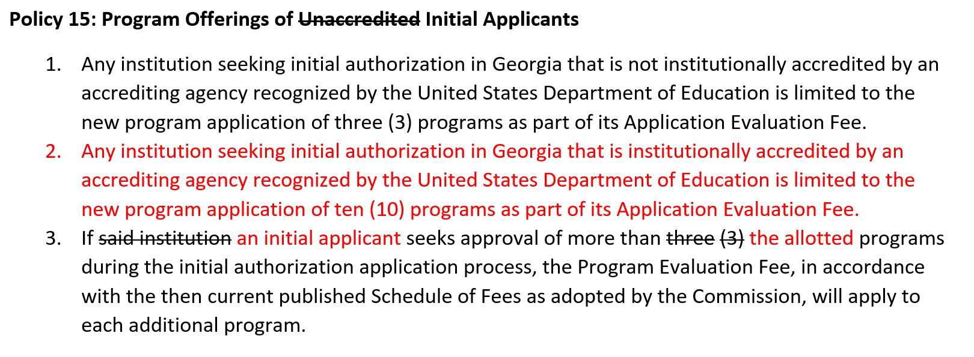

- EXECUTIVE DIRECTOR REPORT
Presented by Kirk Shook, Executive Director
- GNPEC FY22 Operations Budget (3rd Quarter)
- Quarterly Budget Comparison (FY21 Q3 v. FY22 Q3)
- Report on AFY22 and FY23 Budgets
- TGTF LGIP Investment Information, Phil Embry
- Report on Agency Legislation (SB 333)
- New Commission Appointments expected around July 1
  - Post 4 (Shailendra), Post 5 (Kirbo), Post 6 (Nunez-Cortes), & Degree-Granting Institution Representative (Hinton) all expected to be replaced in FY23
- Noncompliant Institution List
- Commission Reporting Discussion – more specifics of institutions (good, bad & ugly)
- NASASPS

- AGENCY OPERATIONS REPORT
Presented by Dr. Laura Vieth, Associate Executive Director

- Division Reports
- Compliance
  - FY22 3rd Quarter Staff Actions Report
  - Communication
    - Legislative Implementation
- Operations
  - Institutional Inspector Role

Staff Actions* by the GNPEC During the Third Quarter of Fiscal Year 2022
(January 1, 2022 – March 31, 2022)

No. | Action | Date | Institution | City and State | Resolution
1. | Cease and Desist Letter | January 11, 2022 | North Georgia Dental Assisting | Johns Creek, GA | Pending AG Review
2. | Cease and Desist  Email | January 25, 2022 | United Youth of America | Atlanta, GA | Application Initiated
3. | Cease and Desist Email | January 27, 2022 | Lab Stat Institute | Tucker, GA | Agency Review
4. | Cease and Desist  Email | January 28, 2022 | Graceland Dental Assistant | Conyers, Ga | Agency Review
5. | Cease and Desist  Email | January 28, 2022 | One Stick Med | Riverdale, GA | Institution Closed
6. | Cease and Desist Letter | January 31, 2022 | JER Group | Dawsonville, GA | Agency Review
7. | Consumer Alert | February 15, 2022 | ADAS Medical Group | Snellville, GA | Consumer Alert Only
8. | Records Demand | March 7, 2022 | The Phlebotomy Institute of Middle Georgia | Macon, GA | Agency Review
9. | Cease and Desist Letter | March 16, 2022 | Graceland Dental Assistant | Conyers, Ga | Agency Review
*Staff actions include warning letters, cease & desist letters, cease & desist emails, student record demand letters, request for AG representation, consumer alerts, legal actions, hearing referral to OSAH, etc.

No approval required for this report.

- AUTHORIZATION COMPLIANCE REPORT
Present by Adam Hawk, Division Director/GA-SARA Coordinator
- Division Reports
  - Authorization
    - FY22 3rd Quarter Newly Authorized Schools Report

Institutions Initially GNPEC Authorized During the Third Quarter of Fiscal Year 2022
(January 1, 2022- March 31, 2022)
 | First Date of Authorization | Institution Name | Accreditation  Status | Profit Type | Bond Amount
1 | January 1, 2022 | Grace Montessori Teacher Education, LLC | Unaccredited | For Profit | $20,000
2 | January 13, 2022 | Ross University School of Medicine | Unaccredited | For Profit | $450,000
3 | January 25, 2022 | Sonoran Desert Institute | Unaccredited | For Profit | $200,000
4 | February 1, 2022 | PWC Training | Unaccredited | For Profit | $20,000
5 | February 15, 2022 | Survival Kit Of Phlebotomy Training LLC | Unaccredited | For Profit | $20,000
6 | February 17, 2022 | ITS Training Institute | Unaccredited | For Profit | $20,000
7 | March 8, 2022 | Athens Institute of Allied Healthcare | Unaccredited | For Profit | $50,000
8 | March 29, 2022 | Heiress Medical Academy | Unaccredited | For Profit | $30,000

- FY22 3rd Quarter Authorization Report

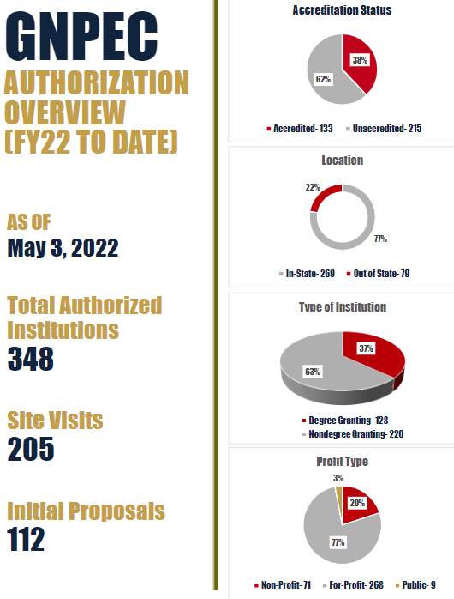
No approval required for this report.

- OTHER BUSINESS
- Pending Commission approval, the next TGTF Board of Trustees Meeting is August 29, 2022 at 1pm (GNPEC Office, 2082 East Exchange Place, Tucker – no virtual option)
  - Topics to be addressed: Policy updates; Minimum Standards revisions; Unaccredited degree programs; and Exemption definitions
- Headshots will be taken before the TGTF meeting

- PUBLIC COMMENTS
No public comments were made.

- ADJOURN
Commissioner Martin moved to adjourn the meeting. Commissioner Squire seconded the motion.

There being no further business, the meeting adjourned at 3:07 PM.

COMMISSION CHAIR APPROVAL: COMMISSION SECRETARY APPROVAL:

____________________________________ ____________________________________
Signature Signature

____________________________________ ____________________________________
Date Date

