DATE | Monday, May 16, 2022
TIME | 12:45 PM
LOCATION | Brenau University  Brenau Downtown Center  301 Main St. SW  Gainesville, GA
PURPOSE | Quarterly TGTF Meeting
BOARD MEETING MINUTES
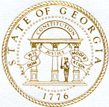
Georgia Nonpublic Postsecondary
Education Commission

Meeting Chair | Toby Hinton
Meeting Title | Board of Trustees of the NPEC Tuition Guaranty Trust Fund
Members Present | Toby Hinton, Chair  Norma Nunez-Cortes, Vice Chair  Ryan Blythe  Kate Patterson  Kirk Shook, Secretary (Non-Voting Member)
Members Absent | Amanda Shailendra
Staff Present | Kirk Shook, Executive Director  Dr. Laura Vieth, Deputy Director  Adam Hawk, GA-SARA Coordinator  Pat Neri, Program Manager  Maggie Rivers, Program Manager  Phil Embry, External Auditor  James Cheek, Senior Regulatory Specialist
Visitors | Erin Greenburg, Georgia Student Finance Commission  Lisa Hardt, Governor’s Office of Planning and Budgeting

- Call to Order and Roll Call
Chair Hinton called the meeting to order at 12:50PM. The Roll Call was taken, and a quorum was declared.

- APPROVAL OF AGENDA
Vice Chair Nunez-Cortes moved to adopt the Agenda for the May 16, 2022, Quarterly Meeting of the Board of Trustees of the Tuition Guaranty Trust Fund. Trustee Patterson seconded the motion.

Upon unanimous vote, it was RESOLVED that the Agenda of the May 16, 2022, Quarterly Meeting of the Board of Trustees of the Tuition Guaranty Trust Fund be adopted.

- APPROVAL OF MINUTES
Trustee Patterson moved to adopt the Minutes from the January 24, 2022, Quarterly Meeting of the Board of Trustees of the Tuition Guaranty Trust Fund. Vice Chair Nunez-Cortes seconded the motion.

Upon unanimous vote, it was RESOLVED that the Minutes from the January 24, 2022, Quarterly Meeting of the Board of Trustees of the Tuition Guaranty Trust Fund be adopted.

- QUARTERLY REPORT (unaudited): TUITION GUARANTY TRUST FUND
External Auditor Phil Embry reported on the following:
- FY22 3rd Quarter Report (January – March 2022)

Trustee Patterson moved to adopt the amended Quarterly Report of the Tuition Guaranty Trust Fund. Vice Chair Nunez-Cortes seconded the motion.

Upon unanimous vote, it was RESOLVED that the Quarterly Report of the Tuition Guaranty Trust Fund
for the nine-month period ending March 31, 2022, be adopted.

- Executive Director’s Report
Executive Director Shook reported on the following:
- SB 333 (Section 16)

- FY22 3rd Quarter School Closures Report (January – March 2022)
Presented by Dr. Laura Vieth, Associate Director
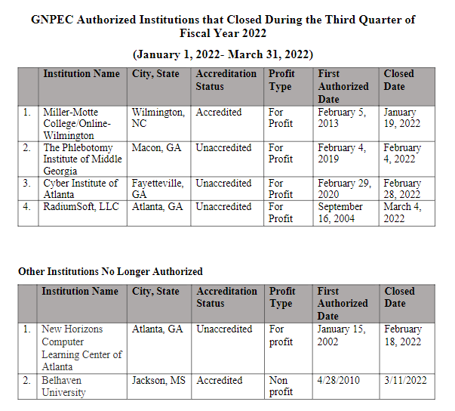

No approval required.

- OTHER BUSINESS
- Pending Commission approval, the next TGTF Board of Trustees Meeting is August 29, 2022, at 12:45pm (GNPEC Office, 2082 East Exchange place, Tucker – no virtual option)
- Headshots will be taken before the TGTF meeting

- ADJOURNMENT
Trustee Patterson moved to adjourn the meeting. Trustee Blythe seconded the motion.

There being no further business, the meeting adjourned at 1:12 p.m.

BOARD OF TRUSTEES CHAIR BOARD OF TRUSTEES SECRETARY
APPROVAL: APPROVAL:

____________________________________ ____________________________________
Signature Signature

____________________________________ ____________________________________
Date Date

