BOARD MEETING MINUTES

MEETING: | Board of Commissioners, Nonpublic Postsecondary Education Commission  Quarterly Meeting
DATE: | May 19, 2025
LOCATION: | Zoom
TIME: | 1:08pm, or at the conclusion of the Quarterly TGTF Board of Trustees Meeting
PUBLIC CALL-IN INSTRUCTIONS: | Dial-in Number: (667) 770-1484  Participant Code: 317138#


Georgia Nonpublic Postsecondary
Education Commission

Meeting Chair | P.K. Martin, Vice Chairman, Exempt Institution Representative
Meeting Title | NPEC Board of Commissioners
Members Present | - P.K. Martin, Vice Chairman, At-Large Post #3  - Kate Patterson, Secretary, At-Large Post #8  - Ryan Blythe, Certificate-Granting Institution Representative  - Dr. Linda Adkinson, Degree-Granting Institution Representative  - Dr. Donald Dowless, Exempt Institution Representative  - Pranay Udutha, At-Large Post #1  - Michael Floor, At-Large Post #4  - Dr. Lance Barry, At-Large Post #5  - Dr. Norma Nunez-Cortes, At-Large Post #6  - Jim Squire, At-Large Post #7
Members Absent | - Doug Roper, At-Large Post #2
Staff Present | - Maggie Rivers, Deputy Director  - Pat Neri, Program Manager-Compliance  - Phil Embry, External Auditor  - James Cheek, Program Manager-Authorization  - Mike Kaiser, Program Manager-Initial Authorization  - Margaret Gotlieb, Regulatory Specialist  - Michelle Williams, Regulatory Specialist  - Carley Henry, Administrative Assistant  - Caroline Fairhurst, Compliance Specialist/Site Visits  - Stephen DeBaun, General Counsel
Visitors | - Steven Walters, AG  - Isabelle Keenum, OPB

- CALL TO ORDER AND INVOCATION
Vice Chairman Martin called the meeting to order at 1:08pm and gave the invocation.

- ROLL CALL
Vice Chairman Martin called the roll, and a quorum was declared.

- WELCOME/INTRODUCTION OF NEW COMMISSIONER
Presented by Vice Chairman Martin

- Dr. Donald Dowless, Exempt Institution Representative (replacing Dr. Drew Van Horn)

- WELCOME/INTRODUCTION OF VISITORS
Presented by Vice Chairman Martin

ACTION ITEMS
Presented by Vice Chairman Martin

- APPROVAL OF AGENDA
Commissioner Squire moved to adopt the Agenda for the May 19, 2025, Quarterly Commission Meeting of the Georgia Nonpublic Postsecondary Education Commission. Commissioner Floor seconded the motion. There was no discussion.

Upon unanimous vote, it was RESOLVED that the Agenda for the May 19, 2025, Quarterly Commission Meeting of the Georgia Nonpublic Postsecondary Education Commission be adopted.

- APPROVAL OF MINUTES
Secretary Patterson moved to adopt the Minutes from the February 24, 2025, Quarterly Meeting of the Georgia Nonpublic Postsecondary Education Commission. Commissioner Adkison seconded the motion. There was no discussion.

Upon a unanimous vote, it was RESOLVED that the Minutes from the February 24, 2025, Quarterly Meeting of the Georgia Nonpublic Postsecondary Education Commission be adopted.

- APPROVAL OF QUARTERLY REPORT: TUITION GUARANTY TRUST FUND (unaudited)
Presented by Phil Embry, External

  - FY25 3nd Quarter Report (Jan – Mar 2025) [Unaudited], Phil Embry
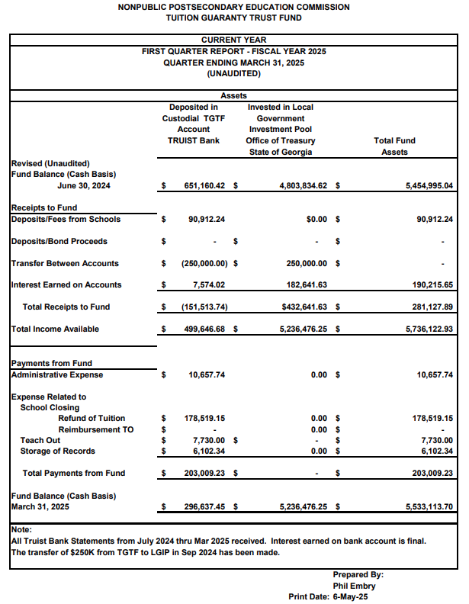

Commissioner Nunez-Cortez moved to adopt the Quarterly Report of the Tuition Guaranty Trust Fund for January – March 2025 period, as presented. Secretary Patterson seconded the motion. There was no discussion.

Upon unanimous vote, it was RESOLVED that the Quarterly Report of the Tuition Guaranty Trust Fund January – March 2025 as approved by the Board of Trustees of the Tuition Guaranty Trust Fund, be adopted.

- APPROVAL OF FY26 Commission Meeting Dates and Locations

Dr. Shook presented the proposed FY26 Commission meeting dates and locations.

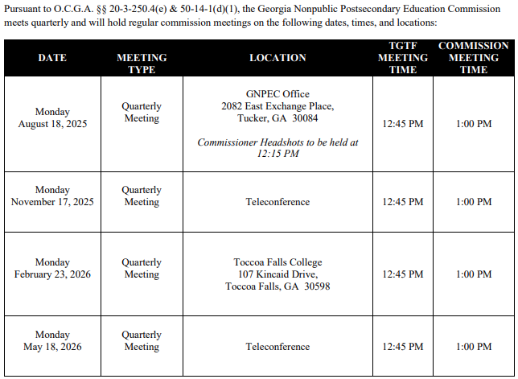

Commissioner Squire moved to adopt the FY26 Commission Meeting dates and locations, as presented. Secretary Patterson seconded the motion. There was no discussion.

Upon a unanimous vote, it was RESOLVED that the FY26 Commission Meeting dates and locations be adopted.

- APPROVAL OF FY26 NPEC SCHEDULE OF FEES

Dr. Shook presented the proposed FY26 Schedule of Fees. The below changes were presented:

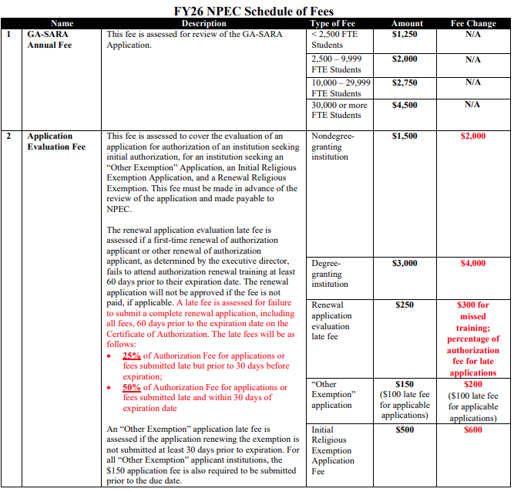
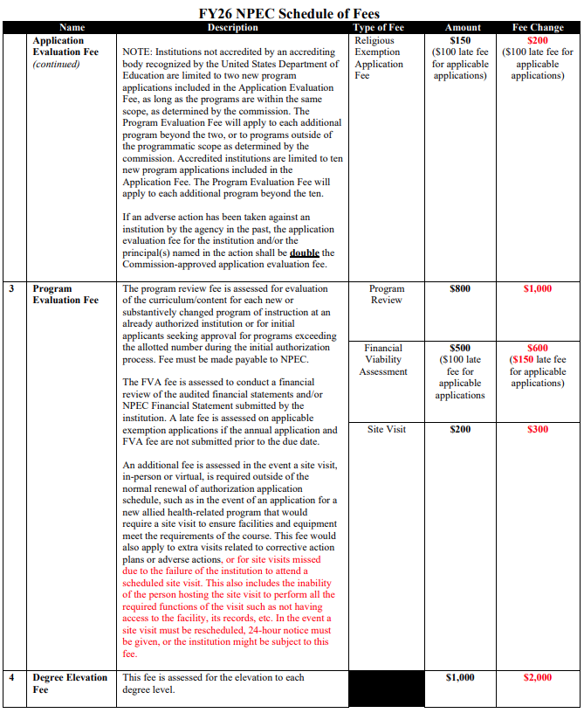
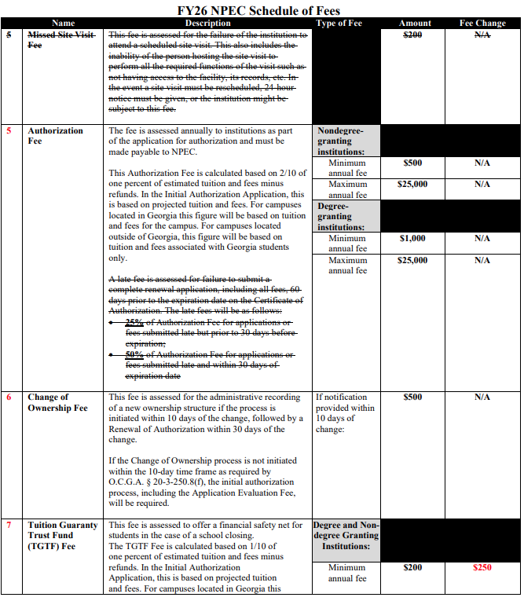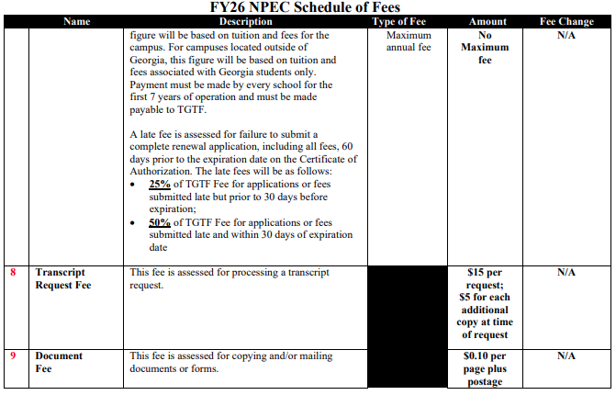
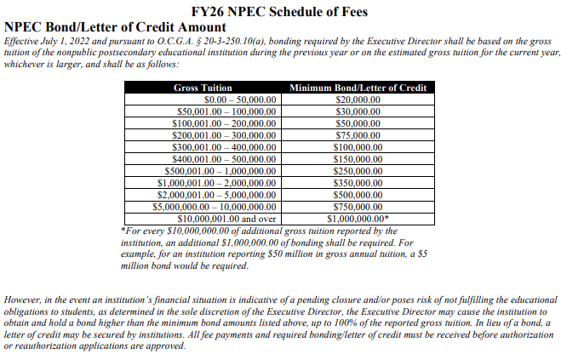

Commissioner Adkison moved to adopt the FY26 NPEC Schedule of Fees, as presented. Commissioner Nunez-Cortez seconded the motion. There was no discussion.

Upon unanimous vote, it was RESOLVED that the FY26 NPEC Schedule of Fees be adopted.

- APPROVAL OF FY26 SCHEDULE OF FINES

Dr. Shook presented the proposed FY26 Schedule of Fines as follows:
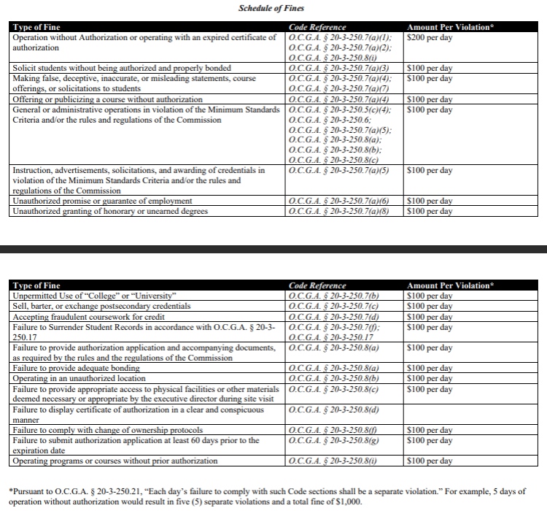

Secretary Patterson moved to adopt the FY26 NPEC Schedule of Fines, as presented. Commissioner Floor seconded the motion. There was no discussion.

Upon unanimous vote, it was RESOLVED that the FY26 NPEC Schedule of Fines, be adopted.

- APPROVAL OF COMMISSION OFFICER ELECTIONS

Slate of Officers Report:
- Chairman – P.K. Martin
- Vice Chairman – Jim Squire
- Secretary – Pranay Udutha

Commissioner Udutha moved to adopt the slate for the FY26 Commission Officers, as presented. Secretary Patterson seconded the motion. There was no discussion.

- APPROVAL OF TGTF OFFICER ELECTIONS

O.C.G.A. § 20-3-250.27(b)(2), “at least two members, by June 30, 2020, shall represent postsecondary education institutions.” Additionally, he noted that the bylaws of the board state that members shall serve no more than 6 terms on the TGTF board

Report:
- Trustee #1: P.K. Martin, Chairman
- Trustee #2: Jim Squire, Vice Chairman
- Trustee #3: Pranay Udutha
- Trustee #4 (Institution Representative): Dr. Linda Adkinson
- Trustee #5 (Institution Representative): Dr. Don Dowless

Vice Chairman Martin moved to adopt the slate for the FY26 TGTF Board of Trustees, as presented. Commissioner Nunez-Cortez seconded the motion. There was no discussion.

Upon unanimous vote, it was RESOLVED that the slate for the FY26 TGTF Board of Trustees be adopted.

- APPROVAL OF UPDATES TO MINIMUM STANDARDS CRITERIA

The following proposed changes to the Minimum Standards Criteria:
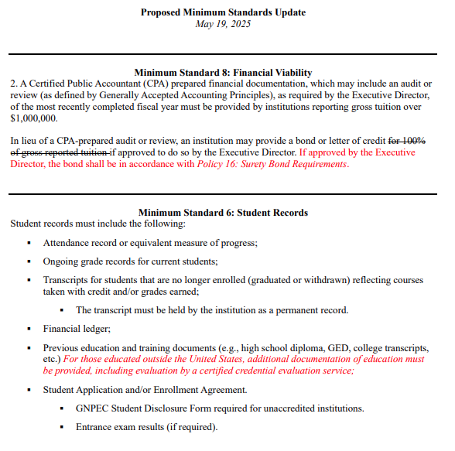
Commissioner Squire moved to adopt the FY26 Updates to Minimum Standards, as amended. Commissioner Blythe seconded the motion. There was no discussion.

Upon unanimous vote, it was RESOLVED that the FY26 Updates to Minimum Standards be adopted.

- EXECUTIVE DIRECTOR REPORT
Presented by Dr. Kirk Shook, Executive Director

- NPEC FY25 Operations Budget (3rd Quarter)
- Quarterly Budget Comparison (FY24 Q3 v. FY25 Q3)
- Program Evaluation Changes – Student Outcome Data Benchmarks

- NPEC FY25 Operations Budget (3rd Quarter)
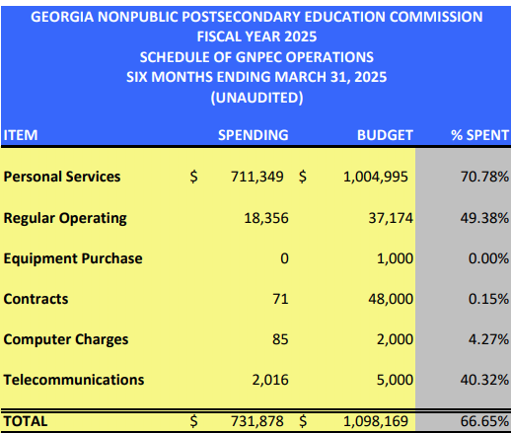

- Quarterly Budget Comparison (FY24 Q3 v. FY25 Q3)

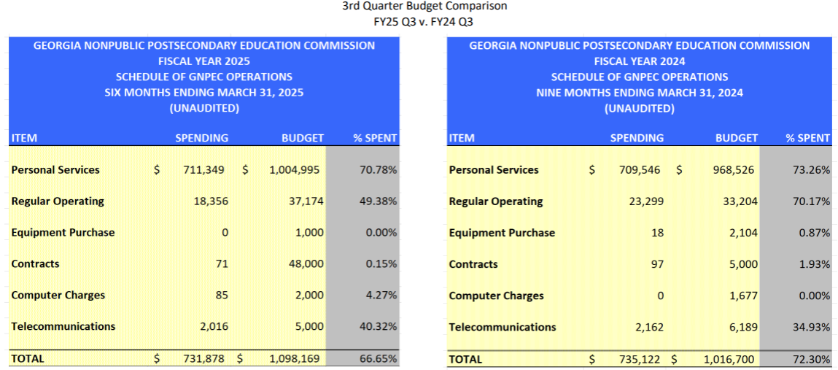

- AGENCY OPERATIONS REPORTS
Presented by Maggie Rivers, Deputy Director

- FY25 3rd Quarter Staff Actions

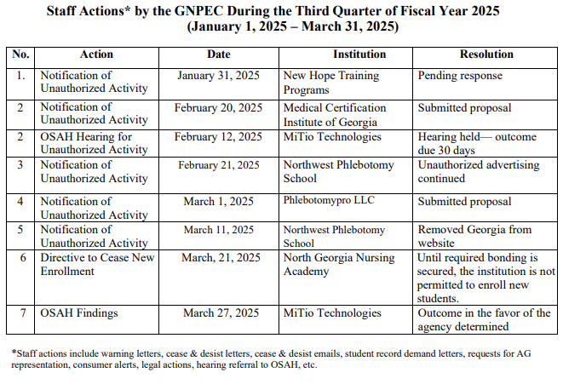

Commissioner Squire moved to adopt the FY25 Updates to FY25 3rd Quarter Staff Actions, as amended. Commissioner Udutha seconded the motion. There was no discussion.

Upon a unanimous vote, it was RESOLVED that the FY25 3rd Quarter Staff Actions be adopted.

- FY25 3nd Quarter Newly Authorized Schools Report
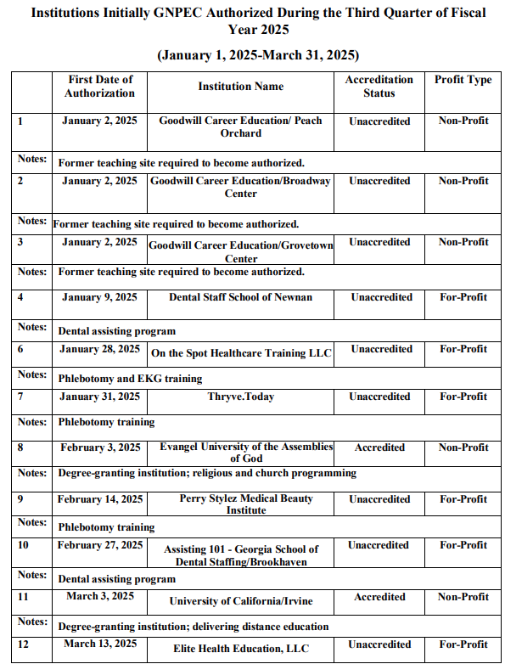
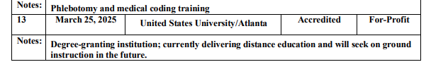
Commissioner Squire moved to adopt the FY25 Updates to FY25 3rd Quarter Newly Authorized School Report, as amended. Commissioner Udutha seconded the motion. There was no discussion.

Upon a unanimous vote, it was RESOLVED that the FY25 3rd Quarter Newly Authorized School Report be adopted.

- EXECUTIVE SESSION

Commissioner Squire moved to enter Executive Session. Commissioner Udutha seconded the motion. There was no discussion.

Upon a unanimous vote at 2:10pm, the meeting of the GNPEC Board of Commissioners entered the Executive Session.

    - Pursuant to O.C.G.A. § 50-14-2(1), this portion of the meeting is “closed in order to consult and meet with legal counsel pertaining to pending or potential litigation, settlement, claims, administrative proceedings, or other judicial actions brought or to be brought by or against the agency”
    - Report on pending litigation from Steven Walters, Assistant Attorney General

Commissioner Squire moved for the Commissioners to exit Executive Session. Secretary Patterson seconded the motion. There was no discussion.

Upon a unanimous vote at 2:42pm, the meeting of the GNPEC Board of Commissioners exited Executive Session.

- ACTIONS ITEMS FROM EXECUTIVE SESSION

Commissioner Adkison moved to adopt the initial decision from the Office of State Administrative Hearing, MiTio Technologies, Inc. v. Georgia Nonpublic Postsecondary Education Commission, as amended. Commissioner Blythe seconded the motion. There was no discussion.

Upon a unanimous vote, it was RESOLVED that the initial decision from the Office of State Administrative Hearing, MiTio Technologies, Inc. v. Georgia Nonpublic Postsecondary Education Commission Actions be adopted.

- OTHER BUSINESS
Presented by Vice Chairman Martin

- The next Quarterly Commission Meeting is August 18, 2025, at 1pm
- Location: GNPEC Office, 2082 East Exchange Place, Tucker, GA
- Agenda:
      - 10am – New Member Board Training
      - 11:30am – Headshots
      - 11:45am – Lunch
      - 12:45pm – Meetings Start

- PUBLIC COMMENTS

All public comments are limited to three (3) minutes per individual

- ADJOURN

Commissioner Blythe moved to adjourn the meeting. Secretary Patterson seconded the motion. There being no further business, the meeting was adjourned at 2:44pm.

