MEETING: | Board of Trustees, Tuition Guaranty Trust Fund  Quarterly Meeting
DATE: | May 19, 2025
LOCATION: | Zoom
TIME: | 12:45pm
PUBLIC CALL-IN INSTRUCTIONS: | Dial-in Number: (667) 770-1484  Participant Code: 317138#

BOARD MEETING MINUTES

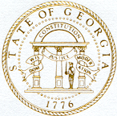

Georgia Nonpublic Postsecondary
Education Commission

Meeting Chair | P.K. Martin, Vice Chairman
Meeting Title | Board of Trustees of the NPEC Tuition Guaranty Trust Fund
Members Present | Kate Patterson  Jim Squire  Ryan Blythe  Dr. Kirk Shook, Secretary (Non-Voting Member)
Members Absent | None
Staff Present | Maggie Rivers, Deputy Director  Pat Neri, Program Manager, Compliance  Phil Embry, External Auditor  James Cheek, Program Manager/Authorization  Mike Kaiser, Program Manager/Initial Authorization  Margaret Gotlieb, Regulatory Specialist  Michelle Williams, Regulatory Specialist  Carley Henry, Administrative Assistant  Caroline Fairhurst, Compliance Specialist/Site Visits  Stephen DeBaun, General Counsel
Visitors | Steven Walters, AG

- CALL TO ORDER AND ROLL CALL
P.K Martin, Vice Chairman called the meeting to order at 12:45 pm. Roll Call was taken, and a quorum was declared.

- APPROVAL OF AGENDA
Trustee Squire moved to adopt the Agenda for the May 19, 2025, Quarterly Meeting of the Board of Trustees of the Tuition Guaranty Trust Fund. Trustee Patterson seconded the motion.

Vice Chairman Martin moved to adopt the amended Quarterly Report of the Tuition Guaranty Trust Fund. Trustee Squire seconded the motion.

Upon a unanimous vote, it was RESOLVED that the Agenda of May 19, 2025, Quarterly Meeting of the Board of Trustees of the Tuition Guaranty Trust Fund be adopted.

- APPROVAL OF MINUTES
Trustee Squire moved to adopt the Minutes from February 24, 2025, Quarterly Meeting of the Board of Trustees of the Tuition Guaranty Trust Fund. Vice Chairman Martin seconded the motion.

Upon unanimous vote, it was RESOLVED that the Minutes from February 24, 2025, Quarterly Meeting of the Board of Trustees of the Tuition Guaranty Trust Fund be adopted.

- APPROVAL OF QUARTERLY REPORT (unaudited): TUITION GUARANTY TRUST FUND
External Auditor Phil Embry reported on the following:

- FY25 3rd Quarter Report (January – March 2025)
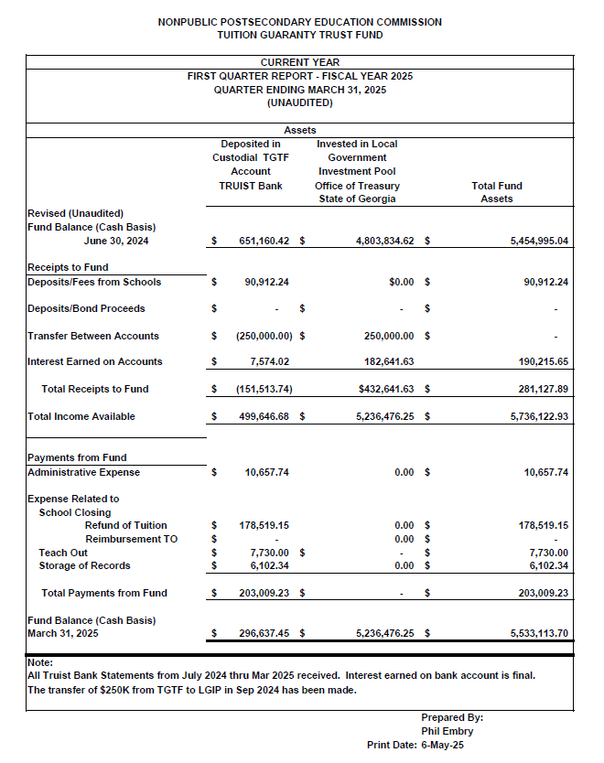
Upon unanimous vote, it was RESOLVED that the Quarterly Report of the Tuition Guaranty Trust Fund for the period January – March 2025 be adopted.

- EXECUTIVE DIRECTOR REPORT
- Georgia Fund Market Update, Phil Embry
- Update on Precipitous Closures
    - Health and Style Institute, Atlanta School of Massage, and Athens Institute of Allied Health

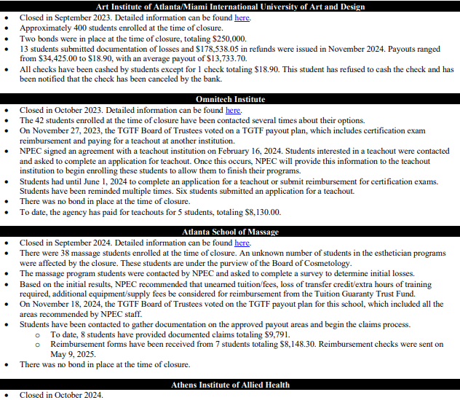
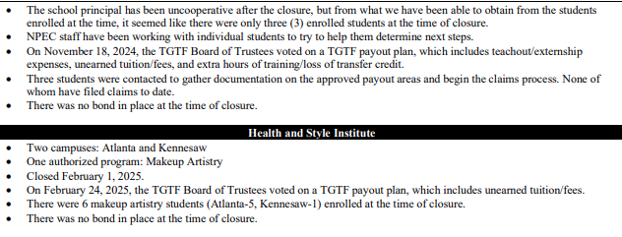

- REPORT ON FY25 3rd QUARTER SCHOOL CLOSURES
Presented by Maggie Rivers, Deputy Director

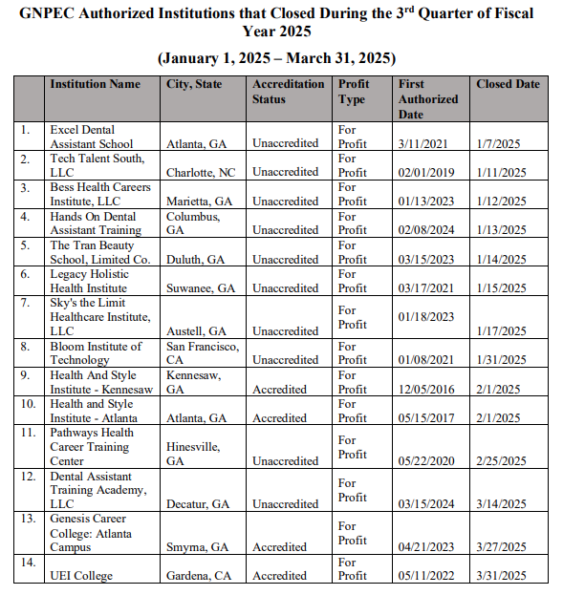
No approval required.

- OTHER BUSINESS
- The next Quarterly TGTF Board of Trustees Meeting is August 19, 2025, at 12:45pm
- Location: GNPEC Office, 2082 East Exchange Place, Tucker, GA

ADJOURNMENT

There being no further business, the meeting adjourned at 1:07pm.

BOARD OF TRUSTEES CHAIR BOARD OF TRUSTEES SECRETARY
APPROVAL: APPROVAL:

____________________________________ ____________________________________
Signature Signature

____________________________________ ____________________________________
Date Date

