BOARD MEETING MINUTES
MEETING: | Board of Commissioners, Nonpublic Postsecondary Education Commission  Quarterly Meeting
DATE: | May 20, 2024
LOCATION: | Covenant College, 14049 Scenic Hwy., Lookout Mountain, GA
TIME: | 1:00pm, or at the conclusion of the Quarterly TGTF Board of Trustees Meeting
PUBLIC CALL-IN INSTRUCTIONS: | Dial-in Number: (667) 770-1484  Participant Code: 317138#


Georgia Nonpublic Postsecondary
Education Commission

Meeting Chair | Kate Patterson, Secretary
Meeting Title | NPEC Board of Commissioners
Members Present | - P.K. Martin, Vice Chairman, At-Large Post #3  - Kate Patterson, Secretary, At-Large Post #8  - Dr. Linda Adkinson, Degree-Granting Institution Representative  - Ryan Blythe, Certificate-Granting Institution Representative  - Pranay Udutha, At-Large Post #1  - Doug Roper, At-Large Post #2  - Amanda Shailendra, At-Large Post #4  - Dr. Lance Barry, At-Large Post #5  - Dr. Norma Nunez-Cortes, At-Large Post #6  - Jim Squire, At-Large Post #7
Members Absent | - Dr. Drew Van Horn, Chairman, Exempt Institution Representative
Staff Present | - Dr. Kirk Shook, Executive Director  - Maggie Rivers, Deputy Director  - Pat Neri, Program Manager, Compliance  - Phil Embry, External Auditor  - Stephen Debaun, VP, General Counsel, Legal and Compliance  - Kristen Settlemire, Assistant Attorney General
Visitors | Toby Hinton, Former Commissioner

- CALL TO ORDER AND INVOCATION
Secretary Patterson called the meeting to order at 1:06pm and gave the invocation. Secretary Patterson called the roll, and a quorum was declared.
- WELCOME/INTRODUCTION OF NEW COMMISSIONERS
Secretary Patterson welcomed all the guests and visitors in attendance. She allowed the new commissioners to introduce themselves:
  - Dr. Linda Adkison, Degree-Granting Institution Representative (replacing Toby Hinton)
  - Dr. Lance Barry, At-Large Post #5 (replacing Holly Kirbo)

- ROLL CALL
Secretary Patterson called the roll, and a quorum was declared.

- WELCOME/INTRODUCTION OF VISITORS
Presented by Secretary Patterson

Former Commissioner Toby Hinton was recognized for his attendance.

- RECOGNITION OF BOARD MEMBER SERVICE
Presented by Dr. Kirk Shook, Executive Director

Dr. Shook read the commendations from Governor Kemp for the outgoing commissioners, Commissioner Hinton, who received his commendation in person, and Commissioner Kirbo. Both were thanked for their many years of service to the commission.

- RECOGNITION OF STAFF ACHIEVEMENT
Presented by Dr. Kirk Shook, Executive Director

Dr. Shook recognized NPEC Deputy Director, Maggie Rivers, for her election to the National Association of State Administrators and Supervisors of Private Schools (NASASPS) Board of Directors.

- HOST SCHOOL SPOTLIGHT
Presented by Dr. Kirk Shook, Executive Director

Dr. Shook thanked Covenant College for their warm hospitality and welcomed a current student, Sarah Wynn Caston (Class of 2026), to address the board and share her experiences at the school.

ACTION ITEMS
Presented by Kate Patterson, Secretary

- APPROVAL OF AGENDA
Commissioner Udutha moved to adopt the Agenda for the May 20, 2024, Quarterly Commission Meeting of the Georgia Nonpublic Postsecondary Education Commission. Commissioner Squire seconded the motion. There was no discussion.

Upon unanimous vote, it was RESOLVED that the Agenda for the May 20, 2024, Quarterly Commission Meeting of the Georgia Nonpublic Postsecondary Education Commission be adopted.

- APPROVAL OF MINUTES
Commissioner Udutha moved to adopt the Minutes from the February 26, 2024, Quarterly Meeting of the Georgia Nonpublic Postsecondary Education Commission. Vice Chairman Martin seconded the motion. There was no discussion.

Upon a unanimous vote, it was RESOLVED that the Minutes from the February 26, 2024, Quarterly Meeting of the Georgia Nonpublic Postsecondary Education Commission be adopted.

- APPROVAL OF QUARTERLY REPORT: TUITION GUARANTY TRUST FUND (unaudited)
Presented by Phil Embry, External

  - FY24 3rd Quarter Report (Jan – Mar 2024)

Commissioner Udutha moved to adopt the Quarterly Report of the Tuition Guaranty Trust Fund for January - March 2024 period, as presented. Commissioner Blythe seconded the motion. There was no discussion.

Upon unanimous vote, it was RESOLVED that the Quarterly Report of the Tuition Guaranty Trust Fund for January - March 2024, as approved by the Board of Trustees of the Tuition Guaranty Trust Fund, be adopted.

- APPROVAL OF FY25 COMMISSION MEETING DATES AND LOCATIONS

Dr. Shook presented the proposed FY25 Commission meeting dates and locations. Of note, the timing of the virtual and in-person meetings was flipped to avoid busier times of the year.

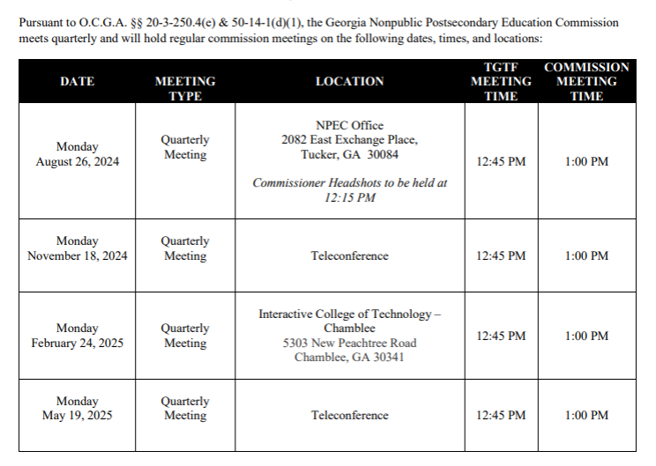

Commissioner Barry moved to adopt the FY25 Commission Meeting Dates and Locations, as presented. Commissioner Nunez-Cortes seconded the motion. There was no discussion.

Upon unanimous vote, it was RESOLVED that the FY25 Commission Meeting Dates and Locations be adopted.

- APPROVAL OF FY25 NPEC SCHEDULE OF FEES

Dr. Shook presented the proposed FY25 Schedule of Fees. The below changes were presented:

 | Name | Description | Type of Fee | Amount | Fee Change
1 | GA-SARA  Annual Fee | This fee is assessed for review of the GA-SARA Application. | < 2,500 FTE Students | $1,250 | $1,500
1 | GA-SARA  Annual Fee | This fee is assessed for review of the GA-SARA Application. | 2,500 – 9,999 FTE Students | $2,000 | $2,500
1 | GA-SARA  Annual Fee | This fee is assessed for review of the GA-SARA Application. | 10,000 – 29,999 FTE Students | $2,750 | $3,500
1 | GA-SARA  Annual Fee | This fee is assessed for review of the GA-SARA Application. | 30,000 or more FTE Students | $4,500 | New fee
2 | Application Evaluation Fee | This fee is assessed to cover the evaluation of an application for authorization of an institution seeking initial authorization, for an institution seeking an “Other Exemption” Application, an Initial Religious Exemption Application, and a Renewal Religious Exemption. This fee must be made in advance of the review of the application and made payable to NPEC.  The renewal application evaluation late fee is assessed if a first-time renewal of authorization applicant or other renewal of authorization applicant, as determined by the executive director, fails to attend authorization renewal training at least 60 days prior to their expiration date. The renewal application will not be evaluated if the training requirement is not satisfied. An “Other Exemption” application late fee is assessed if the application renewing the exemption is not submitted at least 30 days prior to expiration. For all “Other Exemption” applicant institutions, the $150 application fee is also required to be submitted prior to the due date.  NOTE: Institutions not accredited by an accrediting body recognized by the United States Department of Education are limited to three new program applications included in the Application Evaluation Fee, as long as the programs are within the same scope, as determined by the commission. The Program Evaluation Fee will apply to each additional program beyond the three, or to programs outside of the programmatic scope as determined by the commission. Accredited institutions are limited to ten new program applications included in the Application Fee. The Program Evaluation Fee will apply to each additional program beyond the ten.  If an adverse action has been taken against an institution by the agency in the past, the application evaluation fee for the institution and/or the principal(s) named in the action shall be double the Commission-approved application evaluation fee. | Nondegree-granting institution | $1,500 | N/A
2 | Application Evaluation Fee |  | Degree-granting institution | $3,000 | N/A
2 | Application Evaluation Fee |  | Renewal application evaluation late fee | $250 | New Fee
2 | Application Evaluation Fee |  | “Other Exemption” application | $150  ($100 late fee for applicable applications) | Fee Category Changed; fee increased $50
2 | Application Evaluation Fee |  | Initial Religious Exemption Application Fee | $500 | Fee Category Changed
2 | Application Evaluation Fee |  | Religious Exemption Application Fee | $150  ($100 late fee for applicable applications) | Fee Category Changed; fee increased $50
3 | Program Evaluation Fee | The program review fee is assessed for evaluation of the curriculum/content for each new or substantively changed program of instruction at an already authorized institution or for initial applicants seeking approval for programs exceeding the allotted number during the initial authorization process. Fee must be made payable to NPEC.  The FVA fee is assessed to conduct a financial review of the audited financial statements and/or NPEC Financial Statement submitted by the institution. A late fee is assessed on applicable exemption applications if the annual application and FVA fee are not submitted prior to the due date.  An additional fee is assessed in the event a site visit, in-person or virtual, is required outside of the normal renewal of authorization application schedule, such as in the event of an application for a new allied health-related program, teaching site, or mobile teaching site that would require a site visit to ensure facilities and equipment meet the requirements of the course. This fee would also apply to extra visits related to corrective action plans or adverse actions. | Program Review | $800 | N/A
3 | Program Evaluation Fee |  | Financial Viability Assessment | $500  ($100 late fee for applicable applications) | Fee Category Changed
3 | Program Evaluation Fee |  | Site Visit | $200 | N/A
4 | Degree Elevation Fee | This fee is assessed for the elevation to each degree level. |  | $1,000 | N/A
5 | Missed Site Visit Fee | This fee is assessed for the failure of the institution to attend a scheduled site visit. This also includes the inability of the person hosting the site visit to perform all the required functions of the visit such as not having access to the facility, its records, etc. In the event a site visit must be rescheduled, 24-hour notice must be given, or the institution might be subject to this fee. |  | $200 | N/A
6 | Authorization Fee | The fee is assessed annually to institutions as part of the application for authorization and must be made payable to NPEC.  This Authorization Fee is calculated based on 2/10 of one percent of estimated tuition and fees minus refunds. In the Initial Authorization Application, this is based on projected tuition and fees. For campuses located in Georgia this figure will be based on tuition and fees for the campus. For campuses located outside of Georgia, this figure will be based on tuition and fees associated with Georgia students only.  A late fee is assessed for failure to submit a complete renewal application, including all fees, 60 days prior to the expiration date on the Certificate of Authorization. The late fees will be as follows:  - 25% of Authorization Fee for applications or fees submitted late but prior to 30 days before expiration;  - 50% of Authorization Fee for applications or fees submitted late and within 30 days of expiration date | Nondegree-granting institutions:
6 | Authorization Fee |  | Minimum annual fee | $500 | N/A
6 | Authorization Fee |  | Maximum annual fee | $25,000 | N/A
6 | Authorization Fee |  | Degree-granting institutions:
6 | Authorization Fee |  | Minimum annual fee | $1,000 | N/A
6 | Authorization Fee |  | Maximum annual fee | $25,000 | N/A
7 | Authorization Late Fee | This fee is assessed for failure to submit a complete renewal application, including all fees, 60 days prior to the expiration date on the Certificate of Authorization. |  | 25% of Authorization Fee for applications or fees submitted late but prior to 30 days before expiration;  50% of Authorization Fee for applications or fees submitted late and within 30 days of expiration date | N/A
8 | Financial Viability Assessment (FVA) Fee | This fee is assessed to conduct a financial review of the audited financial statements and/or GNPEC Financial Statement submitted by the institution. |  | $500 | N/A
9 | FVA Late Fee | This fee is assessed on applicable exemption applications if the annual application and FVA fee are not submitted prior to the due date. |  | $100 | N/A
10 | Change of Ownership Fee | This fee is assessed for the administrative recording of a new ownership structure if the process is initiated within 10 days of the change, followed by a Renewal of Authorization within 30 days of the change.  If the Change of Ownership process is not initiated within the 10-day time frame as required by O.C.G.A. § 20-3-250.8(f), the initial authorization process, including the Application Evaluation Fee, will be required. | If notification provided within 10 days of change: | $500 | N/A
11 | Tuition Guaranty Trust Fund (TGTF) Fee | This fee is assessed to offer a financial safety net for students in the case of a school closing.  The TGTF Fee is calculated based on 1/10 of one percent of estimated tuition and fees minus refunds. In the Initial Authorization Application, this is based on projected tuition and fees. For campuses located in Georgia this figure will be based on tuition and fees for the campus. For campuses located outside of Georgia, this figure will be based on tuition and fees associated with Georgia students only. Payment must be made by every school for the first 7 years of operation and must be made payable to TGTF.  A late fee is assessed for failure to submit a complete renewal application, including all fees, 60 days prior to the expiration date on the Certificate of Authorization. The late fees will be as follows:  - 25% of TGTF Fee for applications or fees submitted late but prior to 30 days before expiration;  - 50% of TGTF Fee for applications or fees submitted late and within 30 days of expiration date | Degree and Non-degree Granting Institutions:
11 | Tuition Guaranty Trust Fund (TGTF) Fee |  | Minimum annual fee | $200 | N/A
11 | Tuition Guaranty Trust Fund (TGTF) Fee |  | Maximum annual fee | No Maximum fee | N/A
12 | Other Exemption Application Fee | This fee is assessed to conduct the “Other Exemption” Application. |  | $100 | N/A
13 | Other Exemption Application Late Fee | This fee is assessed to any "Other Exemption" institution if the renewal application is not submitted prior to expiration. For all “Other Exemption” applicant institutions, the $100 application fee is also required to be submitted prior to the due date. |  | $100 | N/A
14 | Initial Religious Application Fee | This fee is assessed to process applications for religious schools applying for initial formal designation as exempt. |  | $500 | N/A
15 | Religious Renewal Application Fee | This fee is assessed to process application for religious schools applying to renew their formal designation as exempt. |  | $100 | N/A
16 | Religious Renewal Late  Fee | This fee is assessed if renewal application and fee are not submitted prior to the due date. |  | $100 | N/A
17 | Teaching/ Student Services Site Fee | This fee is assessed for the administrative recording of a new teaching or student services site. |  | $100 | N/A
18 | Transcript Request Fee | This fee is assessed for processing a transcript request. |  | $15 per request;  $5 for each additional copy at time of request | N/A
19 | Document Fee | This fee is assessed for copying and/or mailing documents or forms. |  | $0.10 per page plus postage | N/A

NPEC Bond/Letter of Credit Amount
Effective July 1, 2022 and pursuant to O.C.G.A. § 20-3-250.10(a), bonding required by the Executive Director shall be based on the gross tuition of the nonpublic postsecondary educational institution during the previous year or on the estimated gross tuition for the current year, whichever is larger, and shall be as follows:

Gross Tuition | Minimum Bond/Letter of Credit
$0.00 – 50,000.00 | $20,000.00
$50,001.00 – 100,000.00 | $30,000.00
$100,001.00 – 200,000.00 | $50,000.00
$200,001.00 – 300,000.00 | $75,000.00
$300,001.00 – 400,000.00 | $100,000.00
$400,001.00 – 500,000.00 | $150,000.00
$500,001.00 – 1,000,000.00 | $250,000.00
$1,000,001.00 – 2,000,000.00 | $350,000.00
$2,000,001.00 – 5,000,000.00 | $500,000.00
$5,000,000.00 – 10,000,000.00 | $750,000.00
$10,000,001.00 and over | $1,000,000.00*
*For every $10,000,000.00 of additional gross tuition reported by the institution, an additional $1,000,000.00 of bonding shall be required. For example, for an institution reporting $50 million in gross annual tuition, a $5 million bond would be required.

In lieu of a bond, a letter of credit may be secured by institutions. All fee payments and required bonding/letter of credit must be received before authorization or reauthorization applications are approved.

Commissioner Squire moved to adopt the FY25 NPEC Schedule of Fees, as presented. Commissioner Shailendra seconded the motion. There was no discussion.

Upon unanimous vote, it was RESOLVED that the FY25 NPEC Schedule of Fees be adopted.

- APPROVAL OF FY25 SCHEDULE OF FINES

Dr. Shook presented the proposed FY25 Schedule of Fines as follows:

Type of Fine | Code Reference | Amount Per Violation*
Operation without Authorization or operating with an expired certificate of authorization | O.C.G.A. § 20-3-250.7(a)(1);  O.C.G.A. § 20-3-250.7(a)(2);  O.C.G.A. § 20-3-250.8(i) | $200 per day
Solicit students without being authorized and properly bonded | O.C.G.A. § 20-3-250.7(a)(3) | $100 per day
Making false, deceptive, inaccurate, or misleading statements, course offerings, or solicitations to students | O.C.G.A. § 20-3-250.7(a)(4);  O.C.G.A. § 20-3-250.7(a)(7) | $100 per day
Offering or publicizing a course without authorization | O.C.G.A. § 20-3-250.7(a)(4) | $100 per day
General or administrative operations in violation of the Minimum Standards Criteria and/or the rules and regulations of the Commission | O.C.G.A. § 20-3-250.5(c)(4);  O.C.G.A. § 20-3-250.6;  O.C.G.A. § 20-3-250.7(a)(5);  O.C.G.A. § 20-3-250.8(a);  O.C.G.A. § 20-3-250.8(b);  O.C.G.A. § 20-3-250.8(c) | $100 per day
Instruction, advertisements, solicitations, and awarding of credentials in violation of the Minimum Standards Criteria and/or the rules and regulations of the Commission | O.C.G.A. § 20-3-250.7(a)(5) | $100 per day
Unauthorized promise or guarantee of employment | O.C.G.A. § 20-3-250.7(a)(6) | $100 per day
Unauthorized granting of honorary or unearned degrees | O.C.G.A. § 20-3-250.7(a)(8) | $100 per day
Unpermitted Use of “College” or “University” | O.C.G.A. § 20-3-250.7(b) | $100 per day
Sell, barter, or exchange postsecondary credentials | O.C.G.A. § 20-3-250.7(c) | $100 per day
Accepting fraudulent coursework for credit | O.C.G.A. § 20-3-250.7(d) | $100 per day
Failure to Surrender Student Records in accordance with O.C.G.A. § 20-3-250.17 | O.C.G.A. § 20-3-250.7(f);  O.C.G.A. § 20-3-250.17 | $100 per day
Failure to provide authorization application and accompanying documents, as required by the rules and the regulations of the Commission | O.C.G.A. § 20-3-250.8(a) | $100 per day
Failure to provide adequate bonding | O.C.G.A. § 20-3-250.8(a) | $100 per day
Operating in an unauthorized location | O.C.G.A. § 20-3-250.8(b) | $100 per day
Failure to provide appropriate access to physical facilities or other materials deemed necessary or appropriate by the executive director during site visit | O.C.G.A. § 20-3-250.8(c) | $100 per day
Failure to display certificate of authorization in a clear and conspicuous manner | O.C.G.A. § 20-3-250.8(d)
Failure to comply with change of ownership protocols | O.C.G.A. § 20-3-250.8(f) | $100 per day
Failure to submit authorization application at least 60 days prior to the expiration date | O.C.G.A. § 20-3-250.8(g) | $100 per day
Operating programs or courses without prior authorization | O.C.G.A. § 20-3-250.8(i) | $100 per day

Commissioner Squire moved to adopt the FY25 NPEC Schedule of Fines, as presented. Commissioner Barry seconded the motion. There was no discussion.

Upon unanimous vote, it was RESOLVED that the FY25 NPEC Schedule of Fines, be adopted.

- APPROVAL OF COMMISSION OFFICER ELECTIONS

Secretary Kate Patterson presented the slate of officers:
- Chairman – Dr. Drew Van Horn
- Vice Chairman – P.K. Martin
- Secretary – Kate Patterson

Commissioner Squire moved to adopt the slate for the FY25 Commission Officers, as presented. Commissioner Udutha seconded the motion. There was no discussion.

Upon unanimous vote, it was RESOLVED that the slate for the FY25 Commission Officers be adopted.

- APPROVAL OF TGTF TRUSTEE ELECTIONS

Dr. Shook reminded commissioners that pursuant to O.C.G.A. § 20-3-250.27(b)(2), “at least two members, by June 30, 2020, shall represent postsecondary education institutions.” Additionally, he noted that the bylaws of the board state that members shall serve no more than 6 terms on the TGTF board.

Secretary Patterson presented the slate of the following individuals:
- Chairman – Dr. Drew Van Horn
- Vice Chairman – P.K. Martin
- Kate Patterson
- Ryan Blythe
- Jim Squire

Commissioner Roper moved to adopt the slate for the FY25 TGTF Board of Trustees, as presented. Commissioner Nunez-Cortes seconded the motion. There was no discussion.

Upon unanimous vote, it was RESOLVED that the slate for the FY25 TGTF Board of Trustees be adopted.

- APPROVAL OF UPDATES TO MINIMUM STANDARDS CRITERIA

Deputy Director Rivers presented the following proposed changes to the Minimum Standards Criteria:

Standard 1: Programmatic Integrity
Statutory Authority: O.C.G.A. §§ 20-3-250.5(b)(2); 20-3-250.6(a)(1)
An institution's programmatic offerings must sufficiently address the learning objectives to prepare graduates for employment in the field for which the training is offered, as determined by the GNPEC in its sole discretion.
- Each individually offered program must be approved by GNPEC.
- Each program of study must include the following:
  - Clear objectives;
  - Established and appropriate entrance requirements;
  - A detailed curriculum outline;
  - Theoretical and practical components;
  - Assessment of knowledge gained;
  - Remediation services; and
  - Final evaluation.
- Each program must have syllabi and written lesson plans available for each course or, in the instance of single course programs, for the whole program.
- Programmatic length must be satisfactory to ensure the amount of content offered is relative to the programmatic level.
  - Certificate—no minimum length Minimum credit hours (or equivalent) as determined by the commission; can be offered at any postsecondary level
  - Associate—requires at least 60 semester credit hours (or equivalent)
  - Bachelor—requires at least 120 semester credit hours (or equivalent)
- Institutions offering credit for experience and/or competency, or equivalent, must have a policy in place for how credit is granted based upon documented metrics.
- Programmatic Institutional accreditation, or institutional accreditation including programs, must be first attained in order to offer graduate degree programs.
- The institution must be able to make available a list of potential employment opportunities for which the program prepares.
- If certification, licensure, or other state and/or national vocational approval may be required of the graduate to become employed in the field, the institution must disclose if the program does not meet those requirements prior to, or at the time of, enrollment in published institutional materials.
  - No program shall use the word “certified” in the program name unless the program is specifically designed to lead to an industry-recognized certification and the institution requires the student to sit and pass the exam for graduation from the program [,or as determined by the Executive Director in his/her sole discretion].
NOTE: The language in blue above was added by commissioners in the May 2024 Commission meeting and approved by a vote of the commission.
- The institution must have a system in place for evaluating and documenting student achievement such as through periodic examinations, skills assessment logs, and/or standardized achievement tests. Furthermore, the following practices are required:
  - Established grading system;
  - Ongoing/updated record of grades; and
  - Established exit criteria for determining successful completion of course work and programs.
- The institution must incorporate teaching methods and procedures to provide for direct meaningful interaction between students and faculty.
  - The commission has the authority to deny programs for insufficient program length or curricular quality.
  - Unaccredited institutions are prohibited from offering fully asynchronous online-only program delivery, as determined by the commission, which includes the use of curriculums developed by third-party vendors. Hands on/lab training related to a field or profession associated with public health, public welfare, or public safety, as determined by the commission, must be done in person, not virtually.
  - Asynchronous delivery of the curriculum as part of the total clock hours of the program instruction may be denied by the Executive Director based on the nature of the occupations for which the training is intended.
- The institution must periodically evaluate its ability to satisfy its mission statement through methods such as student surveys or an institutional effectiveness committee and develop procedures to improve its ability to satisfy its mission statement as necessary.
- The institution must periodically survey faculty as part of an institution-wide evaluation of its ability to satisfy its mission statement.
  - Faculty and staff must be notified of relevant institutional policy changes through regular training and/or meetings.

Standard 3: Faculty and Staff (i.e., Personnel)
Statutory Authority: O.C.G.A. §§ 20-3-250.5(b)(2); 20-3-250.6(a)(3)
The faculty and staff must be qualified, based on previous education and experience, to fulfill the responsibilities of each of their institutional roles. Credentials reported must be earned from an institution with accreditation recognized by United States Department of Education, licensure recognized by the State of Georgia, or equivalent based on supporting documentation, as determined acceptable by the GNPEC in its sole discretion. For those educated outside the United States, additional documentation of education must be provided, including evaluation by a certified credential evaluation service at the expense of the institution. If applicable, active state licensure or certification relevant to the specific field of instruction must be maintained.
Faculty (Instructor) Qualifications
- A certificate-granting institution must employ faculty (instructors) who demonstrate competency in the field for which training is offered, as evidenced by at least one of the following:
  - A bachelor's degree with a major in the field of instruction from an institution accredited by an accrediting agency recognized by the United States Department of Education; or
  - At least two years of teaching experience and/or work experience in the field for which training is offered.
  - Faculty must hold valid and current licensure/certification if the field of instruction requires licensure/certification for employment.
- A degree-granting institution must employ faculty (instructors) who demonstrate competency in the field for which training is offered, as evidenced by the following:
  - A degree in the field of instruction, at least one degree level higher than the program being taught, from an institution accredited by an accrediting agency recognized by the United States Department of Education.
    - A reasonable number of faculty must have earned a doctorate or terminal degree from an institution accredited by an agency recognized by the United States Department of Education.
    - In some instances, as approved by the Executive Director, experience and professional recognition may be an acceptable substitute for the degree requirement.
  - At least two years of teaching experience and/or work experience in the field for which training is offered.
- A graduate degree-granting institution must employ faculty (instructors) who demonstrate competency in the field for which training is offered, as evidenced by the following:
  - A doctorate or terminal degree in the field of instruction from an institution accredited by an accrediting agency recognized by the United States Department of Education.
    - In some instances, as approved by the Executive Director, experience and professional recognition may be an acceptable substitute for the degree requirement.
  - At least two years of teaching experience and/or work experience in the field for which training is offered.
- The institutional organization chart must reflect adequate personnel necessary to support programming scope.
- The institution must provide programmed orientation to familiarize new hires with institutional policies and procedures along with job requirements.
- Faculty and staff must be provided with an employee handbook with confirming attestation of receipt to be documented in employee file.

Staff Qualifications
- A certificate-granting institution has designated a director who meets at least two of the following requirements:
- A bachelor’s degree from an institution accredited by an agency recognized by the United States Department of Education;
- At least one year of administrative or supervisory experience; and/or
- At least two years of teaching experience and/or work experience in the specific field for which training is offered.
- A degree-granting institution must have a designated director who meets the following requirements:
- A bachelor’s degree from an institution accredited by an agency recognized by United States Department of Education;
    - In some instances, as approved by the Executive Director, experience and professional recognition may be an acceptable substitute for the degree requirement.
- At least two years of administrative or supervisory experience; and
- At least two years of teaching experience and/or work experience in the specific field for which training is offered.
- Institutions with more than one (1) distinct occupational area that leads to an occupational or academic degree must have a program head (e.g., lead faculty, department chair, dean, etc.) who possesses an educational background equal to or exceeding the maximum credential offered in that program area, the requisite qualifications for technical faculty teaching in a degree program, and an ability to administer the occupational components of the program.
- For an institution offering only one (1) program or group of programs in one distinct occupational area, a single individual may fulfill both the director of education and the program head requirements as long as the individual possesses the requisite qualifications for each position.
- Institutions must employ administrators and supervisors who meet the following requirements:
  - An earned degree from an institution accredited by an agency recognized by the United States Department of Education appropriate for the programming of the institution and/or area of responsibility; and/or
  - Adequate professional experience and education necessary to satisfy responsibilities of the position.
- Institutions who employ agents to recruit on behalf of an institution ensure the agents do not engage in advertising, sales, collection, credit, or other practices of any type that are false, deceptive, misleading, or unfair.

Personnel Records
Information on all owners, trustees, board members, faculty, and staff persons must be made available upon GNPEC request.
- Faculty records must, at a minimum, include the following:
- Proof of employment;
- Record of education and experience (i.e., resume/CV);
- Proof of highest level of education (i.e., transcript/diploma); and
- Proof of completion of orientation and notification of updated institutional policies.

Standard 6: Student Records
Statutory Authority: O.C.G.A. §§ 20-3-250.5(b)(2); 20-3-250.6(a)(6); 20-3-250.17
- Student records must include the following:
  - Attendance record or equivalent measure of progress;
  - Ongoing grade records for current students;
  - Transcripts for students that are no longer enrolled (graduated or withdrawn) reflecting courses taken with credit and/or grades earned;
    - The transcript must be held by the institution as a permanent record.
  - Financial ledger;
  - Previous education and training documents (e.g., high school diploma, GED, college transcripts, etc.); and
  - Student Application and/or Enrollment Agreement.
    - GNPEC Student Disclosure Form required for unaccredited institutions.
    - Entrance exam results (if required).
- The institution, while operating, must provide for the permanent storage, retrieval, confidentiality, and adequate protection of student academic records including the following:
  - The protection of hard copies of student academic records against pilferage, fire and tampering via digital cloud storage or a second copy off-site.
- The institution must have established internal policies, controls, and procedures guiding the record keeping of attendance, grades, finances, enrollment, and program/course completion.
  - In the case of institutional closure, the closing institution is responsible for teaching out currently enrolled students prior to closure or facilitating teach-out arrangements, which must be approved by the Commission, at another approved institution prior to closure.
- Should an institution cease operation in Georgia, it must file with GNPEC (or a third party acting on behalf of GNPEC) transcripts for all former students and academic records of students that were active at the time of closure.
- In the event it appears to the executive director that any such records of an institution discontinuing its operations are in danger of being destroyed, secreted, mislaid, or otherwise made unavailable to the executive director, the executive director may, with court order, seize and take possession of such records, subject to the confidentiality accorded normal school records.

Commissioner Blythe raised concerns about the revision to MSC 1.8.a and gave some potential examples of the changes that might have unintended consequences. Dr. Shook suggested that to the proposed language additions to that standard, the phrase “as determined by the Executive Director in his/her sole discretion” be added to the end of the sentence to provide flexibility to commission staff. Commissioner Blythe agreed to this change.

Commissioner Barry moved to adopt the FY25 Updates to Minimum Standards, as amended. Commissioner Roper seconded the motion. There was no discussion.

Upon unanimous vote, it was RESOLVED that the FY25 Updates to Minimum Standards be adopted.

- APPROVAL OF POLICY UPDATES

Deputy Director Rivers gave an overview of the proposed update to Policy 16. The proposed policy is as follows:

Policy 16: Surety Bond Form and Requirements
1. Pursuant to Code Section 20-3-250.8(a) Each nonpublic postsecondary educational institution desiring to operate or conduct postsecondary activities in this state shall make application to the commission, upon forms to be provided by the commission.
2. In accordance with O.C.G.A. § 20-3-250.10, an initial or renewing applicant for authorization to operate may be required to file with the executive director a good and sufficient surety bond with at least a B+ bond rating by a recognized bond rating agency in such sum as determined by the Commission in accordance with the bond amount schedule. As of July 1, 2022, required bond amounts are as follows:
Gross Tuition | Minimum Bond/Letter of Credit
$0.00 – 50,000.00 | $20,000.00
$50,001.00 – 100,000.00 | $30,000.00
$100,001.00 – 200,000.00 | $50,000.00
$200,001.00 – 300,000.00 | $75,000.00
$300,001.00 – 400,000.00 | $100,000.00
$400,001.00 – 500,000.00 | $150,000.00
$500,001.00 – 1,000,000.00 | $250,000.00
$1,000,001.00 – 2,000,000.00 | $350,000.00
$2,000,001.00 – 5,000,000.00 | $500,000.00
$5,000,000.00 – 10,000,000.00 | $750,000.00
$10,000,001.00 and over | $1,000,000.00*
*For every $10,000,000.00 of additional gross tuition reported by the institution, an additional $1,000,000.00 of bonding shall be required. For example, for an institution reporting $50 million in gross annual tuition, a $5 million bond would be required.
The required bond amounts are subject to change from time to time by commission vote.
Pursuant to statute and this Policy, the bond must be provided to GNPEC in substantial conformance with the such forms attached hereto as Exhibit “A,” as provided by the commission and incorporated herein by reference.
3. These forms may be updated from time to time by the commission to reflect revisions to statute and to make administrative revisions.
4. The Executive Director is authorized, in his or her sole discretion, to require an applicant to file with the commission a surety bond if a financial assessment includes findings or notes raising concern about such applicant’s institutional internal controls or recommends that such applicant be placed on financial monitoring status.
5. An institution’s failure to maintain a surety bond as set forth herein will result in suspension and/or termination of its authorization to operate, in accordance with O.C.G.A. § 20-3-250.10 and a determination by the Executive Director in accordance with applicable law and agency policies.
6. In lieu of a bond, the Executive Director may accept an irrevocable bank standby letter of credit from a federally insured financial institution in the amount required to satisfy the bonding requirements set forth by the Commission.
Exhibit A
Removed Current Bond Form

Commissioner Squire moved to adopt the Revision of Policy 16: Surety Bond Requirements, as presented. Vice Chairman Martin seconded the motion. There was no discussion. Prior to the vote, Secretary Patterson opened up the floor to public comments. No public comments were made.

Upon unanimous vote, it was RESOLVED that the Revision of Policy 16: Surety Bond Requirements be adopted.

- EXECUTIVE DIRECTOR REPORT
Presented by Dr. Kirk Shook, Executive Director

- NPEC FY24 Operations Budget (3rd Quarter)
- Quarterly Budget Comparison (FY23 Q3 v. FY24 Q3)
- Program Evaluation Updates
- Precipitous Closure Updates

- AGENCY OPERATIONS REPORTS
Presented by Maggie Rivers, Deputy Director

- FY24 3rd Quarter Staff Actions

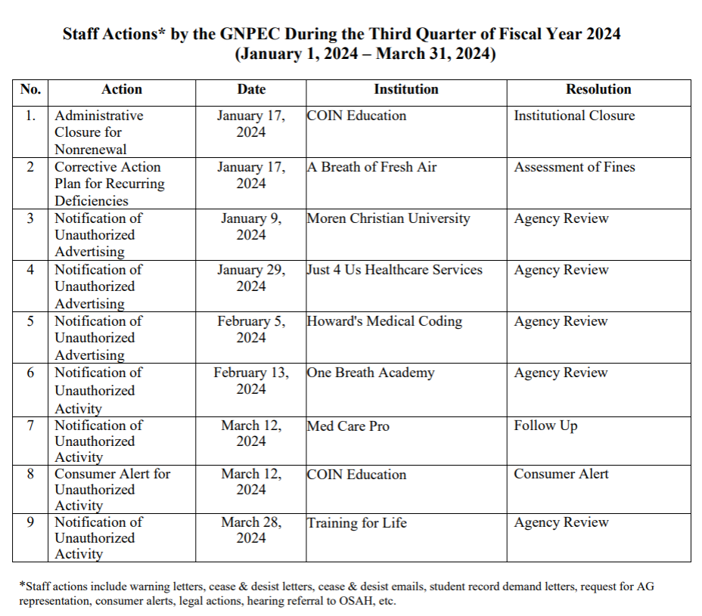

No approval required for this report.

- FY24 3rd Quarter Newly Authorized Schools Report

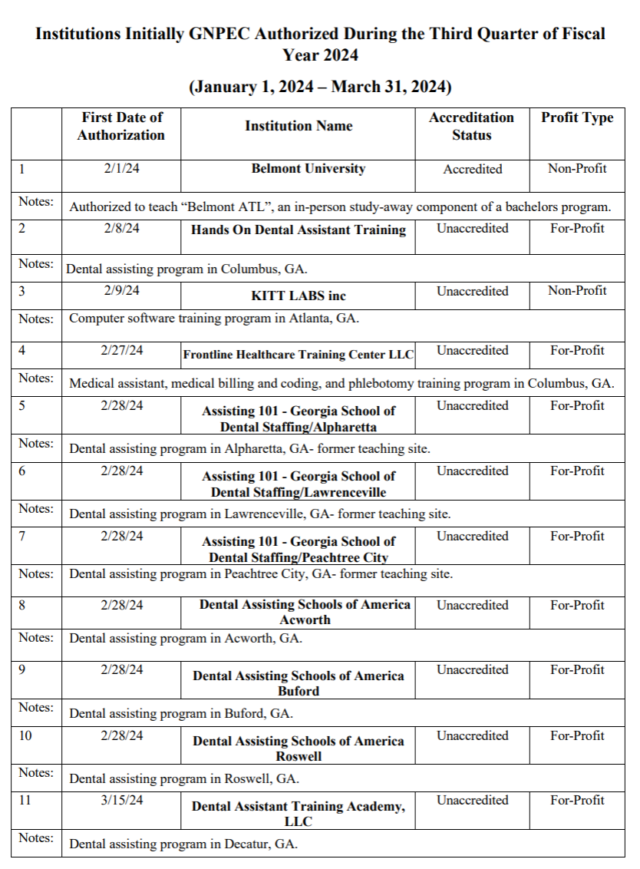

No approval required for this report.

- EXECUTIVE SESSION

There was no need for executive session at this meeting.

- SCHOOL SPOTLIGHT
Presented by Dr. Kirk Shook, Executive Director

Health Tech of Georgia shared the following information in an authorization survey, which was read to the Commissioners by Dr. Shook:

In 2022, we had a plasma lab hire our entire Phlebotomy class. They came in to talk to our students in regard to jobs available. They watched as every student proceeded to perform the process in class clinical. They were so amazed they hired them all (14 students). They have continued to hire directly from us since.

We have a medical assistant who came to us shortly after getting a divorce and struggling to find her new path. She went through every class with ease. She worked hard and managed to pass her classes with great effort. Being a single mom and living on welfare really made her work hard. She never wanted her kids to look at welfare as just being lazy and not working. She cried upon finishing her last class a year later. Today she is in a physician office as their office manager. She only hires students from us. Three students now work with her. She is full of confidence and just glows now that she has found her way. She was named employee of the month for 5 months straight working on her job. She comes by just to say hello to us and is now a guest speaker to our students.

- OTHER BUSINESS
Presented by Kate Patterson, Secretary

- The next Quarterly Commission Meeting is August 26, 2024 at 1pm (Lunch at 11:45 am, Headshots at 12:15pm)
  - Location: Georgia Nonpublic Postsecondary Education Commission, 2082 East Exchange Place, Tucker, GA
- Commissioner Jim Squire took a point of personal privilege to congratulate Executive Director Shook on his recent graduation from the University of Georgia with a Doctor of Education degree.

- PUBLIC COMMENTS

No public comments were made.

- ADJOURN
Commissioner Blythe moved to adjourn the meeting. Commissioner Nunez-Cortes seconded the motion. There being no further business, the meeting adjourned at 2:38pm.

