MEETING: | Board of Trustees, Tuition Guaranty Trust Fund  Quarterly Meeting
DATE: | May 20, 2024
LOCATION: | Covenant College, 14049 Scenic Hwy., Lookout Mountain, GA
TIME: | 12:45pm
PUBLIC CALL-IN INSTRUCTIONS: | Dial-in Number: (667) 770-1484  Participant Code: 464977#

BOARD MEETING MINUTES



Georgia Nonpublic Postsecondary
Education Commission

Meeting Chair | Kate Patterson
Meeting Title | Board of Trustees of the NPEC Tuition Guaranty Trust Fund
Members Present | P.K. Martin, Vice Chairman  Ryan Blythe  Kate Patterson  Jim Squire  Dr. Kirk Shook, Secretary (Non-Voting Member)
Members Absent | Dr. Drew Van Horn, Chairman
Staff Present | Maggie Rivers, Deputy Director  Pat Neri, Program Manager, Compliance  Phil Embry, External Auditor  Stephen Debaun, VP, General Counsel, Legal and Compliance  Kristen Settlemire, Assistant Attorney General
Visitors | Toby Hinton, (Board of Commissioners 2018-2024, Board Chair FY22)

- CALL TO ORDER AND ROLL CALL
Trustee Patterson called the meeting to order at 12:51 pm. Roll Call was taken, and a quorum was declared.

- APPROVAL OF AGENDA
Trustee Squire moved to adopt the Agenda for May 20, 2024, Quarterly Meeting of the Board of Trustees of the Tuition Guaranty Trust Fund. Trustee Blythe seconded the motion.

Upon unanimous vote, it was RESOLVED that the Agenda of the May 20, 2024, Quarterly Meeting of the Board of Trustees of the Tuition Guaranty Trust Fund be adopted.

- APPROVAL OF MINUTES
Vice Chairman Martin moved to adopt the Minutes from the February 26, 2024, Quarterly Meeting of the Board of Trustees of the Tuition Guaranty Trust Fund. Trustee Blythe seconded the motion.

Upon unanimous vote, it was RESOLVED that the Minutes from the February 26, 2024, Quarterly Meeting of the Board of Trustees of the Tuition Guaranty Trust Fund be adopted.

- QUARTERLY REPORT (unaudited): TUITION GUARANTY TRUST FUND
External Auditor Phil Embry reported on the following:
- FY24 3rd Quarter Report (Jan – Mar 2024)

Trustee Suire moved to adopt the amended Quarterly Report of the Tuition Guaranty Trust Fund. Trustee Blythe seconded the motion.

Upon unanimous vote, it was RESOLVED that the Quarterly Report of the Tuition Guaranty Trust Fund for the period January – March 2024 be adopted.

- EXECUTIVE DIRECTOR REPORT
    - Georgia Fund Market Update, Phil Embry

- REPORT ON FY24 3rd QUARTER SCHOOL CLOSURES
Presented by Maggie Rivers, Deputy Director

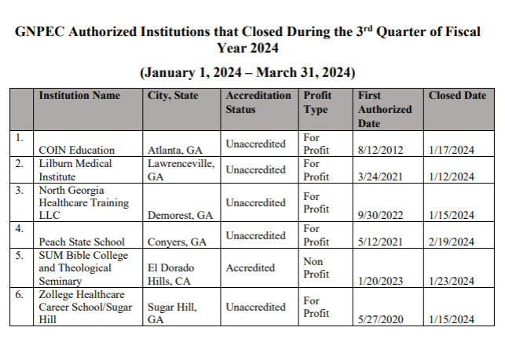
No approval required.

OTHER BUSINESS
      - The next Quarterly TGTF Board of Trustees Meeting is August 26, 2024, at 12:45pm (Headshots at 12:15pm)
      - Location: Georgia Nonpublic Postsecondary Education Commission, 2082 East Exchange Place, Tucker, GA

ADJOURNMENT
Trustee Squire moved to adjourn the meeting. Vice Chairman Martin seconded the motion.

There being no further business, the meeting adjourned at 1:04pm.

BOARD OF TRUSTEES CHAIR BOARD OF TRUSTEES SECRETARY
APPROVAL: APPROVAL:

____________________________________ ____________________________________
Signature Signature

____________________________________ ____________________________________
Date Date

