BOARD MEETING MINUTES
MEETING: | Board of Commissioners, Nonpublic Postsecondary Education Commission  Quarterly Meeting
DATE: | November 18, 2024
LOCATION: | Zoom
TIME: | 1:00pm, or at the conclusion of the Quarterly TGTF Board of Trustees Meeting
PUBLIC CALL-IN INSTRUCTIONS: | Dial-in Number: (646) 558-8656  Meeting ID: 876 0079 2586  Passcode: 733138


Georgia Nonpublic Postsecondary
Education Commission

Meeting Chair | Dr. Drew Van Horn, Chairman, Exempt Institution Representative
Meeting Title | NPEC Board of Commissioners
Members Present | - P.K. Martin, Vice Chairman, At-Large Post #3  - Kate Patterson, Secretary, At-Large Post #8  - Dr. Linda Adkinson, Degree-Granting Institution Representative  - Ryan Blythe, Certificate-Granting Institution Representative  - Pranay Udutha, At-Large Post #1  - Dr. Lance Barry, At-Large Post #5
Members Absent | - Doug Roper, At-Large Post #2  - Amanda Shailendra, At-Large Post #4  - Dr. Norma Nunez-Cortes, At-Large Post #6  - Jim Squire, At-Large Post #7
Staff Present | - Dr. Kirk Shook, Executive Director  - Maggie Rivers, Deputy Director  - Pat Neri, Program Manager, Compliance  - Phil Embry, External Auditor  - James Cheek, Program Manager/Authorization  - Mike Kaiser, Program Manager/Initial Authorization  - Caroline Fairhurst, Compliance Specialist  - Stephen Debaun, General Counsel
Visitors | - Steven Walters, AG  - Isabelle Keenum, OPB  - Francesca Tracy, The CE Shop

- CALL TO ORDER AND INVOCATION
Chairman Van Horn called the meeting to order at 1:11am and gave the invocation.

- ROLL CALL
Chairman Van Horn called the roll, and a quorum was declared.

- WELCOME/INTRODUCTION OF VISITORS
Presented by Chairman Van Horn

ACTION ITEMS
Presented by Chairman Van Horn

- APPROVAL OF AGENDA
Secretary Patterson moved to adopt the Agenda for the November 18, 2024, Quarterly Commission Meeting of the Georgia Nonpublic Postsecondary Education Commission. Commissioner Udutha seconded the motion. There was no discussion.

Upon unanimous vote, it was RESOLVED that the Agenda for the November 18, 2024, Quarterly Commission Meeting of the Georgia Nonpublic Postsecondary Education Commission be adopted.

- APPROVAL OF MINUTES
Chairman Van Horn moved to adopt the Minutes from the August 26, 2024, Quarterly Meeting of the Georgia Nonpublic Postsecondary Education Commission. Vice Chairman Martin seconded the motion. There was no discussion.

Upon a unanimous vote, it was RESOLVED that the Minutes from the August 26, 2024, Quarterly Meeting of the Georgia Nonpublic Postsecondary Education Commission be adopted.

- APPROVAL OF QUARTERLY REPORT: TUITION GUARANTY TRUST FUND (unaudited)
Presented by Phil Embry, External

  - FY25 1st Quarter Report (July - September)
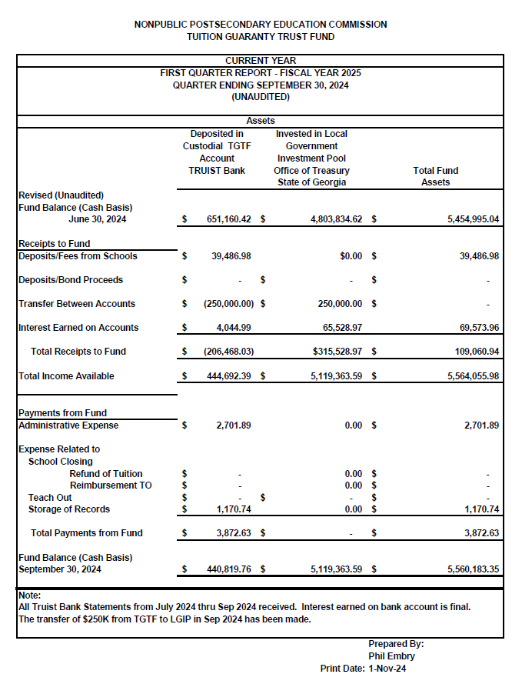

Secretary Patterson moved to adopt the Quarterly Report of the Tuition Guaranty Trust Fund for April - June 2024 period, as presented. Vice Chairman Martin seconded the motion. There was no discussion.

Upon unanimous vote, it was RESOLVED that the Quarterly Report of the Tuition Guaranty Trust Fund for July – September as approved by the Board of Trustees of the Tuition Guaranty Trust Fund, be adopted.

- APPROVAL OF REVISIONS TO THE FY25 SCHEDULE OF FEES

Dr. Shook presented the proposed change to the FY25 Schedule of Fees. The single change is shown below in red:

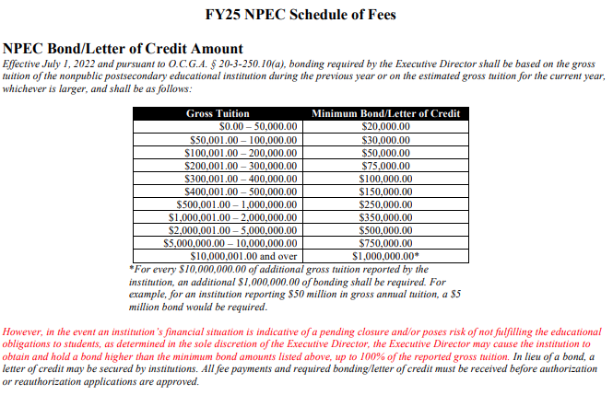

Secretary Patterson moved to approve the change to the FY25 Schedule of Fees, as presented. Commissioner Udutha seconded the motion. There was no discussion.

Upon unanimous vote, it was RESOLVED that Revisions to the FY25 Schedule of Fees, be adopted.

- APPROVAL OF POLICY UPDATES

Dr. Shook presented the proposed policy updates. Since both changes reflect already approved changes made by the Commission, Dr. Van Horn asked for the proposed changes to be presented and voted on together.

The update to Policy 15 is as follows:
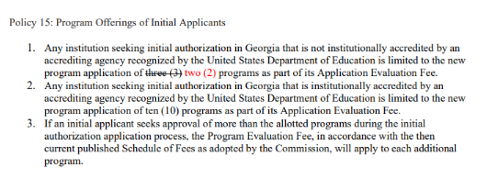

The update to Policy 16 is as follows:
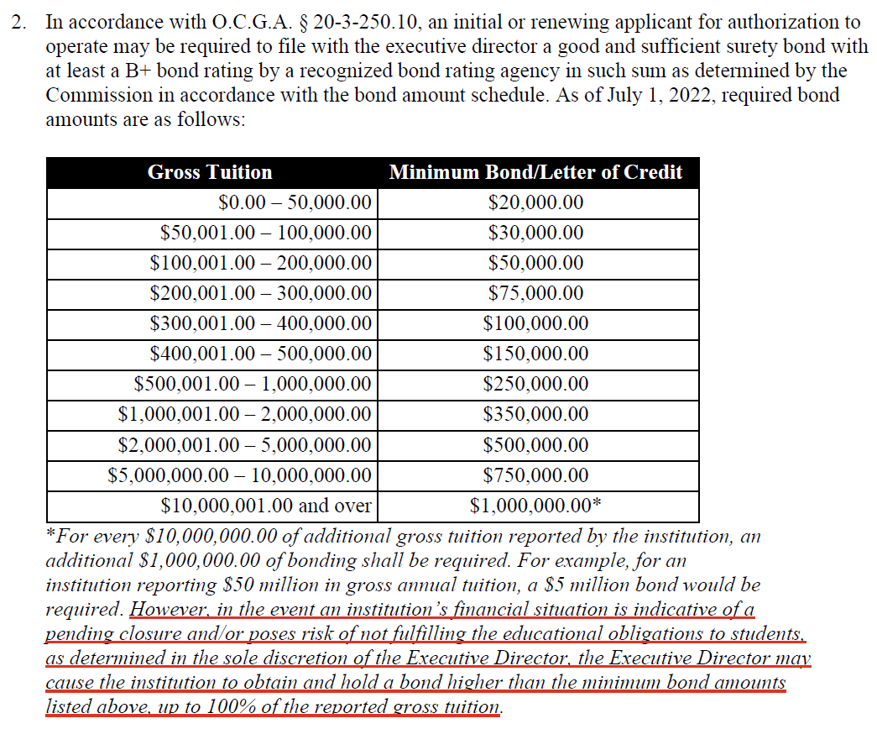

Commissioner Udutha moved to adopt the revisions of Policy 15: Program Offerings of Initial Applicants and Revisions to Policy 16: Surety Bond Requirements, as presented. Secretary Patterson seconded the motion. There was no discussion.

Upon unanimous vote, it was RESOLVED to adopt the revisions of Policy 15: Program Offerings of Initial Applicants and revisions to Policy 16: Surety Bond Requirements TGTF Board of Trustees Bylaws, be adopted.

- EXECUTIVE DIRECTOR REPORT
Presented by Dr. Kirk Shook, Executive Director

- Recognition of Commissioners and Staff who contributed to the Clark’s Christmas Kids
- NPEC FY25 Operations Budget (1st Quarter)
- Quarterly Budget Comparison (FY24 Q1 v. FY25 Q1)

- AGENCY OPERATIONS REPORTS
Presented by Maggie Rivers, Deputy Director

- FY25 1st Quarter Staff Actions

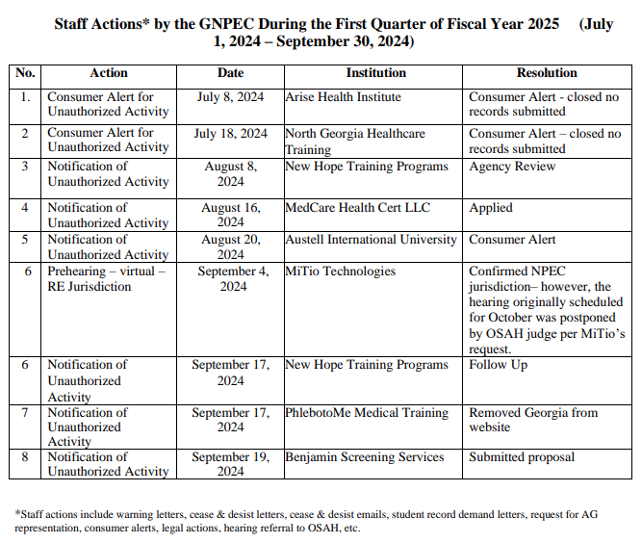

No approval required for this report.

- FY25 1st Quarter Newly Authorized Schools Report

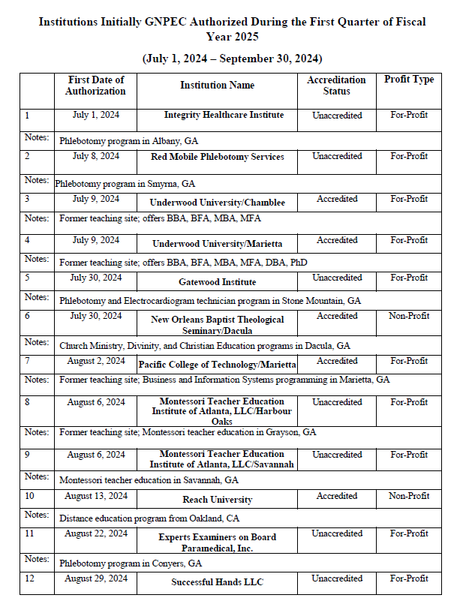
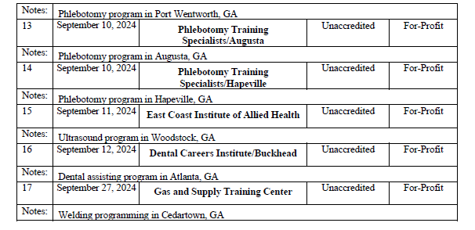

No approval required for this report.

- EXECUTIVE SESSION

Chairman Van Horn moved to enter Executive Session. Vice Chairman Martin seconded the motion. There was no discussion.

Upon unanimous vote at 1:33pm, the meeting of the GNPEC Board of Commissioners entered Executive Session.

After hearing a report from Steven Walters with the Attorney General’s Office concerning pending litigation, Commissioner Barry moved for the Commissioners to exit Executive Session. Commissioner Udutha seconded the motion. There was no discussion.

Upon unanimous vote at 1:37pm, the meeting of the GNPEC Board of Commissioners exited Executive Session.

- SCHOOL SPOTLIGHT
Presented by Dr. Kirk Shook, Executive Director

Ultimate Medical Academy
- Held a commencement on September 14, 2024 at the Yuengling Center in Tampa, FL
- More than 5,100 graduates (591 Georgia students) participated
- Georgia programs:

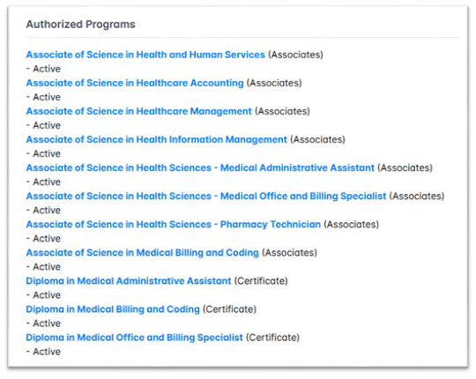
- The commencement speaker was Chaunte Lowe, a four-time Olympian and cancer survivor. She trained for the 2021 Tokyo Olympics while undergoing chemotherapy and recovering from a double mastectomy.
- The school was excited to celebrate their graduates!

- OTHER BUSINESS
Presented by Chairman Van Horn

- The next Quarterly Commission Meeting is February 24, 2025, at 1pm
- Location: Interactive College of Technology-Chamblee, 5303 New Peachtree Rd., Chamblee

- PUBLIC COMMENTS

No public comments were made.

- ADJOURN
Secretary Patterson moved to adjourn the meeting. Commissioner Udutha seconded the motion. There being no further business, the meeting adjourned at 1:44pm.

