MEETING: | Board of Trustees, Tuition Guaranty Trust Fund  Quarterly Meeting
DATE: | November 18, 2024
LOCATION: | Zoom
TIME: | 12:45pm
PUBLIC CALL-IN INSTRUCTIONS: | Dial-in Number: (646) 558-8656  Meeting ID: 876 0079 2586  Passcode: 733138

BOARD MEETING MINUTES



Georgia Nonpublic Postsecondary
Education Commission

Meeting Chair | Dr. Drew Van Horn, Chairman
Meeting Title | Board of Trustees of the NPEC Tuition Guaranty Trust Fund
Members Present | P.K. Martin, Vice Chairman  Kate Patterson  Dr. Kirk Shook, Secretary (Non-Voting Member)
Members Absent | Ryan Blythe  Jim Squire
Staff Present | Maggie Rivers, Deputy Director  Pat Neri, Program Manager, Compliance  Phil Embry, External Auditor  James Cheek, Program Manager/Authorization  Mike Kaiser, Program Manager/Initial Authorization  Caroline Fairhurst, Compliance Specialist  Stephen Debaun, General Counsel
Visitors | Isabelle Keenum, OPB  Francesca Tracy, The CE Shop  Steven Walters, AG

- CALL TO ORDER AND ROLL CALL
Chairman Van Horn called the meeting to order at 12:47 pm. Roll Call was taken, and a quorum was declared.

- APPROVAL OF AGENDA
Vice Chairman Martin moved to adopt the Agenda for the November 18, 2024, Quarterly Meeting of the Board of Trustees of the Tuition Guaranty Trust Fund. Trustee Patterson seconded the motion.

Upon unanimous vote, it was RESOLVED that the Agenda of the November 18, 2024, Quarterly Meeting of the Board of Trustees of the Tuition Guaranty Trust Fund be adopted.

- APPROVAL OF MINUTES
Trustee Patterson moved to adopt the Minutes from the August 26, 2024, Quarterly Meeting of the Board of Trustees of the Tuition Guaranty Trust Fund. Vice Chairman Martin seconded the motion.

Upon unanimous vote, it was RESOLVED that the Minutes from the August 26, 2024, Quarterly Meeting of the Board of Trustees of the Tuition Guaranty Trust Fund be adopted.

- APPROVAL OF QUARTERLY REPORT (unaudited): TUITION GUARANTY TRUST FUND
External Auditor Phil Embry reported on the following:

- FY25 1st Quarter Report (Jul – Sept 2024)
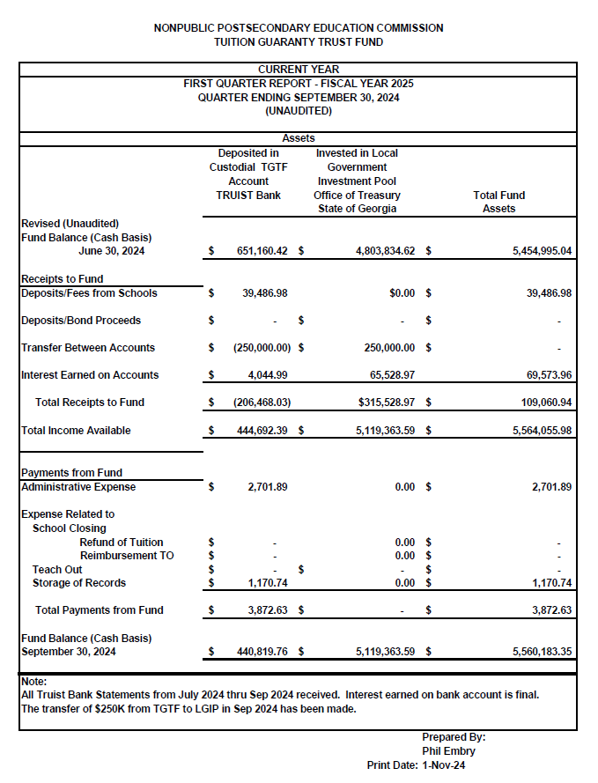

Vice Chairman Martin moved to adopt the amended Quarterly Report of the Tuition Guaranty Trust Fund. Trustee Patterson seconded the motion.

Upon unanimous vote, it was RESOLVED that the Quarterly Report of the Tuition Guaranty Trust Fund for the period July - September 2024 be adopted.

- APPROVAL OF INITIAL PAYOUT FOR ATLANTA SCHOOL OF MASSAGE CLOSURE

Dr. Shook discussed the recent closure of Atlanta School of Massage and the information collected by staff. Based on this information, he presented the following initial payout plan for students of this institution impacted by the closure:
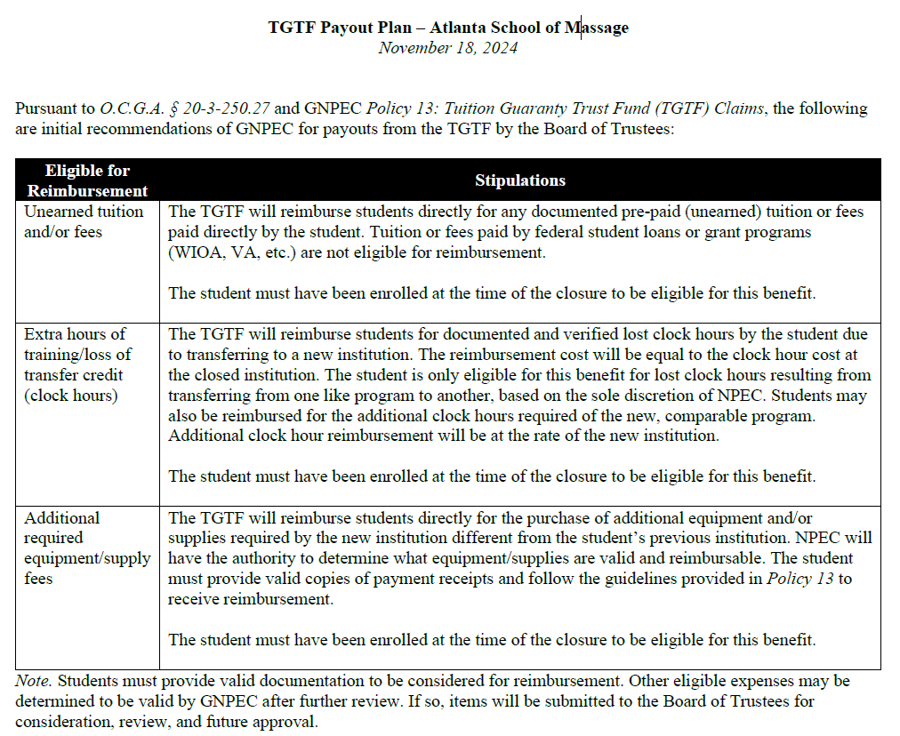

Trustee Patterson moved to adopt Initial Payout for Atlanta School of Massage closure. Vice Chairman Martin seconded the motion.

Upon unanimous vote, it was RESOLVED that the Initial Payout for Atlanta School of Massage closure be adopted.

- APPROVAL OF INITIAL PAYOUT FOR ATHENS INSTITUTE OF ALLIED HEALTH CLOSURE

Dr. Shook discussed the recent closure of Athens Institute of Allie Health and the information collected by staff. Based on this information, he presented the following initial payout plan for students of this institution impacted by the closure:
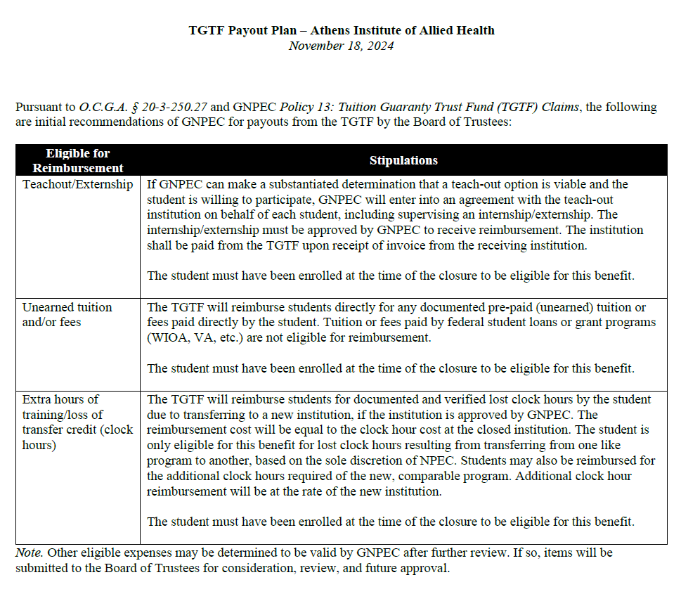

Vice Chairman Martin Trustee Patterson moved to adopt Initial Payout for Athens Institute of Allied Health closure. Trustee Patterson seconded the motion.

Upon unanimous vote, it was RESOLVED that the Initial Payout for Athens Institute of Allied Health closure be adopted.

- EXECUTIVE DIRECTOR REPORT

- Georgia Fund Market Update, Phil Embry
- Update on Precipitous Closures
- Art Institute of Atlanta, Miami International University of Art & Design, and Omnitech Institute

- REPORT ON FY25 1ST QUARTER SCHOOL CLOSURES
Presented by Maggie Rivers, Deputy Director

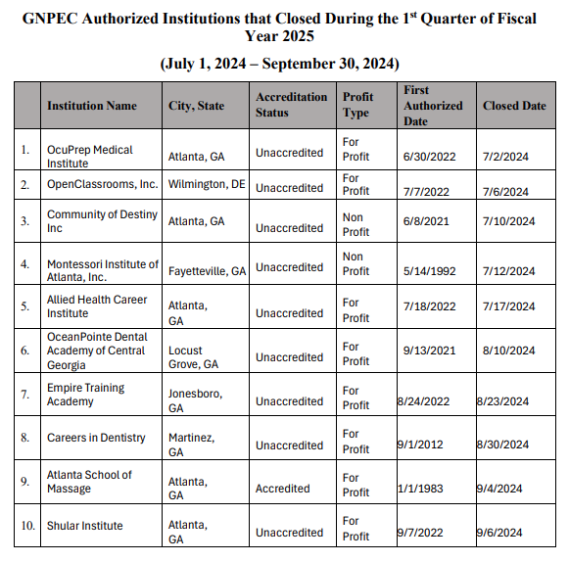
No approval required.

OTHER BUSINESS
- The next Quarterly TGTF Board of Trustees Meeting is February 24, 2025, at 12:45pm
- Location: Interactive College of Technology-Chamblee, 5303 New Peachtree
Rd., Chamblee

ADJOURNMENT
Trustee Patterson moved to adjourn the meeting. Vice Chairman Martin seconded the motion.

There being no further business, the meeting adjourned at 1:11pm.

BOARD OF TRUSTEES CHAIR BOARD OF TRUSTEES SECRETARY
APPROVAL: APPROVAL:

____________________________________ ____________________________________
Signature Signature

____________________________________ ____________________________________
Date Date

