BOARD MEETING MINUTES
DATE | Monday, November 27, 2023
TIME | 1:00 PM
LOCATION | PCOM South Georgia, 2050 Tallokas Rd., Moultrie, GA
PURPOSE | Quarterly Commission Meeting
Public Call-In Instructions | Dial-in Number: (667) 770-1484  Participant Code: 317138#

Georgia Nonpublic Postsecondary
Education Commission

Meeting Chair | Dr. Drew Van Horn
Meeting Title | NPEC Board of Commissioners
Members Present | - Dr. Drew Van Horn, Chairman, Exempt Institution Representative  - P.K. Martin, Vice Chairman, At-Large Post #3  - Kate Patterson, Secretary, At-Large Post #8  - Toby Hinton, Degree-Granting Institution Representative  - Pranay Udutha, At-Large Post #1  - Doug Roper, At-Large Post #2  - Holly Kirbo, At-Large Post #5  - Jim Squire, At-Large Post #7
Members Absent | - Ryan Blythe, Certificate-Granting Institution Representative  - Amanda Shailendra, At-Large Post #4  - Dr. Norma Nunez-Cortes, At-Large Post #6
Staff Present | Kirk Shook, Executive Director  Adam Hawk, Deputy Director  Maggie Rivers, Division Director  Phil Embry, External Auditor  James Cheek, Regulatory Specialist  Lily Grant, Regulatory Specialist  Stephen Debaun, General Counsel
Visitors | Danna Yu, AG

- CALL TO ORDER AND INVOCATION
Chairman Van Horn called the meeting to order at 1:22pm and gave the invocation. Moment of silence was observed for the recent passing the Executive Director’s mother, Bridget Shook.

Chairman Van Horn called the roll, and a quorum was declared.
- WELCOME/INTRODUCTION OF VISITORS
Chairman Van Horn welcomed all the guests and visitors in attendance.

- SCHOOL SPOTLIGHT
Executive Director Shook and Chairman Van Horn thanked PCOM South Georgia for their hospitality during the visit to the campus.

- APPROVAL OF AGENDA
Commissioner Hinton moved to adopt the Agenda for the August 28, 2023, Quarterly Commission Meeting of the Georgia Nonpublic Postsecondary Education Commission. Commissioner Kirbo seconded the motion. There was no discussion.

Upon unanimous vote, it was RESOLVED that the Agenda for the August 28, 2023, Quarterly Commission Meeting of the Georgia Nonpublic Postsecondary Education Commission be adopted.

- APPROVAL OF MINUTES
Vice Chairman Martin moved to adopt the Minutes from the August 28, 2023, Quarterly Meeting of the Georgia Nonpublic Postsecondary Education Commission with changes. Commissioner Squire seconded the motion. There was no discussion.

Upon a unanimous vote, it was RESOLVED that the Minutes from the August 28, 2023, Quarterly Meeting of the Georgia Nonpublic Postsecondary Education Commission be adopted.

- APPROVAL OF QUARTERLY REPORT: TUITION GUARANTY TRUST FUND (unaudited)
External Auditor Phil Embry reported on the following:
- FY24 1st Quarter Report (July - September 2023)

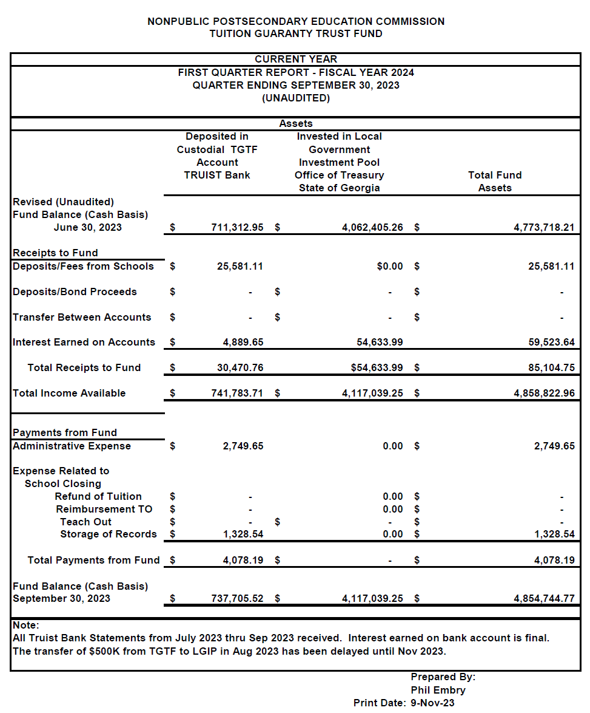
Commissioner Hinton moved to adopt the Quarterly Report of the Tuition Guaranty Trust Fund for July – September 2023 period, as presented. Commissioner Kirbo seconded the motion. There was no discussion.

Upon unanimous vote, it was RESOLVED that the Quarterly Report of the Tuition Guaranty Trust Fund for July - September 2023, as approved by the Board of Trustees of the Tuition Guaranty Trust Fund, be adopted.

- APPROVAL OF POLICY 16: SURETY BOND FORM AND REQUIREMENTS REFUND POLICY REVISION
Executive Director Shook presented the changes to Policy 16. He noted that the only change to the Policy concerned the bond amounts. These amounts were approved as part of the FY24 Schedule of Fees in May 2023, but were not captured in Policy 16. The update to the bond amounts are reflected below and are effective immediately:

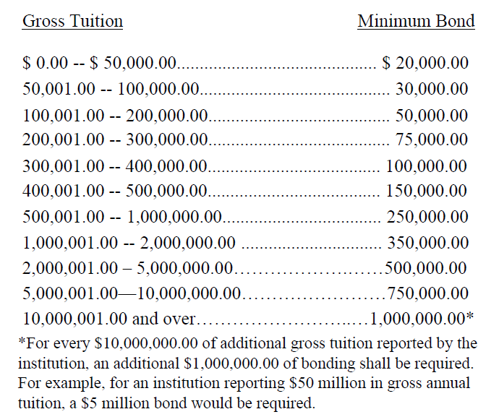

Commissioner Udutha moved to adopt Approval of Policy 16: Surety Bond Form and Requirements, as presented. Commissioner Hinton seconded the motion. There was no discussion.

Upon unanimous vote, it was RESOLVED that Policy 16: Surety Bond Form and Requirements be adopted.

- EXECUTIVE DIRECTOR REPORT
Presented by Kirk Shook, Executive Director
- GNPEC FY24 Operations Budget (1st Quarter)
- Quarterly Budget Comparison (FY23 Q1 v. FY24 Q1)
- Agency Updates
- Precipitous Closures / Bonds
- Revision of Agency Performance Review Instrument
- Teaching Site Changes

- AGENCY OPERATIONS REPORT
Presented by Maggie Rivers, Division Director

- FY24 1st Quarter Staff Actions

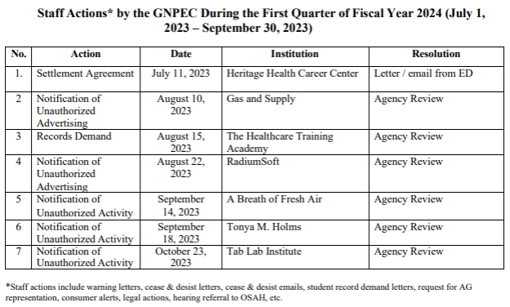

No approval required for this report.

- AUTHORIZATION COMPLIANCE REPORT
Presented by Adam Hawk, Deputy Director
- Division Reports
    - FY23 4th Quarter Newly Authorized Schools Report

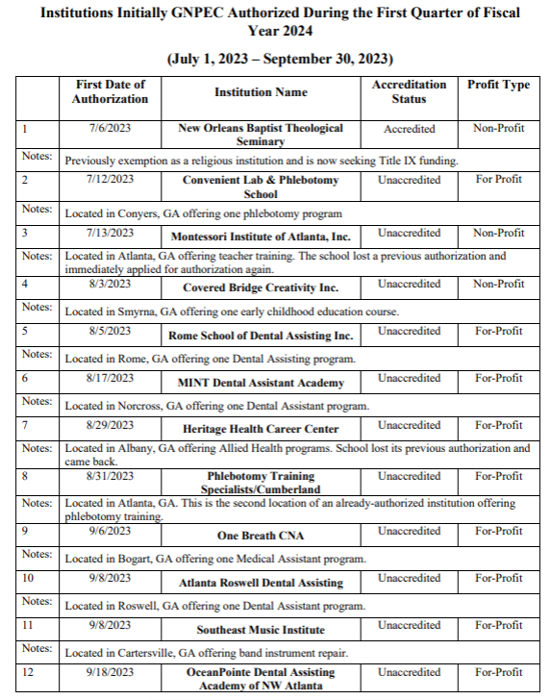

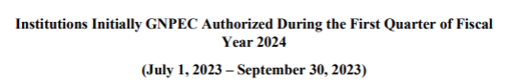
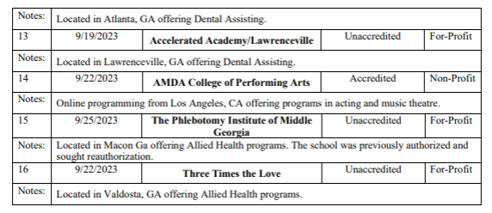

No approval required for this report.

- EXECUTIVE SESSION
There was no need for Executive Session at this time.

- PUBLIC COMMENTS

- OTHER BUSINESS
Presented by Dr. Drew Van Horn, Chairman
- The next Quarterly Commission Meeting is February 26, 2024 at 1pm via Zoom

- ADJOURN
Commissioner Kirbo moved to adjourn the meeting. Commissioner Udutha seconded the motion. There being no further business, the meeting adjourned at 2:14 pm.

COMMISSION CHAIR APPROVAL: COMMISSION SECRETARY APPROVAL:

____________________________________ ____________________________________
Signature Signature

____________________________________ ____________________________________
Date Date

