DATE | Monday, November 27, 2023
TIME | 12:45 PM
LOCATION | PCOM South Georgia, 2050 Tallokas Rd., Moultrie, GA
PURPOSE | Quarterly TGTF Meeting
PUBLIC CALL-IN INSTRUCTIONS: | Dial-in Number: (667) 770-1484  Participant Code: 317138#

BOARD MEETING MINUTES

Georgia Nonpublic Postsecondary
Education Commission

Meeting Chair | Dr. Drew Van Horn
Meeting Title | Board of Trustees of the NPEC Tuition Guaranty Trust Fund
Members Present | Dr. Drew Van Horn, Chairman  P.K. Martin, Vice Chairman  Kate Patterson  Jim Squire  Kirk Shook, Secretary (Non-Voting Member)
Members Absent | Ryan Blythe
Staff Present | Kirk Shook, Executive Director  Adam Hawk, Deputy Director  Maggie Rivers, Division Director  Phil Embry, External Auditor  James Cheek, Regulatory Specialist  Lily Grant, Regulatory Specialist  Stephen Debaun, General Counsel
Visitors | Danna Yu, AG

- CALL TO ORDER AND ROLL CALL
Chair Van Horn called the meeting to order at 12:53 pm. Roll Call was taken, and a quorum was declared.

- APPROVAL OF AGENDA
Trustee Squire moved to adopt the Agenda for the August 28, 2023, Quarterly Meeting of the Board of Trustees of the Tuition Guaranty Trust Fund. Vice Chairman Martin seconded the motion.

Upon unanimous vote, it was RESOLVED that the Agenda of the August 28, 2023, Quarterly Meeting of the Board of Trustees of the Tuition Guaranty Trust Fund be adopted.

- APPROVAL OF MINUTES
Vice Chairman Martin moved to adopt the Minutes from the August 28, 2023, Quarterly Meeting of the Board of Trustees of the Tuition Guaranty Trust Fund. Trustee Squire seconded the motion.

Upon unanimous vote, it was RESOLVED that the Minutes from the August 28, 2023, Quarterly Meeting of the Board of Trustees of the Tuition Guaranty Trust Fund be adopted.

- QUARTERLY REPORT (unaudited): TUITION GUARANTY TRUST FUND
External Auditor Phil Embry reported on the following:
- FY24 1st Quarter Report (July - September 2023)
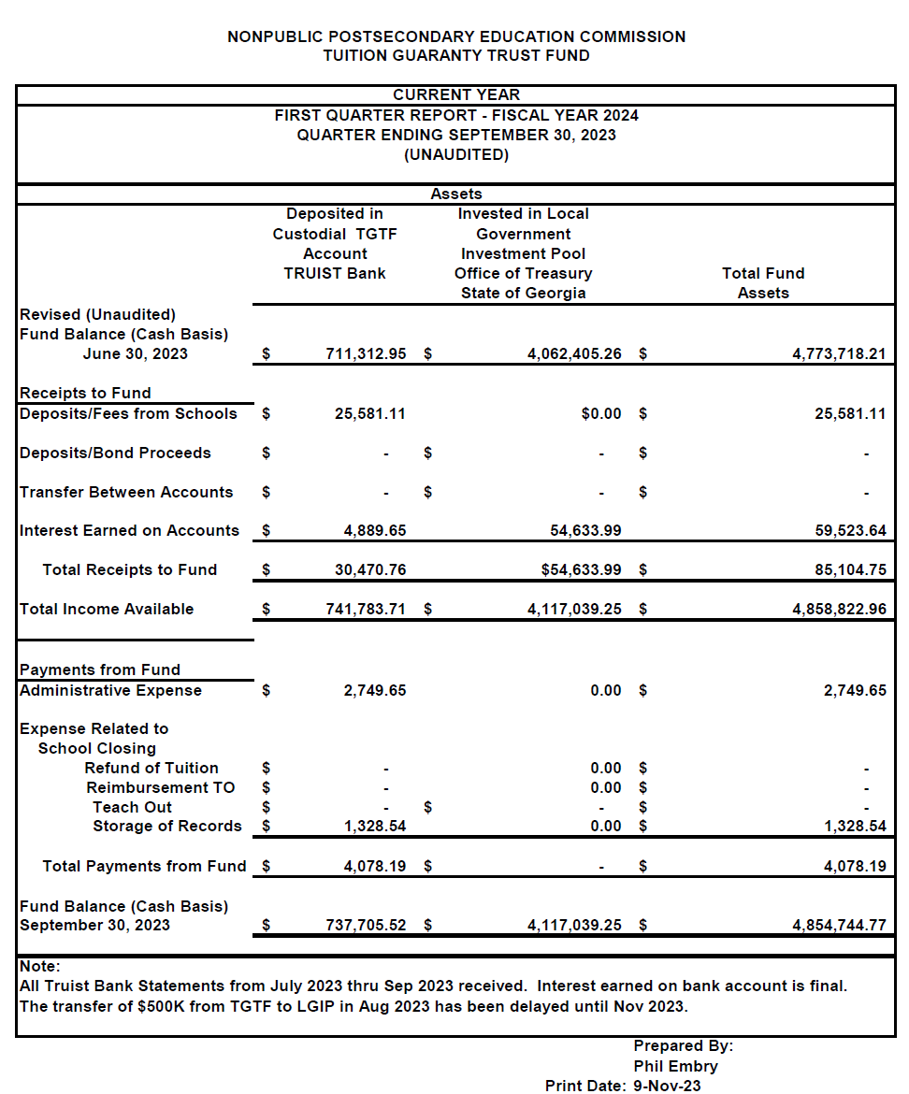

Trustee Squire moved to adopt the amended Quarterly Report of the Tuition Guaranty Trust Fund. Trustee Patterson seconded the motion.

Upon unanimous vote, it was RESOLVED that the Quarterly Report of the Tuition Guaranty Trust Fund
for the period July - September 2023 be adopted.

- APPROVAL OF THE FUNDING OF OMNITECH INSTITUTE PAYOUT CATEGORIES
Executive Director Shook presented that proposed funding categories to payout to students due to the precipitous closure of Omnitech Institute. Below is what was presented:

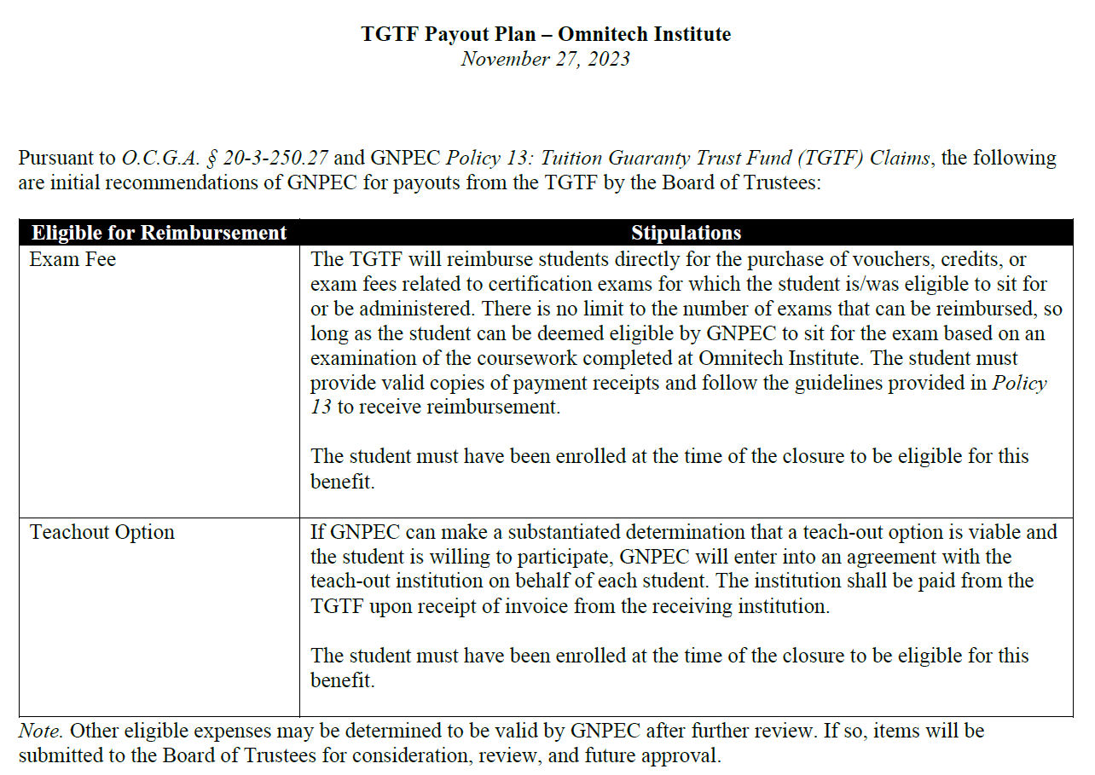

Trustee Squire moved to adopt the approval of the Funding of Omnitech Institute Payout Categories. Vice Chairman Martin seconded the motion.

Upon unanimous vote, it was RESOLVED that the approval of the Funding of Omnitech Institute Payout Categories be adopted.

- EXECUTIVE DIRECTOR REPORT
- Update on Recent Closures – Precipitous Closure Fact Sheet
- Art Institute of Atlanta, Miami International University of Art & Design, & Omnitech Institute
- Georgia Fund Market Update, Phil Embry

REPORT ON FY24 1st QUARTER SCHOOL CLOSURES
Presented by Adam Hawk, Deputy Director

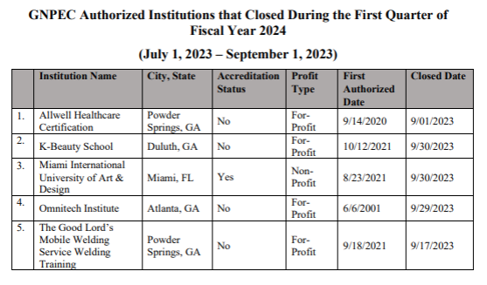

No approval required.

- OTHER BUSINESS
The next TGTF Board of Trustees Meeting is February 26, 2024 at 12:45pm via Zoom

- ADJOURNMENT
Vice Chairman Martin moved to adjourn the meeting. Trustee Squire seconded the motion.

There being no further business, the meeting adjourned at 1:21 pm

BOARD OF TRUSTEES CHAIR BOARD OF TRUSTEES SECRETARY
APPROVAL: APPROVAL:

____________________________________ ____________________________________
Signature Signature

____________________________________ ____________________________________
Date Date

