BOARD MEETING MINUTES
DATE | Monday, October 25, 2021
TIME | 1:00 PM
LOCATION | Helms College – Augusta
PURPOSE | Quarterly Commission Meeting
Georgia Nonpublic Postsecondary
Education Commission

Meeting Chair | Toby Hinton
Meeting Title | NPEC Board of Commissioners
Members Present | - Toby Hinton, Chair, Degree-Granting Institution Representative  - Dr. Norma Nunez-Cortes, Vice Chair, At-Large Post #6  - Ryan Blythe, Certificate-Granting Institution Representative  - Dr. Drew Van Horn, Exempt Institution Representative  - Pranay Udutha, At-Large Post #1  - Doug Roper, At-Large Post #2  - P.K. Martin, At-Large Post #3  - Holly Kirbo, At-Large Post #5  - Kate Patterson, At-Large Post #8
Members Absent | - Amanda Shailendra, Secretary, At-Large Post #4  - VACANT, At-Large Post #7
Staff Present | Dr. Laura Vieth, Associate Executive Director  Adam Hawk, GA-SARA Coordinator/Division Director  Phil Embry, External Auditor  Pat Neri, Program Manager  Maggie Rivers, Program Manager  Brian Annino, NPEC/GSFC General Counsel
Visitors | Isabella Lugo, Office of the Attorney General  Jet Toney, Georgia Independent College Association

- CALL TO ORDER AND INVOCATION
Chairman Hinton called the meeting to order at 1:11 PM and gave the invocation. Chairman Hinton called the roll and a quorum was declared.
- WELCOME/INTRODUCTION OF VISITORS
Chairman Hinton welcomed all the guests and visitors in attendance and thanked Helms College for providing lunch, a meeting location, and a tour of facilities.
- APPROVAL OF AGENDA
Commissioner Van Horn moved to adopt the Agenda for the October 25, 2021 Quarterly Commission Meeting of the Georgia Nonpublic Postsecondary Education Commission. Commissioner Udutha seconded the motion. There was no discussion.

Upon unanimous vote, it was RESOLVED that the Agenda for the October 25, 2021 Quarterly Commission Meeting of the Georgia Nonpublic Postsecondary Education Commission be adopted.

- APPROVAL OF MINUTES
Commissioner Patterson moved to adopt the Minutes from the July 26, 2021 Quarterly Meeting of the Georgia Nonpublic Postsecondary Education Commission. Commissioner Blythe seconded the motion. There was no discussion.

Upon a unanimous vote, it was RESOLVED that the Minutes from the July 26, 2021 Quarterly Meeting of the Georgia Nonpublic Postsecondary Education Commission be adopted.

Commissioner Martin moved to adopt the Minutes from the August 27, 2021 Special Called Meeting of the Georgia Nonpublic Postsecondary Education Commission. Commissioner Patterson seconded the motion. There was no discussion.

Upon a unanimous vote, it was RESOLVED that the Minutes from the August 27, 2021 Special Called Meeting of the Georgia Nonpublic Postsecondary Education Commission be adopted.

- QUARTERLY REPORT (unaudited): TUITION GUARANTY TRUST FUND
External Auditor Phil Embry reported on the following:
- FY22 1st Quarter Report ending September 30, 2021
- Tuition Guaranty Trust Fund 1st Quarter Yearly Comparison Report

Commissioner Van Horn moved to adopt the Quarterly Report of the Tuition Guaranty Trust Fund for the three-month period ending September 30, 2021, as presented. Commissioner Kirbo seconded the motion. There was no discussion.

Upon unanimous vote, it was RESOLVED that the Quarterly Report of the Tuition Guaranty Trust Fund for the three-month period ending September 30, 2021, as approved by the Board of Trustees of the Tuition Guaranty Trust Fund, be adopted.

- EXECUTIVE DIRECTOR REPORT
Presented by Phil Embry, External Auditor
- NPEC FY22 Operations Budget (1st Quarter, ending September 30, 2021)
- Quarterly Budget Comparison (FY21 Q1 v. FY22 Q1)

No approval required for this report.

- AGENCY OPERATIONS REPORT
Presented by Dr. Laura Vieth, Associate Executive Director
- FY22 1st Quarter Staff Actions Report

Staff Actions* by the GNPEC During the First Quarter of Fiscal Year 2022
(July 1, 2021 – September 30, 2021)

No. | Action | Date | Institution | Resolution
1. | Cease & Desist from Attorney | July 11, 2021 | Skillful Coding Techniques Prep-Academy LLC  6080 GA-42, # 110  P.O. Box 877  Ellenwood, GA 30273 | Closed – 8/4/2021
2. | Cease & Desist Letter | July 21, 2021 | Realtime Voice Academy  250 Langely Drive  Lawrenceville, GA 30046 | Hearing Requested on 8/26/21 by institution pursuant to O.C.G.A. § 20-3-250.13
3. | Request for Representation | July 22, 2021 | Medical Advance Prep, Inc.  1804 East Park Avenue, 3rd Floor  Valdosta, GA 31602-5503  Medical Advanced Prep, Inc.  223 North Ashley Street, Rm. 310  Valdosta, GA 31601  Dekoya Adams, Registered Agent  Medical Advance Prep, Inc.  1505 Madison Heights Dr.  Valdosta, GA 31601 | Request sent Attorney General 8/11/2021 to file complaint
4. | Request for Representation | August 11, 2021 | Chronicles Billing, Inc.  2749 Mt Zion Parkway, Suite 100  Jonesboro, GA 30236  425 Winged Foot Drive  McDonough, GA 30236 | Pending with Office of the Attorney General
5. | Hearing Referral | August 26, 2021 | Realtime Voice Academy  250 Langely Drive  Lawrenceville, GA 30046 | Pending with Office of State Administrative Hearings (continuance until October 25, 2021)
6. | Referred to Counsel | September 30, 2021 | Blossom’s Grooming Academy  1368 Housers Mill Road  Fort Valley, GA 31030 | Pending with Agency Counsel
*Staff actions include warning letters, cease & desist letters, cease & desist emails, student record demand letters, request for AG representation, consumer alerts, legal actions, hearing referral to OSAH, etc.

- Legislative Liaison Report, Maggie Rivers
- Strategic Plan Metrics Report

No approval required for this report.
- AGENCY OPERATIONS REPORT
Presented by Adam Hawk, Division Director/GA-SARA Coordinator
- FY22 1st Quarter Newly Authorized Schools Report

Institutions Initially GNPEC Authorized During the First Quarter of Fiscal Year 2022
(July 1, 2021- September 30, 2021)

No. | First Date of Authorization | Institution Name | Fiscal Type | Bond Amount
1 | July 6, 2021 | Middle Georgia School of Massage, LLC (Gray, GA)  - Unaccredited  - Offers certificate in massage | For-profit | $30k
2 | August 5, 2021 | Virginia University of Integrative Medicine (Duluth, GA)  - Accredited by Accreditation Commission for Acupuncture and Oriental Medicine  - Offers graduate degrees and certificates in acupuncture and oriental medicine | Nonprofit | $50k
3 | August 9, 2021 | WrightNow Solutions (Atlanta, GA)  - Unaccredited  - Offers certificates in IT | For-profit | $75k
4 | August 12, 2021 | Datum Tech Academy (Stone Mountain, GA)  - Unaccredited  - Offers a certificates in IT | Nonprofit | $75k
5 | August 18, 2021 | Georgia Orthodontic Assisting School (Lithonia, GA)  - Unaccredited  - Offers certificate in dental assisting | For-profit | $20k
6 | August 20, 2021 | Advanced Medical Academy, LLC (Clarksville, GA)  - Unaccredited  - Offers certificates in allied health | For-profit | $30k
7 | August 23, 2021 | Miami International University of Art & Design (Miami, FL)  - Accredited by Southern Association of Colleges and Schools Commission on Colleges (SACSCOC)  - Offers degrees in art and design | Nonprofit | $50k
8 | September 1, 2021 | What A Blessing Training Center, LLC (Savannah, GA)  - Unaccredited  - Offers certificates in allied health | For-profit | $50k
9 | September 7, 2021 | United Education Institute/ Stone Mountain (Stone Mountain, GA)  - Unaccredited  - Offers a certificate in dental assisting, allied health, office administration, HVAC, and electrical studies | For-profit | $50k
10 | September 13, 2021 | OceanPointe Dental Academy of Central Georgia (Locust Grove, GA)  - Unaccredited  - Offers certificate in dental assisting | For-profit | $50k
11 | September 14, 2021 | Airweb Digital (Gainesville, GA)  - Unaccredited  - Offers a certificate in drone operation | For-profit | $20k
12 | September 14, 2021 | InspectionGo Academy (Tyrone, PA)  - Unaccredited  - Offers a certificate in home inspection | For-profit | $50k
13 | September 18, 2021 | The Good Lord's Mobile Welding Service Welding Training (Powder Springs, GA)  - Unaccredited  - Offers certificate in welding | For-profit | $30k
14 | September 20, 2021 | California State University, Northridge (Northridge, CA)  - Accredited by Western Association of Schools and Colleges (WASC Sr)  - Offers undergraduate and graduate degrees in liberal arts | State | $20k
15 | September 22, 2021 | Augusta Dental Assistant School (Augusta, GA)  - Unaccredited  - Offers certificate in dental assisting | For-profit | $30k
16 | September 23, 2021 | CompTIA Tech Career Academy (Downers Grove, IL)  - Unaccredited  - Offers certificate in IT support | Nonprofit | $50k
17 | September 26, 2021 | American K9 Connection School for Dog Trainers (Marietta, GA)  - Unaccredited  - Offers certificates in dog training | For-profit | $20k
18 | September 30, 2021 | Guided Hands Academy (Albany, GA)  - Unaccredited  - Offers certificates in allied health | For-profit | $50k

- Authorization Report
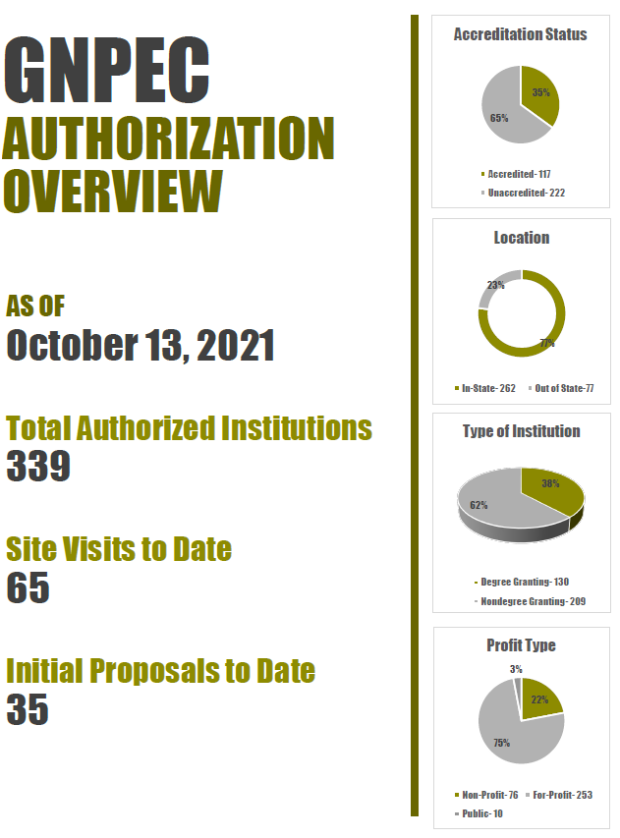
No approval required for this report.

- EXECUTIVE SESSION
Commissioner Martin moved for the Board of Commissioners to go into Executive Session to discuss pending agency litigation. Commissioner Udutha seconded the motion. The Commission voted unanimously to enter into Executive Session.

After discussing legal matters, Commissioner Van Horn moved to close the Executive Session. Commissioner Kirbo seconded the motion. Upon a unanimous vote, the Executive Session was closed.

- OTHER BUSINESS
The next Quarterly Commission Meeting is scheduled for January 24, 2022 at 1pm via Zoom teleconference.

- PUBLIC COMMENTS
Chairman Hinton opened the floor for public comments. No public comments were made.

- ADJOURN
Commissioner Van Horn moved to adjourn the meeting. Commissioner Udutha seconded the motion.

There being no further business, the meeting adjourned at 2:05 PM.

COMMISSION CHAIR APPROVAL: COMMISSION SECRETARY APPROVAL:

____________________________________ ____________________________________
Signature Signature

____________________________________ ____________________________________
Date Date

