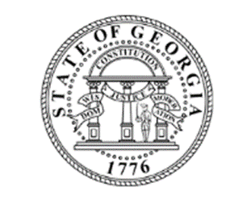
The Georgia Nonpublic postsecondary

Education Commission (GNPEC)

INSTITUTIONAL NEwsletteR
  - June 2017

WELCOME
WE WANT TO HEAR FROM YOU
The plan is to create a schedule for the newsletters that will be helpful but not burdensome. We would love to collect your input on the frequency that you feel would be helpful. Would you like to receive these quarterly? Twice a year? Once a year?
Also, what topics would be of interest to you? We plan to provide information on changes to process and policies as well as to continually seek your input on how to improve our support of you and all you do for your students.
Email your Standards Administrator with your ideas and comments.

Welcome to the first edition of the GNPEC's Institutional Newsletter. As part of the Commission's ongoing efforts to provide support and information to schools serving Georgia residents, we hope to add a regular information newsletter to the mix of the emails and web information currently provided.

Website Updates
In order to assist you with GNPEC regulations, we have recently provided a new Institutional Effectiveness Resources section on www.gnpec.org. Here you can find things like guidelines for meeting the transcript and catalog requirements as well as a spreadsheet for tracking outcome data. We now have an expanded FAQ section, available within the Authorization tab (https://gnpec.org/authorization/), to help provide additional direction for those 'frequently asked questions'. Have one that isn't covered? Send it to your Standards Administrator and look for it in our next update.

A new “Student Resource” section, previously named “Consumer Resources”, has also been added to GNPEC's website. Furthermore, we now have an expanded FAQ section, available within the Authorization tab (https://gnpec.org/authorization/), to help provide additional direction for those 'frequently asked questions'.

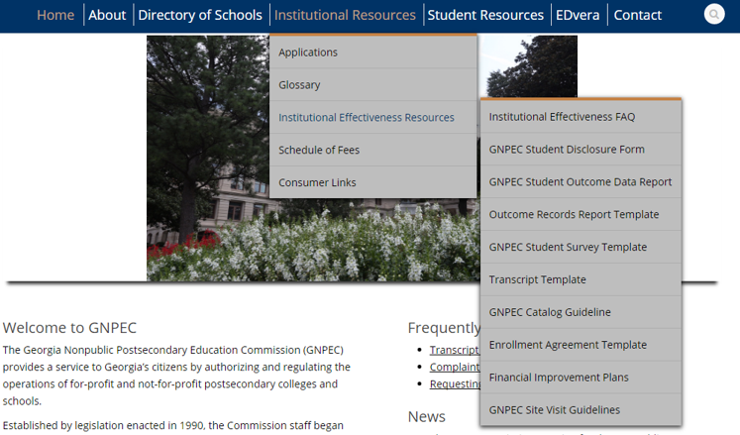

EDvera Updates
Please be on the lookout for a minor change made to our application portal, Edvera. On the Documents page of your Edvera account, what was previously labeled "New Document" is now "Start Document". 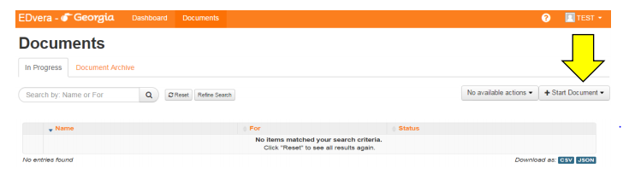

Calendar Reminders
- The next Commission Meeting for the Nonpublic Postsecondary Education Commission will take place on July 17, 2017 at a time and location to be announced at a later date. Please check the “News” section at www.gnpec.org for updates.
- For unaccredited institutions, the GNPEC Student Outcome Form must be submitted via email to your Standards Administrator no later than September 1, 2017. For record keeping, an Outcome Records Report Template is available within the Institutional Effectiveness Resources (https://gnpec.org/institutional-effectiveness-resources/placement-records-spreadsheet-template/). Still have questions about what is required? Email them to Laura Vieth at lauras@gnpec.org.

