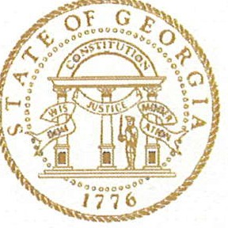

Nonpublic Postsecondary Education Commission
2082 East Exchange Place, Suite 220
Tucker, Georgia 30084-5305
(770) 414-3300
Fax (770) 414-3309

Brian P. Kemp
Governor
Kirk Shook
Executive Director

Board of Commissioners
Georgia Nonpublic Postsecondary Education Commission AGENDA
Special Called Meeting (via teleconference) March 6, 2019 10:00a.m.

Call to Order & Invocation Holly Kirbo, Chair
- Introduction of New Executive Director Kirk Shook

Action Items Holly Kirbo, Chair

- Approval of Agenda
- Approval of whether to Authorize an Administrative Law Judge to hear SIFT Institute appeal to the Commission
  - If this passes in the affirmative, the following items must be voted on:
        - Adopt Rules for Hearing (OSAH Rules are recommended by the Attorney General’s office)
        - Hearing Date Reschedule Option (discretion given to the ED)
        - Administrative Law Judge Designation (discretion given to the ED)
        - Appeal Options
          - Administrative Law Judge Decision is “final” (judicial review option still available for both parties)
          - Commission can reconsider ALJ decision
- Future Process
  - Always defer to Administrative Law Judge (this can be changed at any future Commission meeting)
  - Decide on a case-by-case basis each time

Other Business Holly Kirbo, Chair

ADJOURN

